

**MALWARE ANALYSIS TOOLS AND TECHNIQUES**

Year 2 (2022/23), Semester 4

## SCHOOL OF INFOCOMM TECHNOLOGY

Diploma in Cybersecurity & Digital Forensics

**ASSIGNMENT**

Weightage: 40%

Deadline: *Monday 13th Feb 2022, 9.00 AM*

|  |  |
| --- | --- |
| **Student Name** | **Student ID** |
| Javien Tan Jie En | S10221841F |
| Cassidy Quek Jing Hui | S10222096G |
| Low Jun Jie, Ryan | S10222186E |

Table of Contents

SCHOOL OF INFOCOMM TECHNOLOGY 1

1. Overview 5

2. Lab Setup 5

3. Malware Analysis Tools 6

3.1. Basic Static Analysis 6

3.1.1 HashMyFiles / WinMD5 7

3.1.2 VirusTotal 8

3.1.3 PEStudio 9

3.1.4 PEiD 10

3.1.5 Exeinfo PE 11

3.1.6 ByteHist 12

3.1.7 BinText 14

3.1.8 Dependency Walker 15

3.1.9 PEview 16

3.1.10. Olevba / OfficeMalScanner 16

3.2. Advanced Static Analysis 17

3.2.1 IDA Pro Free 18

3.2.2 Relyze Desktop 20

3.3. Basic Dynamic Analysis 21

3.3.1. ApateDNS 22

3.3.2. Netcat 22

3.3.3. Process Explorer 23

3.3.4. Process Monitor 25

3.3.5. Regshot 26

3.3.6. Tcpdump 27

3.4. Advanced Dynamic Analysis 28

3.4.1. OllyDBG 28

4. Analysis of Malicious Executable 30

4.1. Basic Static Analysis 30

4.1.1 Hashing 30

4.1.2 VirusTotal 31

4.1.2.1 VirusTotal Detection Section 31

4.1.2.2 VirusTotal Relations Section 33

4.1.2.3 VirusTotal Behaviour Section 34

4.1.3 Checking if Malware is Packed 38

4.1.4 Structure and Content of Malware 40

4.1.5 Dependencies of Malware 41

4.1.5.1 KERNEL32.DLL 42

4.1.5.2 ADVAPI32.DLL 43

4.1.5.3 WINHTTP.DLL 44

4.1.6 Strings Analysis 45

4.1.7 General Analysis of Malware 47

4.1.8 Basic Static Analysis Conclusion 48

4.2. Basic Dynamic Analysis 49

4.2.1. Network Activity 49

4.2.2. Process and Registry Activity 52

4.2.3. Basic Dynamic Analysis Conclusion 58

4.3. Advanced Static Analysis 59

4.3.1 Debugger Trap 61

4.3.2 File Creation and Writing to File 63

4.3.3 Sleep Functions 66

4.3.4 Network Related Function 67

4.3.5 Clearing Event Logs 69

4.3.6 Reading Files 72

4.4. Advanced Dynamic Analysis 73

4.4.1. Debugging 73

4.4.2. Bypassing Defence Mechanisms 84

4.4.3. Automated Malware Analysis 89

4.4.3.1. JoeSandbox 90

4.5. General Analysis 101

4.6. Malware Removal 101

5. Analysis of Malicious Document 103

5.1. Basic Static Analysis 104

5.1.1. VirusTotal 104

5.1.2. Malware Fingerprinting 106

5.1.3. Unpacking 107

5.1.4. String Analysis 111

5.1.5. Summary of Basic Static Analysis 112

5.2. Basic Dynamic Analysis 112

5.2.1. General Dynamic Analysis 113

5.2.2. Registry Analysis 115

5.2.3. Process Analysis 117

5.2.4. Network Analysis 119

5.2.5. Process Monitoring 121

5.2.6. Analysing the .ahk File 122

5.2.7. Summary of Basic Dynamic Analysis 123

5.3. Summarization of Malicious Document Analysis 124

5.3.1. Malicious Document Functionalities 124

5.3.2. Malicious Document Removal 124

6. Video Submission Links 126

7. References 127

# 

# 1. Overview

This report encompasses the analysis of 2 malware samples. One of the samples being a malicious executable while the other being a malicious document. Various static and dynamic analysis methods and tools were used to perform comprehensive analysis on the malware samples. These were documented and discussed in this report.

# 2. Lab Setup

Malware should be analysed in an isolated sandbox environment. Doing so prevents the risk of the malware infecting our host systems and potentially spreading to other systems in the network. Furthermore, sandbox environments provide a lot of tools that allow us to perform extensive analysis on malware samples. The snapshotting function of the sandbox also allows us to be able to repeatedly produce consistent testing results of the malware. As such, it is important to contain the malware sample in a sandbox environment.

VMware Workstation was used to contain the malware. The details of the virtual machine are as follows:

* Product: VMware Workstation 16 Pro
* Version: 16.2.4 build-20089737

Within VMware Workstation, 3 guest operating systems were used. These were a Windows XP machine, a Windows 8 machine and a Windows 10 machine. These guest systems were used to analyse the malware.

# 

# 3. Malware Analysis Tools

## 3.1. Basic Static Analysis

Basic Static Analysis is the examination and analysis of malware with the use of tools to gather information about the malware without running the malware and viewing the actual instructions of the malware. This is done to confirm whether the file in question is malicious in nature as well as provide information about its functionality and behaviour. This could be looking at the strings in the malware to spot host or network-based indicators, as well as looking at the import functions that the file imports to give us clues to what the malware intends to do. For example, should the malware have an IP address in its strings, it could be trying to connect with that given IP address to pass information.   
  
Basic Static Analysis can also help to identify if the malware is packed. A packed malware is a malware that is compressed and cannot be analysed. Malware writers often use packing or obfuscation (hiding of certain pieces of code) to make their files more difficult to detect and analyse. By identifying if the malware is packed, an appropriate unpacker could be sourced and used to unpack the malware, making it easier to analyse and examine.  
  
Overall, Basic Static Analysis is generally a quick and straightforward way to do an initial analysis on the malware. However, on more sophisticated malware, it is mostly ineffective as the functionalities of the malware are better obfuscated and hidden. This means that the functionalities cannot be found or identified with just Basic Static Analysis, thus other methods of analysis will need to be used to gather more information about the malware.

### 3.1.1 HashMyFiles / WinMD5

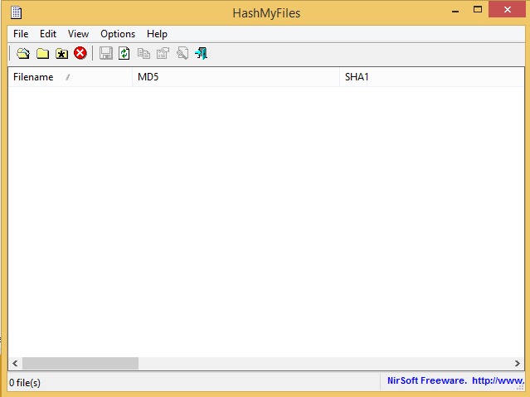  
Figure 3.1.1.1 HashMyFiles Application Interface

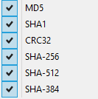  
Figure 3.1.1.2 List of Hashes that can be calculated in HashMyFiles

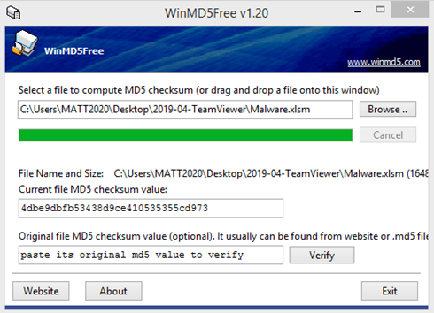

Figure 3.1.1.3 WinMD5 window

Hashing is the process of transforming any given key, string of characters or files into a fixed length value. This value is irreversible and unique to the input, making it a good way to identify malware files as once a malware is published, it cannot be retrieved back, making the file fixed and thus be identified by its hash value.

WinMD5 is a hashing tool that generates the MD5 hash of the user’s input. This input can be any file. The original MD5 of the file can also be inputted into the tool to verify it against the MD5 value that the tool generated. In essence, this is a quick MD5 hashing tool to verify the integrity of files.

HashMyFiles is another tool that allows us to calculate the hashes of one or more files in the system. The hashes can then be easily copied into a clipboard or into a file for use (Nirsoft, n.d.). This hash will be used as the malware fingerprint which can be used to search for the file in anti-virus scanners such as virustotal, to see if the file exists in the database. If the file exists in the database, it confirms that the file is indeed malicious in nature and analysis has been done before. It can also be used to check if the malware sample changed after running it. In all, HashMyFile is a simple but efficient tool for calculating hashes for checking.

### 3.1.2 VirusTotal

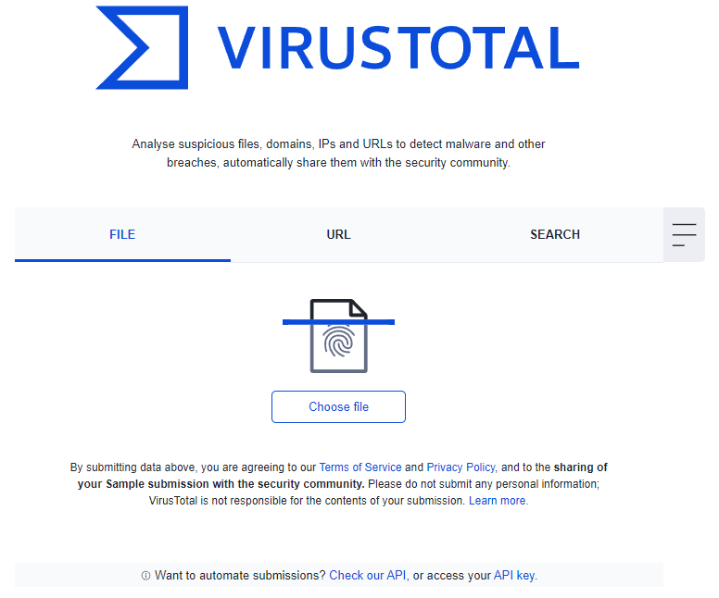  
Figure 3.1.2.1 VirusTotal: Website Interface

VirusTotal is an online website acquired by Google that allows users to upload files, URLs and file hashes. It will then run the file through multiple different antivirus engines and generates a report on the file/URL/hash uploaded. Antivirus engines are not perfect, which means that results usually vary from engine to engine. So, to thoroughly check the authenticity of a file/URL/hash, multiple antivirus engines should be used which VirusTotal does, all in one place.

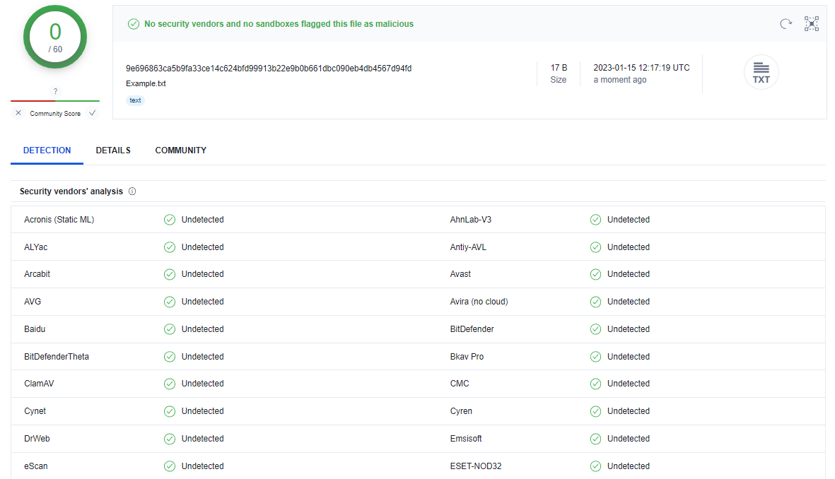  
Figure 3.1.2.1 VirusTotal: Report Sample

The report generated by VirusTotal will list the different antivirus software that it has used to scan the uploaded file/URL/hash. It also has a details page which you see details like the file size, file hash and file type. If it detects it as a malicious file, there will be a behaviour page which will state the detected functionalities and behaviour of the malware. There is also a community page where people can share their findings and hold discussions.

### 3.1.3 PEStudio

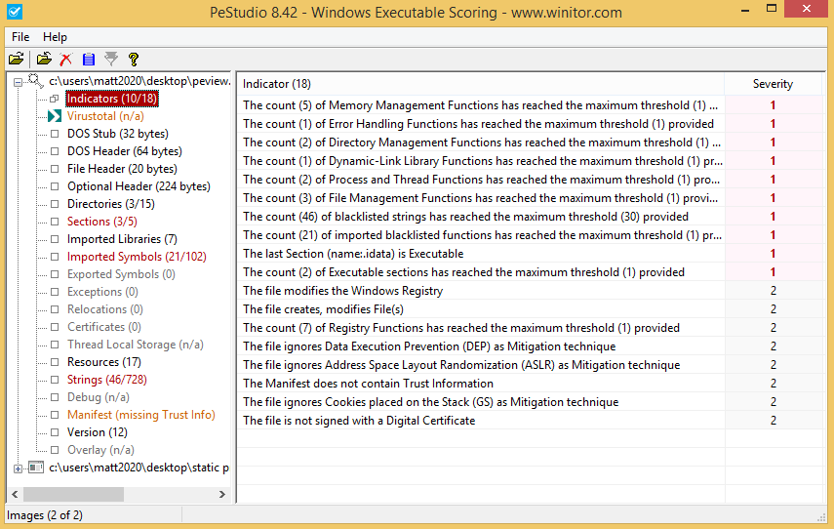

Figure 3.1.3.1 PEStudio: Application Interface

PEStudio is a widely used tool, used to spot artifacts of executable files to speed up the process of the initial malware assessment (Fox, 2021). PEStudio will scan the executable file and then list possible indicators, for example, the lack of digital certificates or the file creates, modifies files. It also queries VirusTotal (section 3.1.2) to get results from the various antivirus scanners that are available on VirusTotal. There are also other portions such as possible malicious strings, imported symbols and imported libraries.   
  
This tool is made with the intention of analysing malware based on patterns from other malware, so when a normal executable file is inputted it still shows malware indicators even when it is a clean file. Thus it is not suitable to use to check if the file in question is malicious in nature. However due to the convenience and usefulness of PEStudio, it is widely used in Computer Emergency Response Teams (CERT), Security Operations Centers (SOC) and Digital-Forensics Labs worldwide. The user interface of PEStudio is similar to the previous tools, just drag and drop the file or click on the folder icon at the top left hand corner of the screen to open a file into PEStudio.

### 3.1.4 PEiD

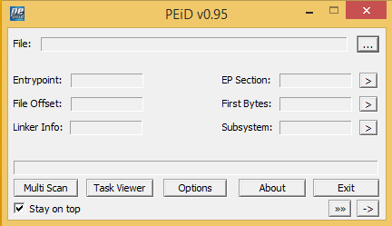  
Figure 3.1.4.1 PEiD: Application Interface

PEiD is a software simple and efficient tool for Basic Static Analysis that is used to determine if a file is packed. It is able to detect most common packers, encryption algorithms and compilers for PE files, being able to detect over 470 different PE file signatures (Aldeid, 2020). This tool is important as it helps to identify the packing algorithm and gives us information about the virtual and real size of each portion of the file. The user interface of PEiD is relatively simple, just drag and drop or give the file path of the file you want to analyse, then PEiD does a quick scan and shows the results. However PEiD is discontinued, thus it may not be as accurate in identifying packers and file signatures as its identification algorithm and database is not up to date.

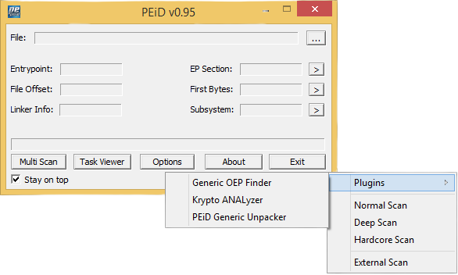

Figure 3.1.4.2 PEiD: Scanning Modes and Plugins

When a file is entered into PEiD, it does a normal scan. However it may not be enough to analyse what packer or file signature it is, so a deep scan and hardcore scan can be done for a more thorough scanning of the file. However the deeper the scan, the longer the scan takes so there may be some wait time before the scan is complete. PEiD also has plugins, in this case there are only 3. PEiD Generic Unpacker is an unpacker so it helps to unpack, packed malware files, but it is generally ineffective so more specialised tools will be needed to unpack malware files. Generic OEP finder helps to find the Original Entry Point (OEP) of the malware file and Krypto Analyzer checks for common encryption algorithms like DES, Blowfish and Twofish.

### 3.1.5 Exeinfo PE

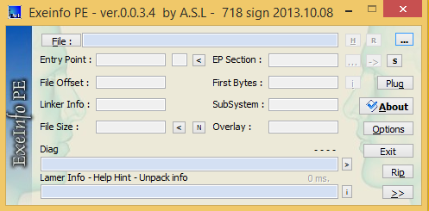  
Figure 3.1.5.1 ExeInfo PE: Application Interface

In practice, ExeInfo PE is updated PEiD with a number of extra features. The first is the “Lamer Info” portion. Same as PEiD, Exeinfo PE will identify the file signature and show the packing algorithm, but with an extra “Lamer Info” portion that will give help on how and where to search for the unpacking algorithm.

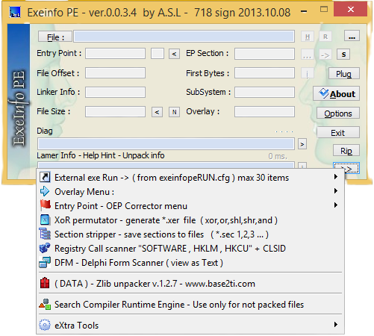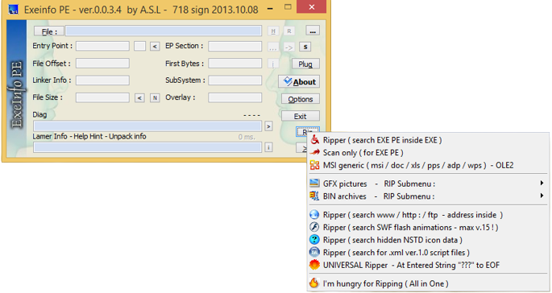

Figure 3.1.5.2 ExeInfo PE: Extra Plugins (left), Rip Plugins (Right)

Exeinfo PE has a wider range of plugins. Some of the more commonly used ones are the “Registry Call scanner” which searches the file for registry calls like HKLM and HKCU which could give hints to the function of the malware. There is also the Ripper that searches for network based indicators called “Ripper (search www/ http/ ftp - address inside)”, which helps to show what network based indicators there are inside the file.

### 3.1.6 ByteHist

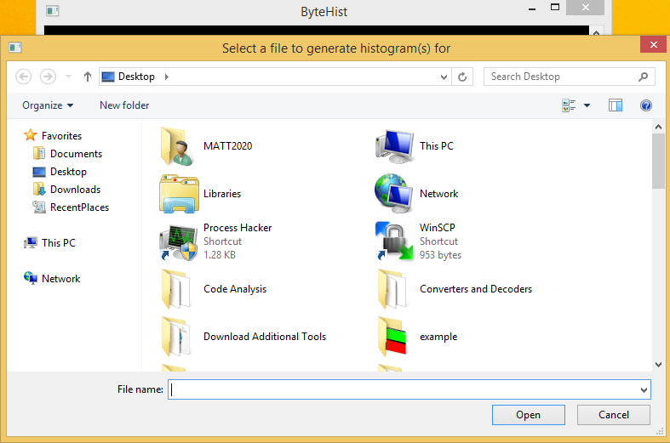

Figure 3.1.6.1 ByteHist: Application Interface

ByteHist is a tool that makes histograms of byte usage of the file. Sub-histograms will also be generated for each section of Portable Executable (PE) files to show the byte usage of each sub-section of the PE file. The histograms generated by ByteHist can be saved as images files (.png/.jpg files) for easy reference during analysis. ByteHist has both a GUI (Graphical User Interface) and CLI (Command Line Interface). For its GUI, you just have to launch the application and it will immediately prompt you to choose a file, while for the CLI, the syntax is “bytehist.exe [-n] [-s _savefile_] [_inputfile_]” where -n means the GUI will not be brought up, -s is to be replaced by the path where the user wants to save the generated histograms and finally “_inputfile_” is to be replaced with the file the user wants to see the byte usage (Wojner, n.d.).

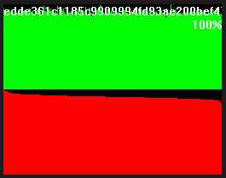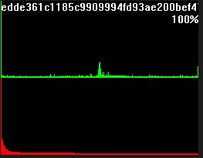  
Figure 3.1.6.2 ByteHist Histograms: Compressed file (left) and normal file (right)

In normal files, the byte usage distribution is generally quite normal, in the sense that a decent number of bytes will be used constantly, however in a compressed file, the byte distribution will be basically maximised throughout as it is compressed. So by looking at the ByteHist’s histograms we can actually identify whether or not a file is packed.

### 3.1.7 BinText

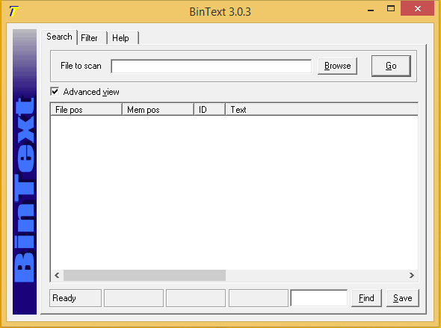  
Figure 3.1.7.1 BinText: Application Interface

BinText is a small but efficient and powerful file text extractor. It can extract the text from any type of file and is able to find and display ASCII text, Unicode text as well as resource strings (Aldeid, 2020). BinText will also show the file offset and memory offset of the strings found, making it easy to identify where the strings are located when looking at the code of the file. The interface is simple, just drag and drop the file or browse to the file for BinText to extract.

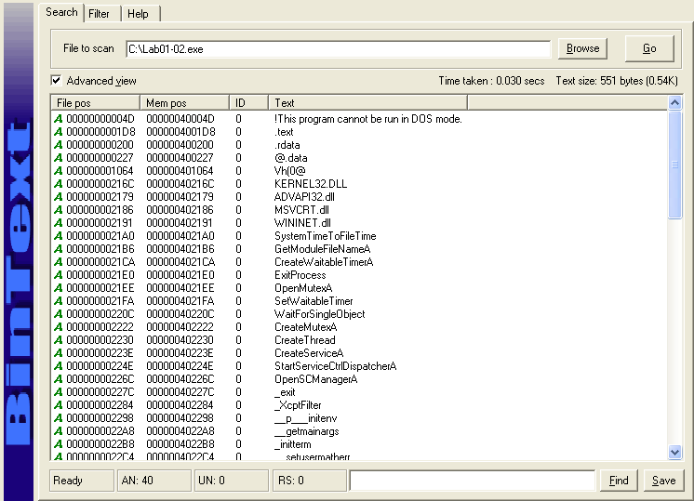  
Figure 3.1.7.2 BinText: Sample Output

BinText can extract information like the DLL (Dynamic Link Library) files being used, the import functions that are being called and used. It could also contain network and host based indicators such as IP addresses, domain names, name of a file that is being created and location (file path) of the created file. So BinText is essential in Basic Static Analysis as there is a lot of information that can be obtained from extracting the text in files.

### 3.1.8 Dependency Walker

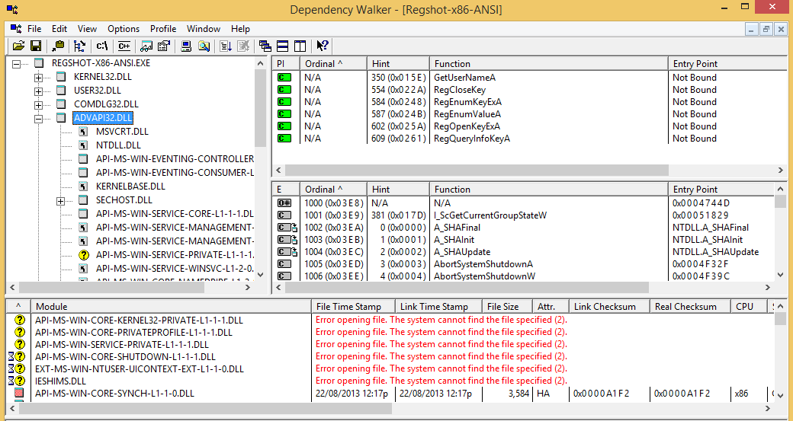  
Figure 3.1.8.1 Dependency Walker: Application Interface

Dependency Walker is a open source utility tool that scans files for any 32-bit or 64-bit Windows module, this could be DLL modules or EXE modules. It will then list all the modules together with the functions that are being exported and imported and build a hierarchical tree diagram of all dependent modules (Dependency Walker, n.d.). The GUI is simple, just drag and drop the file in or click on the folder icon at the top left to open a file for Dependency Walker to scan.  
  
The import functions are placed at the top, colour coded with green, allowing us to easily identify that the file uses certain import functions which could give clues on what the file does. For example if the import function is related to HTTP like WinHttpConnect function from WINHTTP.DLL, it tells us that the malware is trying to connect to a webpage which is a clue into the full behaviour of the malware.

### 3.1.9 PEview

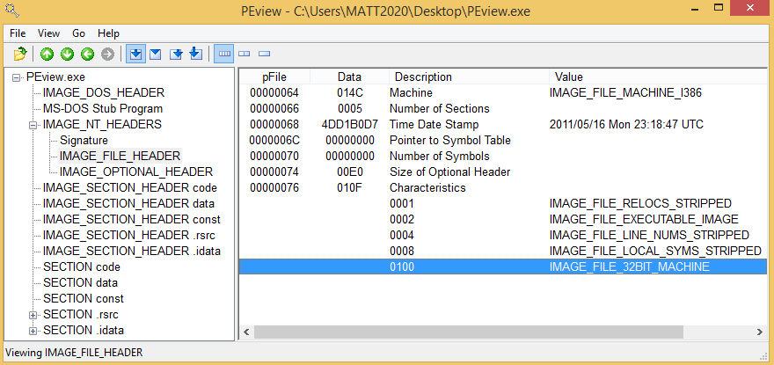

Figure 3.1.9.1 PEView: Sample Output

PEview scans and displays the structure and content of 32-bit PE files (Radburn, 2022). The headers as well as different portions of the file will be displayed. For example, the file signature, file headers as well as the .rsrc section of the code are all displayed. This gives us important information like the time date stamp on when the file was compiled. The information is also displayed in a hierarchical tree diagram, making it easy to browse and extract information. The interface of PEview is similar to the rest, either drag and drop the files, or click on the folder icon at the top left hand corner to open a file in PEview.

### 3.1.10. Olevba / OfficeMalScanner

Olevba and OfficeMalScanner are tools for malicious document analysis. They are easily accessed using the Command Prompt. These tools are useful for examining and extracting the potentially malicious VBA macro code that a malicious document contains. For example, a malicious word document could be identified for macros using the command “oleid Malware.doc”. The output would then show if the document contains any VBA or XLM macros, as well as any external relationships.

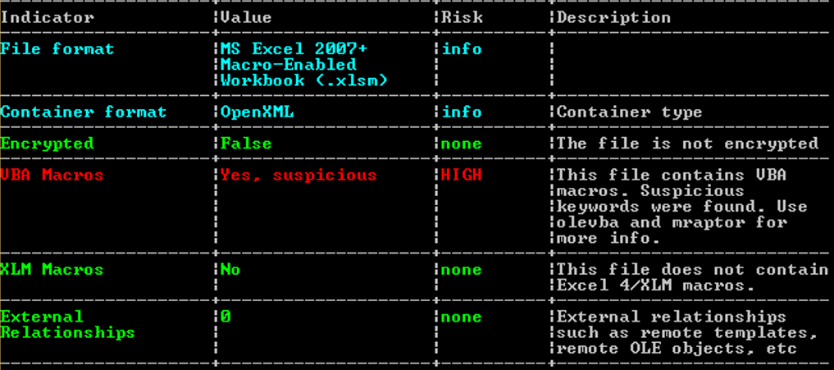

Figure 3.1.10.1 Oleid sample output

These macros could then be extracted using OfficeMalScanner by firstly using the command “OfficeMalScanner Malware.doc inflate”. This command would extract the vbaProject.bin file where all the macros are. The command “OfficeMalScanner vbaProject.bin info” could then be used to extract all the macros for the user to be able to view using a text editor. With this, the user can analyse the code within the macro files and gain more information regarding the malicious document. Hence, Olevba and OfficeMalScanners are useful tools to statically analyse malicious documents.

## 3.2. Advanced Static Analysis

Basic Static Analysis is just looking at the outer frame of the malware, where we can draw some preliminary conclusions but they are generally just clues to what the malware fully does. For example, in Basic Static Analysis, the different import functions of the malware can be found, however there is no way to determine how the import functions are used or if they are being used at all. Basic Dynamic Analysis runs the malware and sees how the malware executes and responds, but if the malware has certain functions obfuscate its behaviour, it will be difficult to draw conclusive conclusions. This means that there needs to be a way to get a more detailed analysis of the malware and its behaviour/functions.

This is where Advanced Static Analysis comes into play. Advanced Static Analysis, or code analysis, breaks down the malware file so that each section can be fully studied, while not executing the malware. The main way of doing this is by using a disassembler or decompiler to translate the machine code to assembly language/code (or other coding languages if a decompiler is being used), which is more legible than machine code, which is in binary. By looking at the disassembled code, we can find out much more concrete information on the malware, instead of just clues in Basic Static Analysis. For example, we are able to see the flow of the malware code, how it goes from one function to another, what are the import functions in each function and even how the import functions are being used. Through Advanced Static Analysis, a clear picture of the malware can be painted, without the running of the malware. Defensive mechanisms placed in the malware by its author to make analysis harder can also be detected in Advanced Static Analysis, so ways to reverse engineer these mechanisms can be identified as well. For example, it could be changing certain jump functions to avoid certain parts of the code or changing the values of registers to ensure that the code will run as per normal.  
  
In all, Advanced Static Analysis plays a large part in understanding the malware’s behaviours and activities. It also helps to prepare the malware analyst for the Advanced Dynamic Analysis stage. Therefore Advanced Static Analysis is essential in the malware analysis process and if not done correctly, the malware analyst may draw incorrect conclusions on the malware’s activities as well as proceeding to do the Advanced Dynamic Analysis incorrectly.

### 3.2.1 IDA Pro Free

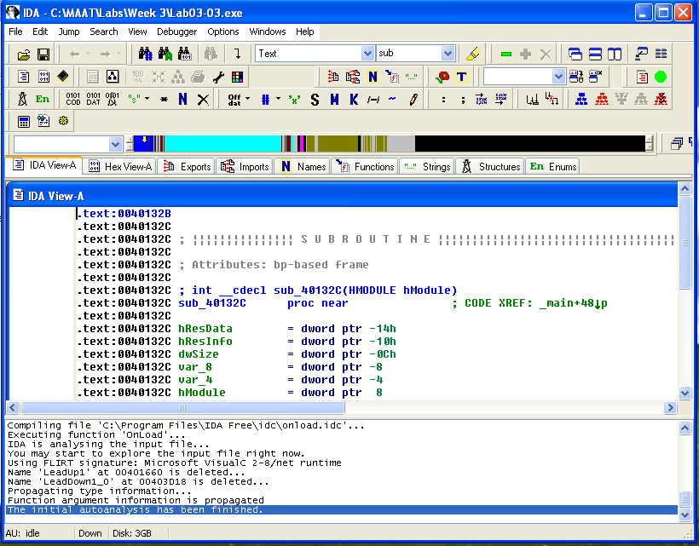|  
Figure 3.2.1.1 IDA Pro Free: Sample UI

IDA Pro Free, is the freeware version of IDA Pro which is a disassembler that translates machine code, binary, into a more readable assembly language source code. This allows it to be legible by humans. IDA Pro Free does not have the full functionality of IDA Pro but there are quite a few features that make IDA Pro convenient to use. For IDA Pro to read the file, you can just drag and drop the file into the window.

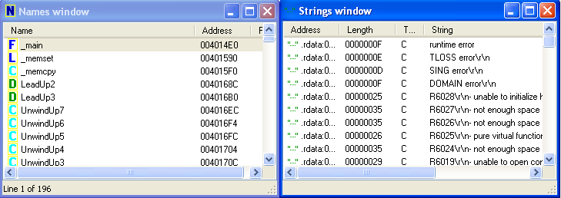  
Figure 3.2.1.2 IDA Pro Free: Strings and Names Window

Strings and names windows in IDA Pro makes finding strings and functions in the code very simple. For example, there is a certain string or section of the code like the main section of the code that is needed, just find it in the names/strings window and double click it, to bring you to its location.

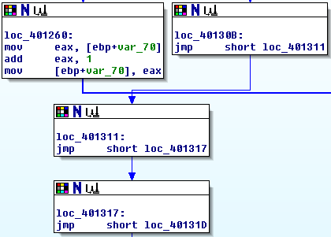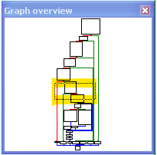

Figure 3.2.1.3 IDA Pro Free: Graph View & Graph Overview

IDA Pro is able to create a map view of the main/start section of the file. This allows for the easy view of how the code flows from memory location to memory location. It also allows for identification of loop functions where the arrows will show how the loop flows as well as if-else statements where there are 2 possible paths for the code to take in the graph. If the code does a function/subroutine call, double click on the function/subroutine to see its relevant code. The graph overview shows the entire graph and has a dotted box (highlighted in yellow) that shows where on the graph the user is currently viewing.

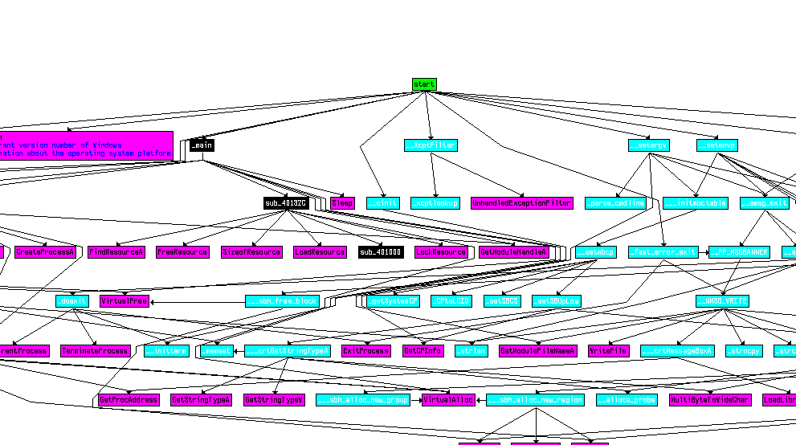

Figure 3.2.1.4 IDA Pro Free: Graph View of All Function Calls

IDA Pro Free is able to create a fully mapped out graph for all function calls. This allows the malware analyst to fully understand how each function links to each other and the different paths it can take to reach a certain function. You can also narrow the graph down to only references to specific functions and references that the functions make. This allows the malware analyst to narrow down his searches instead of slowly dissecting one function’s references from the entire graph.

### 3.2.2 Relyze Desktop

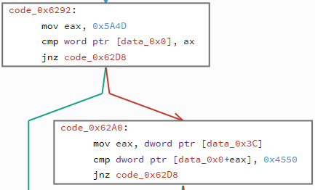

Figure 3.2.2.1 Relyze Desktop: Sample Output

Relyze Desktop is a disassembler similar to IDA Pro Free. It contains many of the same features including, a graph view of the flow of the code and a strings/functions window to travel directly to the chosen string/function. But there is one key difference between IDA Pro Free and Relyze Desktop is that Relyze does not have a graphical view of the connections between the functions, which could be quite hard to find out the pathways to a function. However there is a benefit when using Relyze Desktop compared to IDA Pro Free.

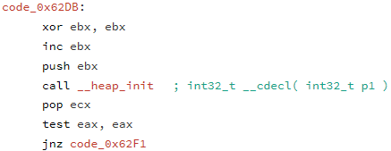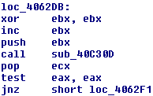

Figure 3.2.2.2 Relyze Desktop (Left) & IDA Pro Free (Right) Code Comparison

When comparing the same piece of code side by side, the Relyze Desktop’s disassembled code is much more readable compared to the code disassembled by IDA Pro Free. Relyze changes the subroutine’s names with a name that is related to the function of the subroutine. This makes analysis on the code easier, as there is not a need to dive into the subroutine to gain a basic understanding of the subroutine, saving time if the malware analysis is time sensitive. It is also easier to keep track of subroutine names being English, readable words then the numbers of the subroutine memory location (similar to how people will rather remember domain names than IP addresses).

## 3.3. Basic Dynamic Analysis

Basic Dynamic Analysis is the process of running the malware to observe its effects on the system. Before the malware is run, several tools will be opened first which will monitor the state of the machine before, during, and after the malware is run. Generally, basic dynamic analysis is performed in a virtual machine setting, where snapshots can be used to revert the virtual machine back to its original state before it was infected.

Typically, basic dynamic analysis is performed after basic static analysis. The tester will have an idea of what the malware might do to the system after observing its static properties, so that they will know what to look out for when performing basic dynamic analysis. Basic dynamic analysis can also be performed because the basic static analysis did not show enough conclusive information on what the malware does.

In basic dynamic analysis, tools that monitor processes, registry changes, and network connections in the system are used to observe the changes made by the malware. These are necessary to observe all changes made by the malware, such as files that were dropped into important system folders which users would not suspect otherwise. Basic dynamic analysis gives testers the clearest image of what the malware does by actually running it, which is the only way the malware can perform its intended functions.

### 3.3.1. ApateDNS

ApateDNS is a tool used for controlling DNS responses from a computer. It can spoof DNS responses to a user-specified address by listening on UDP port 53 on the local machine (FireEye, n.d.). This tool is useful for malware analysts to redirect any traffic or requests made by the malware to the spoofed address. Any IP addresses or domains that the malware will try to connect to will be recorded in the ApateDNS.

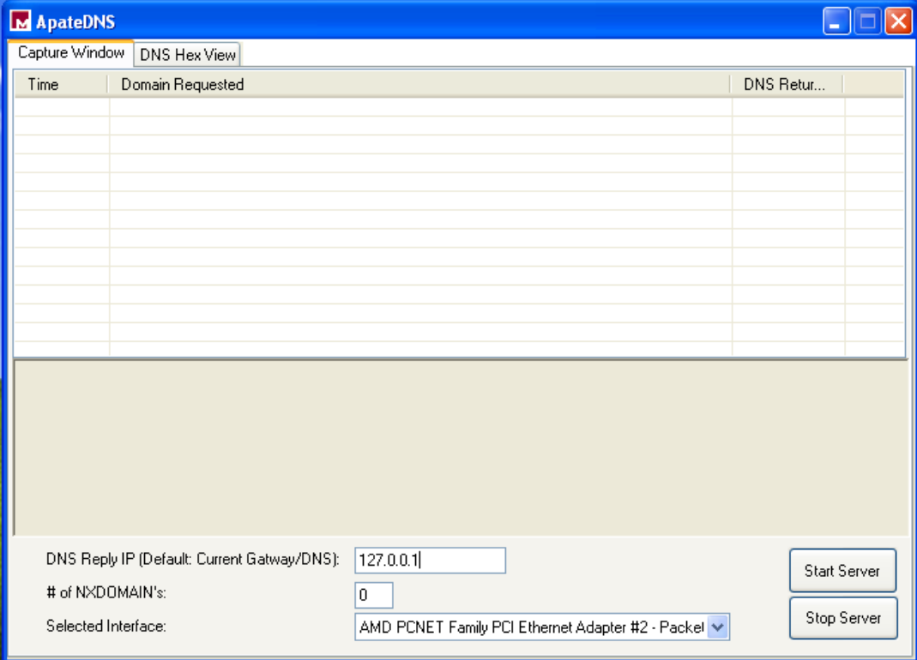

Figure 3.3.1.1. ApateDNS: User Interface

<https://fireeye.market/apps/211380#:~:text=ApateDNS%E2%84%A2%20is%20a%20tool,the%20local%20DNS%20to%20localhost>.

### 3.3.2. Netcat

Netcat is a command-line network monitoring tool. It can be used to create network connections and add listeners to ports to monitor any incoming traffic. In dynamic malware analysis, it is mainly used to add listeners to ports 80 and 443 at the same time to observe if the malware was sending any requests to a particular domain on the internet.

The command “nc -l -p 80” is used to add a listener to port 80, where the 80 in the command can be changed to any port that the tester wants to monitor, such as 443. Any requests made to this port will be shown in the command terminal.

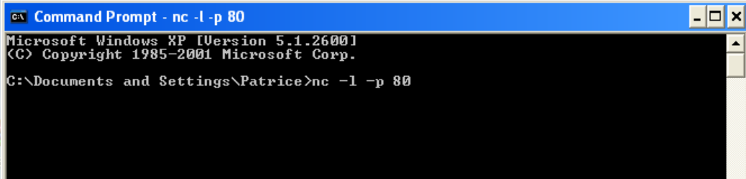

Figure 3.3.2.1. Netcat command run in Command Prompt

### 3.3.3. Process Explorer

Process Explorer is a resource monitoring tool. It provides details about processes and the resources they are using, such as memory usage and the DLLs used by them. It gives the ability to control processes with actions like stopping or restarting the process.

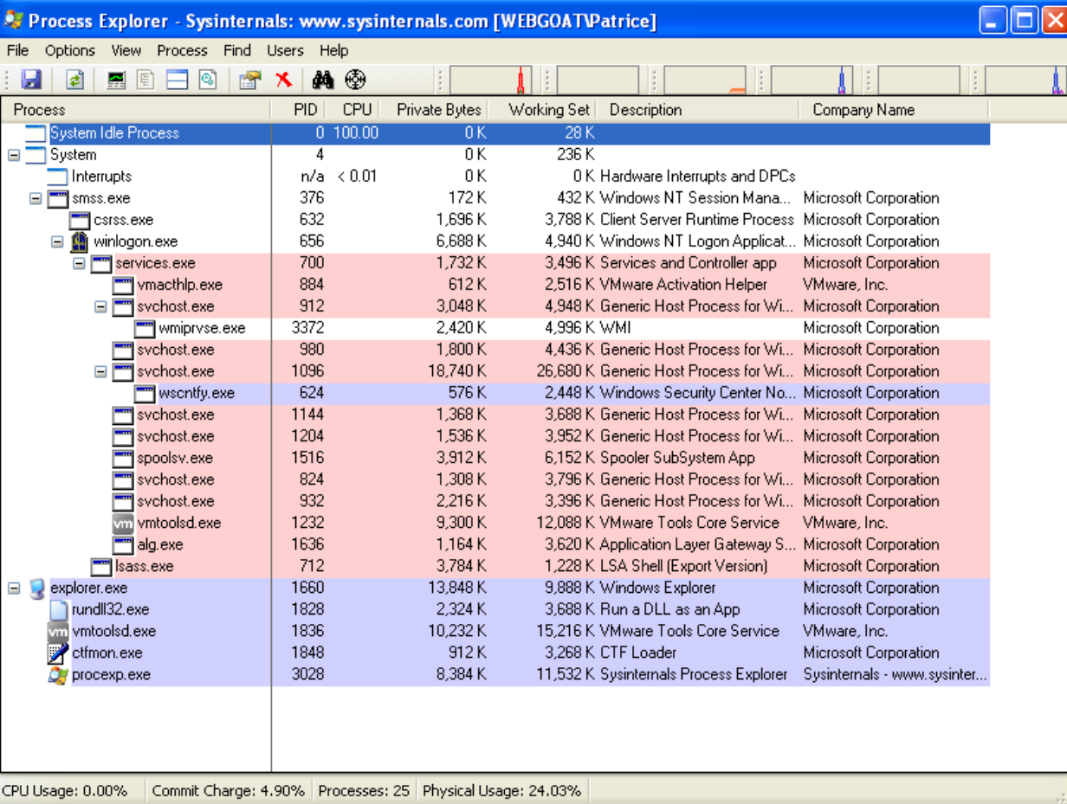

Figure 3.3.3.1. Process Explorer Interface

This tool is useful for basic dynamic analysis as it provides information about what processes are running, to check if there are any suspicious processes created by the malware. It can also compare the strings of the malware before and after it was run, to see if there were any notable changes in the malware.

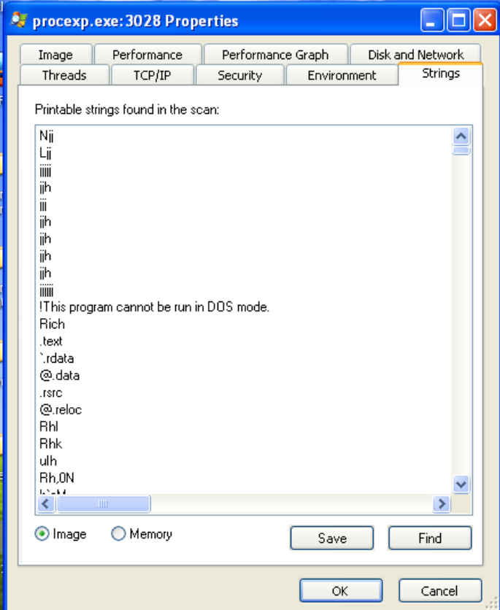

Figure 3.3.3.2. Process Explorer: Properties of a Process

### 3.3.4. Process Monitor

Process monitor is a system monitoring tool that monitors system activity, including registry changes, process activity, file system changes, and more. It shows real-time changes of different processes in the system, such as network connections and process modifications.

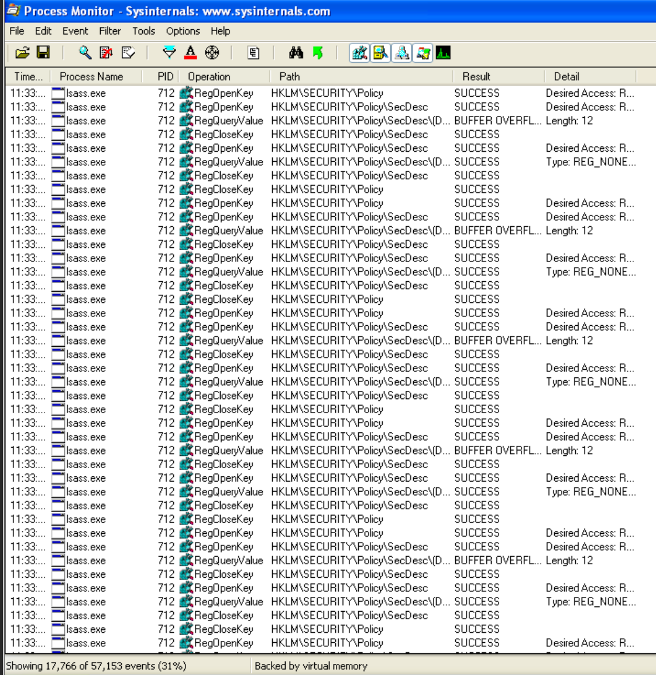

Figure 3.3.4.1. Process Monitor: Interface

This tool is important for basic dynamic analysis as it is able to show details such as a process opening a registry key or reading system information. These actions are often performed when a malware is executed, which will allow analysts to observe its actions. The process monitor also allows analysts to track the execution flow of the malware through the time variable on the left, to see the order of operations in the malware.

### 3.3.5. Regshot

Regshot is a tool that allows analysts to have 2 different snapshots of the Windows registry that can be compared against each other. The snapshots will identify any changes made to the system in the time taken between both snapshots.

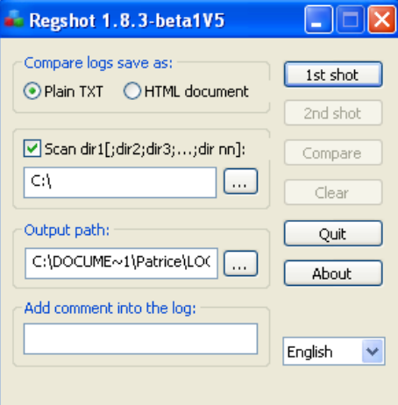

Figure 3.3.5.1. Regshot: Interface

In basic dynamic analysis, the first shot will be taken before the malware is run, and then the second shot will be taken after the malware is run. The two shots will be compared to see what changes were made to the system. This can identify registry keys or values that were modified or created by the malware, which provides information about the malware’s functionalities.

Regshot can also be used to compare an uninfected and an infected system, which can be used to observe the malware’s persistence capabilities and figure out how to remove it from the system completely.

### 3.3.6. Tcpdump

Tcpdump is a network sniffer that can be used for Windows and Linux operating systems. It is able to capture packets and list all the inbound and outbound connections made to and from the host machine. In this case, it will be used to detect any connections made by the malware, which might indicate that it is downloading something from a domain or forwarding information to one.

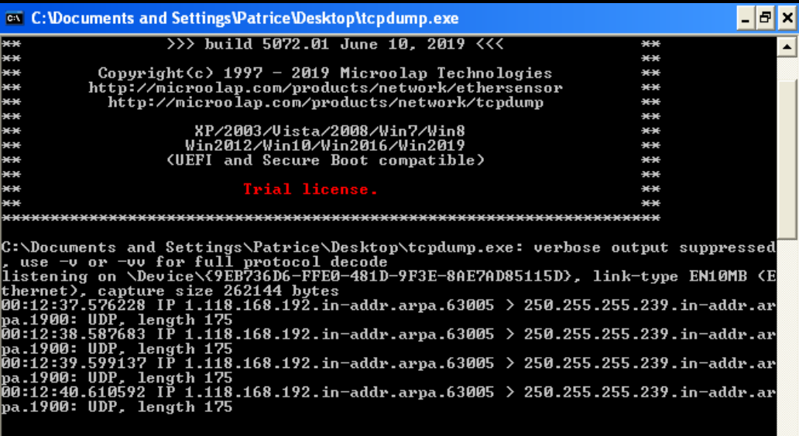

Figure 3.3.6.1. Tcpdump: Interface

## 3.4. Advanced Dynamic Analysis

Advanced dynamic analysis is the process of manipulating the code of the malware to make it run in a specific way. In some malware, there will be defence mechanisms that will hinder the analysis of the malware. For example, the malware could contain functions that put it to sleep when it detects that it is inside a virtual machine. This will prevent any basic dynamic analysis of the malware in a virtual machine, so advanced dynamic analysis can be used to reverse engineer these functions and bypass these defences.

Advanced dynamic analysis is usually performed after basic dynamic analysis comes to a dead end, where something is preventing the analysis of the malware. This analysis method is performed after advanced static analysis, as it is typically performed on the assembly code of the malware. A good understanding of the subroutines and functions in the assembly will allow a tester to reverse engineer the code. The tools used for advanced dynamic analysis will be a disassembly viewer like IDA Pro Free, a debugging tool, and a tool that can create modified versions of the assembly code of the malware.

### 3.4.1. OllyDBG

OllyDBG is a debugging tool used at the assembly level. It is able to debug the assembly code of a malware and allow the user to understand the code. This allows users to understand different subroutines and functions within the assembly in order to reverse engineer the code. OllyDbg can set breakpoints in the code during debugging and trace the execution flow, which can help the analyst to understand the logic and functionality of the malware.

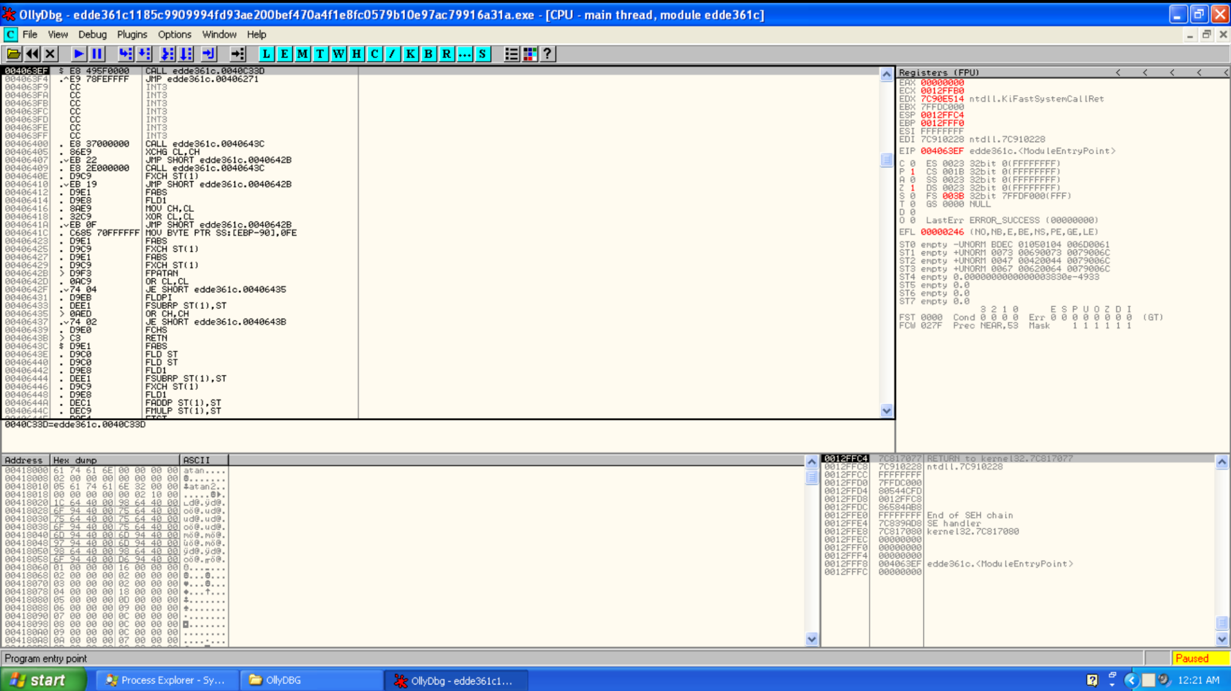

Figure 3.4.1.1. OllyDBG: Interface

# 4. Analysis of Malicious Executable

## 4.1. Basic Static Analysis

Basic static analysis will be carried out with the tools described in section 3.1.1 to section 3.1.10. This section will be documenting the step by step process of Basic Static Analysis with the results from each tool and the findings/clues given by the results to gain a basic understanding of the malware and trying to infer the behaviour of the malware from the findings. However Basic Static Analysis can only give clues and will not be able to tell the complete behaviour of the malware as that can only be observed when the malware is run or the code of the malware is disassembled.

### 4.1.1 Hashing

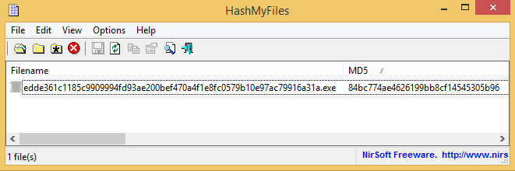  
Figure 4.1.1.1 HashMyFiles: MD5 hash of Malware File

The Basic Static Analysis starts with hashing the malware file to obtain the malware fingerprint, in this case, MD5 hash will be sufficient. This malware fingerprint is noted down and will be used as an identifier to check if this malware exists in the antivirus database. Since the malware fingerprint is unique to this file, if the file changes the hash value will also change, thus the fingerprint can also be used to check the malware after each stage of the analysis to ensure that the malware file is not changed by the tools used.

This malware fingerprint is then uploaded to VirusTotal, where multiple antivirus engines will scan the file to check if the file is really a malicious file, or one that is harmless (false positive). More on VirusTotal in the next section.

### 4.1.2 VirusTotal

Once the malware fingerprint is uploaded to VirusTotal, VirusTotal outputs a report that has been done previously. This shows that this malware sample has been uploaded and scanned previously by others. For VirusTotal, there are a number of different sections in the report that is generated, as such we will be going through each section in detail, showing the findings and conclusions that can be drawn from the section. Link to the VirusTotal report : <https://www.virustotal.com/gui/file/edde361c1185c9909994fd93ae200bef470a4f1e8fc0579b10e97ac79916a31a/behavior>

#### 4.1.2.1 VirusTotal Detection Section

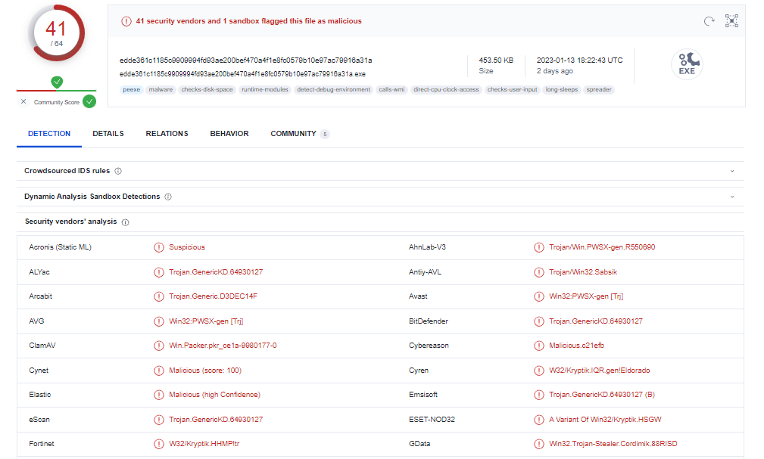

Figure 4.1.2.1.1 VirusTotal: Antivirus Engine Output

On the detection page of the report, it shows that 41 out of 64 antivirus engines have deemed the file to be malicious in nature. It also shows the output of each individual antivirus engine, most saying that it is a trojan malware. A trojan or trojan horse is a type of malware that downloads onto a computer, pretending to be a legitimate program. Once the trojan is downloaded and executed, it will execute the instructions the attacker set for it, usually stealing information or gaining backdoor access to the computer system.

Therefore from these antivirus engine outputs, there are some indicators to look out for in relation to the malware being a trojan. The first could be file creation, where the malware will collect information and append it into the file. Next will be IP addresses or domain names where the attacker will send the information to, so that the attacker can receive the information collected by the malware.

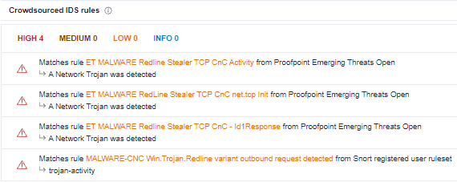

Figure 4.1.2.1.2 VirusTotal: Crowdsourced IDS Rules

This crowdsourced IDS (Intrusion Detection Systems) rules section of the detection page, will display any network traffic generated by the malware sample that matches their IDS rules. These rules are generally made from previous malware samples that have the same network traffic. It can be seen from Figure 4.1.2.2 that this malware’s network traffic corresponds to “ET MALWARE Redline Stealer TCP CnC Activity” and “MALWARE-CNC Win.Trojan.Redline variant”. Both of these will be broken down, to understand what malware is.  
  
Firstly, CnC or Command and Control malware is one that compromises the infected computer system. Once the malware has successfully compromised the system, the malware will establish a connection to a malicious server where the attacker can remotely send commands to the infected computer system, taking full control of the infected machine. Next, a redline stealer is a family of malware known to be sold in underground forums. These malware usually tries to extract personal information from its infected computer like credit card information or saved credentials. It is also known to be able to upload and download files, execute commands and send stolen information back to the attacker.

Therefore from the detection page of VirusTotal, we can conclude that this file is definitely malicious in nature. This malware is likely a trojan and the malware’s intention is most likely to extract and steal information from infected computers and compromise the systems for the attacker to gain control of the infected computer. The malware will also make a connection with a server, to send information as well as for the attacker to remotely send commands to infected computers.

#### 4.1.2.2 VirusTotal Relations Section

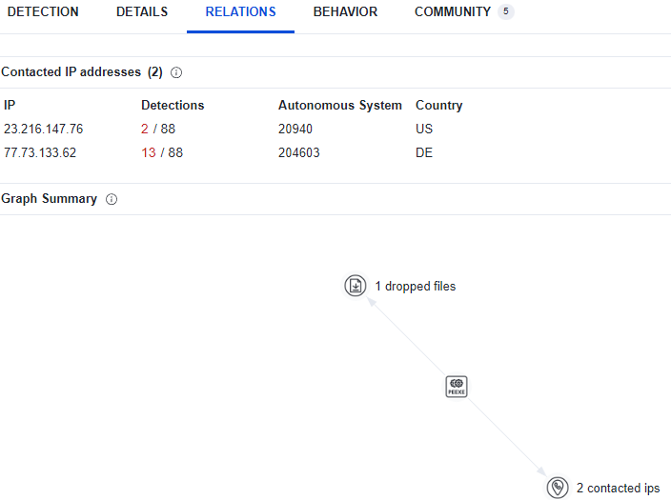  
Figure 4.1.2.3 VirusTotal: Relations Section

In the relations section, it shows the relations, generally IP addresses or domain names of websites that the malware is trying to connect to. As shown in Figure 4.1.2.3, the malware contacts 2 IP addresses, 23.216.147.76 and 77.73.133.62. This tells that there is a need to keep an eye out for network indicators in the malware to confirm these 2 IP addresses. It can be seen that there is a dropped file as well. Knowing from the previous section that this malware is redline stealer trojan, it would be likely that this dropped file was created by and written to by the malware to send information back to the attacker. Thus this also shows that host based indicators such as possible file names, file types or file paths should be noted down.

#### 4.1.2.3 VirusTotal Behaviour Section

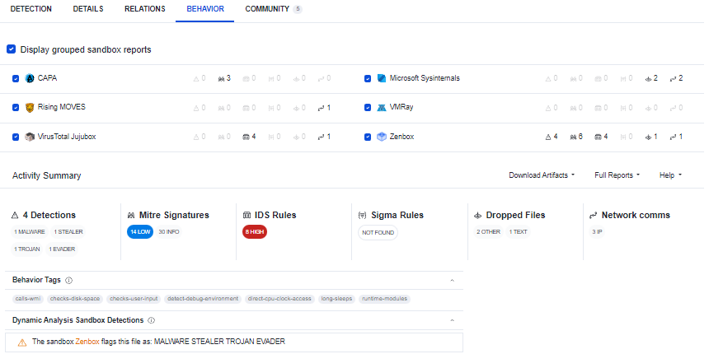  
Figure 4.1.2.3.1 VirusTotal: Behaviour Section Overview

In the behaviour section of VirusTotal, it will document the behaviours of the malware, including its defence mechanisms and execution. This section is a collated reporting of the malware using sandbox malware analysis tools such as VMRay and VirusTotal Jujubox. The results can be filtered should the user want to look at a specific sandbox malware analysis tool report.   
  
From the “Active Summary” section, a short overview of the malware is given. Where the detections, Intrusion Detection System (IDS) Rules, dropped files and network communication of the malware is shown in a brief manner. Below the summary, there are the behaviour tags, which shows some of the behaviours the malware has. These tags are made with reference to previous malware samples having similar properties and have been identified as a possible malware trait. Then finally there is the sandbox detection, which is basically the sandbox malware analysis tool, giving an output similar to what antivirus softwares do, which is to try and identify the type of malware that it is. Not all sandbox analysis tools have this feature, as shown in Figure 4.1.2.3.1 where there is only one sandbox analysis tool that gives an output in this section.

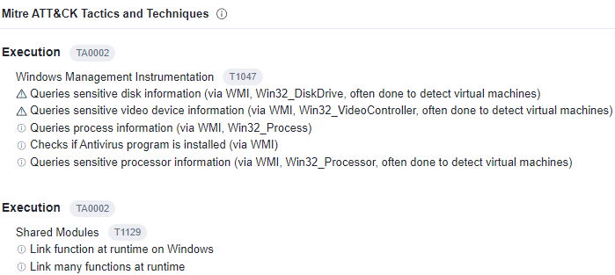  
Figure 4.1.2.3.2 VirusTotal: Behaviour Section Mitre ATT&CK (1)

The Mitre ATT&CK evaluation is a method used to describe what actions malware does, as well as how it does the actions. It helps to give the malware analysts insight on what the malware intends on doing, together with how it is going to do it (Chheda & Moerschel, 2022). Which helps to paint a clear picture of what to look out for in the malware. It also shows the defensive mechanisms that the malware intends on doing, making it easier to identify them later during the analysis.   
  
In Figure 4.1.2.3.2 it indicates what the malware intends on doing during the execution phase. So the malware tries to query and extracts several pieces of important information from the infected computer, from its disk information, antivirus software presence and even processor information which could indicate to the malware it is in a virtual machine environment. These pieces of information could be used to check if the malware is being run in a virtual machine/sandbox environment, which it could then proceed to terminate and stop itself from running to prevent analysis on the malware. So it is important that functions relating to this information to be identified and checks such as if-else statements be modified if needed (during Advanced Dynamic Analysis) to allow the malware to run in the virtual environment.

It can also be seen that the malware links many functions at runtime. This could become an issue if the malware links the functions in a manner that causes some functions to call each other many times. As once the function calling becomes very intricate and complex, it may not be possible to analyse the code effectively during Advanced Static Analysis as it will be very hard to understand how the malware code flows from function to function.

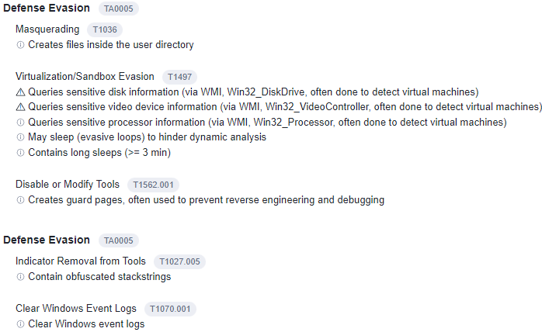  
Figure 4.1.2.3.3 VirusTotal: Behaviour Section Mitre ATT&CK (2)

Defence Evasion, in other words defensive mechanisms are ways that the malware hides itself or does certain actions and checks to make it harder for malware analysts to analyse the malware. This is usually done to buy as much time as possible for the attackers to be able to gain as much as they can from the malware before it starts to be detected and quarantined by antivirus softwares.

It can be seen that files will be created in the user directory. Generally users do not regularly check their user directory for new and malicious files so this allows the malware to masquerade itself as a legitimate file, usually with a filename that looks similar to other important files in the user directory. It also contains long sleeps, meaning that the malware will have long breaks in between its actions making it hard to detect the malware actions unless analysis is done for prolonged periods of time.   
  
The malware also contains obfuscated strings, meaning that the strings in the file, will be encrypted or changed in some form, making it impossible to identify the use of the string unless decrypted or reversed. The windows event logs are also cleared meaning that the malware actions can no longer be tracked using windows event logs, making it harder for the malware analyst to do analysis by removing one possible source of clues.

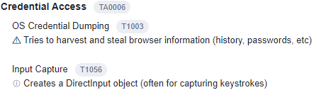  
Figure 4.1.2.3.4 VirusTotal: Behaviour Section Mitre ATT&CK (2)

Credential access will mean that the malware is trying to extract and get certain passwords or user credentials in some form. It can be seen that the malware harvests and steals browser information. This is usually done to gain information about the infected computer and could even be used to get user credentials that are saved on browsers, such as credit card information and sensitive passwords for certain websites and applications. There is also an input capture, which means that there is a chance that the malware is a keylogger that tracks the direct input into the infected computer by the user.

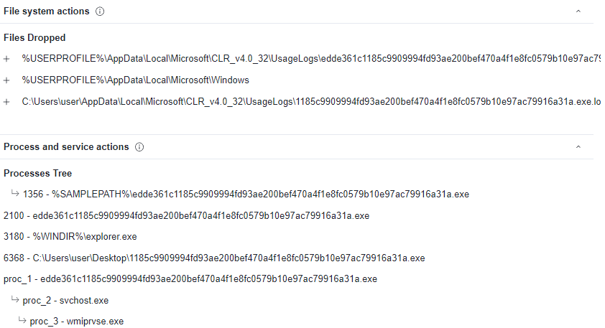  
Figure 4.1.2.3.5 VirusTotal: Behaviour Section Mitre ATT&CK (3)

The dropped files as well as created processes are shown here. These information is important to look out for in strings analysis for Static Analysis as well as during Basic Dynamic Analysis, when the malware is being run to check for these created processes and files. The strings analysis could be redundant due to the obfuscated strings so it is even more important to look out for these information during the Dynamic Analysis.

### 4.1.3 Checking if Malware is Packed

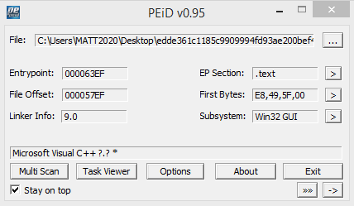  
Figure 4.1.3.1 PEiD: Scan Output

Before we proceed to analyse the malware with other tools, there is a need to check if the malware is packed. If the malware is packed, analysis on the malware will be extremely difficult, as most of the content will be obfuscated and thus analysis will not be feasible. PEiD was used at first, however no matter how deep the scan, PEiD was not able to identify the exact version of the Microsoft Visual C++ as seen in figure 4.1.3.1. This could mean that PEiD is not able to correctly or accurately identify the compiler, even though Microsoft Visual C++ means that the malware is not packed, it may not be accurate as PEiD has been discontinued and thus another round of checks should be implemented.

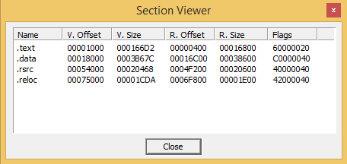  
Figure 4.1.3.2 PEiD: Section Viewer

PEiD’s section view also helps to determine if the malware is packed. Should the virtual size (V. Size) of the malware be larger than the real size (R. Size), it means that the malware is packed. This is because if the real size is smaller than the virtual size, it means that the program has been compressed, minimising the real size, while having the virtual size be the same. As shown in Figure 4.1.3.2, the virtual size is smaller than the real size which means that the malware is not packed.

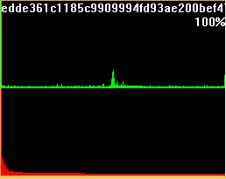|  
Figure 4.1.3.3 ByteHist: Histogram Of Malware’s Byte Usage

Viewing the byte usage of files is another way of checking if a file is packed or compressed. The byte usage of this malware file is normal, unlike packed files which have incredibly high byte usage throughout. So ByteHist also suggests that the file is unpacked.

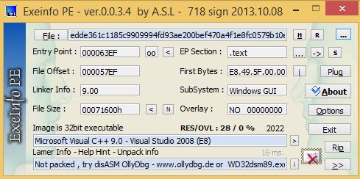  
Figure 4.1.3.4 Exeinfo PE: Scan Output

Another round of scanning is used to ensure that the compiler used is not a packer. Exeinfo PE’s scan shows that the algorithm is in fact Microsoft Visual C++ and its version 9.0. It also states that the malware is not packed and that a disassembler or debugger can be used to view the file’s code. The usage of disassemblers and debuggers will be covered in Advanced Static Analysis and Advanced Dynamic Analysis.

In conclusion, the malware file is not packed, and compiled using Microsoft Visual C++ 9.0.

### 4.1.4 Structure and Content of Malware

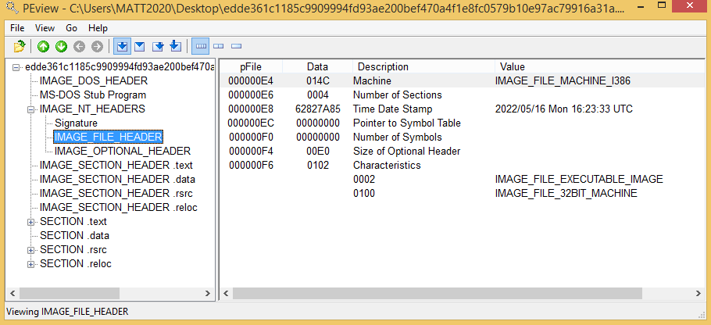  
Figure 4.1.4.1 PEview: Malware Structure and Content

The structure of the malware (executable file) is as shown in Figure 4.1.3.1. Generally there is not much information that PEview is able to extract, however there is one very important piece of information that it has, being the time date stamp of the malware. It can be seen that the time date stamp is “2022/05/16 Mon 16:23:33 UTC”. This shows that the malware was created very recently and could be a newer version of the redline stealer, which could mean that antivirus programs may not contain signatures for the malware, which could be the reason why 23 antivirus engines in VirusTotal were not able to detect this file as a malicious software and PEiD could not properly detect the compiler as it is a new version that is not in it’s database (PEiD is discontinued).

### 

### 4.1.5 Dependencies of Malware

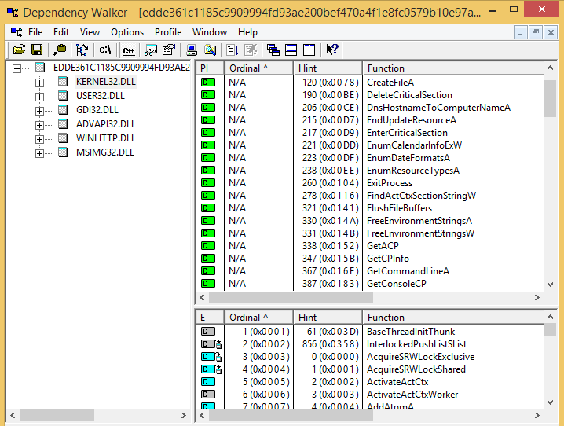Figure 4.1.5.1 Dependency Walker: Overview of Output

Malware files generally link libraries to the malware executable so that the attacker does not have to re-implement certain functionalities in multiple programs. Generally the libraries are linked dynamically, meaning the host operating system searches for the necessary libraries when the program is loaded. When the malware calls the linked library, the malware executes within the library.   
  
For this malware, it can be seen that there are 6 dynamic Link Libraries (DLLs) . Each DLL, together with its import functions will be examined to gain an understanding of the malware. This is done by understanding the import functions and their possible uses to infer what the malware could possibly do. Only DLL that have import functions that could clue to the malware’s behaviour will be covered.

#### 

#### 4.1.5.1 KERNEL32.DLL

The core of all operating systems is called the kernel. It forms the fundamental code which the operating system is built upon. So KERNE32.DLL provides functionalities like memory management, file management, checking firmware and device management. KERNEL32.DLL generally has most basic functionalities for the malware and generally has many import functions (Techopedia, n.d.). As such, this portion will zoom into only certain import functions that could give clues on the malware’s behaviour.





Figure 4.1.5.1.1 KERNEL32.DLL: Import Functions (1)

The import function “CreateFileA'' allows the malware to create a file inside the infected computer. While the import function “WriteFile'' allows the malware to write to files which would most likely be used to write to the file created using the previous import function. In a previous section (section 4.1.2), this malware has been identified as a redline stealer and therefore these functions will be used to create a file for the malware to enter all the information that it has extracted from the infected computer.

****Figure 4.1.5.1.2 KERNEL32.DLL: Import Functions (2)

The import function “IsDebuggerPresent” allows the malware to check if it is opened inside a debugging software (Microsoft, 2021). This could be used as a defence mechanism for the malware, where if it detects that it is in a debugging software, it will stop the malware from running, obscuring it from malware analysis.

  
Figure 4.1.5.1.3 KERNEL32.DLL: Import Functions (3)

A performance counter is an interface used for collecting various types of system data such as CPU, memory and disk usage (Microsoft, 2022). While it is usually used to monitor system performance, it can be used by the malware to query the system that it is being run in, allowing the malware to check if it is being run in a virtual machine. Once the malware queries this information, it could choose to terminate or do another process to obscure analysis on the malware.

  
Figure 4.1.5.1.4 KERNEL32.DLL: Import Function (4)

This function retrieves the system directory’s path. In the system directory, it contains system files, such as drivers and important system files used for the host operating system (Microsoft, 2022). By retrieving the system directory, the malware could be able to extract information on the host machine.

  
Figure 4.1.5.1.5 KERNEL32.DLL: Import Function (5)

This function specifies a communication device and a set of events that should be monitored for that device (Microsoft, 2021). This function shows that there is a communication device that will be used. This could be the monitoring for the attacker’s device.

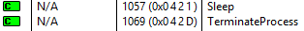  
Figure 4.1.5.6 KERNEL32.DLL: Import Function (6)

The “Sleep” function suspends the malware’s execution for a given amount of time (Microsoft, 2022). This is usually used to hinder dynamic analysis as when the execution gets suspended, there can be interruptions and the analyst may think the malware has finished execution and stop the analysis. “TerminateProcess” can be used to suddenly terminate the running processes of the malware when a condition is met. For example, a debugger is used on the malware and the import function “IsDebuggerPresent” is used and detects the debugger, the malware will then terminate to prevent analysis.

#### 4.1.5.2 ADVAPI32.DLL

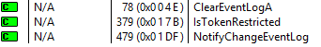

Figure 4.1.5.2.1 ADVAPI32.DLL: All Import Functions

The function “ClearEventLogA” is used to clear a specific event log file and can optionally save the copy of the log into another file before clearing it (Microsoft, 2022). This can be used to erase traces of the malware activities that could be possibly logged and traced by tools. This obscures event logs changes from the analyst, making it harder to analyse the malware. “NotifyChangeEventLog” allows the malware to receive a notification whenever an event is written into the specified event log file. This could be used to track user activities.

#### 4.1.5.3 WINHTTP.DLL



Figure 4.1.5.3.1 WINHTTP.DLL: All Import Functions

The function “WinHttpSetDefaultProxyConfiguration”, sets a default proxy server for the malware to use (Microsoft, 2021). A proxy server is usually used as an intermediary server that passes user requests from an internal network to the internet via a firewall. However the attacker could be using this function to turn the computer into a proxy server from which the attacker can stay anonymous while doing malicious activities.

### 4.1.6 Strings Analysis

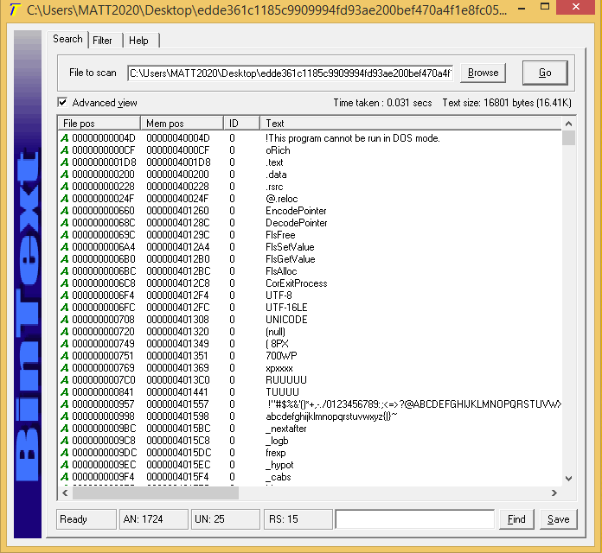  
Figure 4.1.6.1 BinText: Strings Inside Malware file

Malwares will almost always contain strings within the code. These could be comments that were placed by the malware authors to help understand each portion of the malware during the creation of the malware file. It could also be strings that were placed into the code for various reasons such as assigning strings to the variables or outputs that require strings for people to understand. BinText is used to extract these strings to view and identify possible clues to the functionality of the malware. Since there are many lines of strings, only some portions will be covered, mainly portions that are of interest such as network or host based indicators.

  
Figure 4.1.6.2 BinText: Application Response to Error

This string “Please contact the application’s support team for more information” occurs multiple times and it occurs mostly after error messages like the one shown in Figure 4.1.6.2, “An application has made an attempt to load the C runtime library incorrectly.”. This confirms that this malware is a software service that the malware authors sell to people that are willing to pay to use and deploy this malware for their own benefits.

  
Figure 4.1.6.3: BinText: Host Based Indicator

This string, “C:\daw.pdb” is a host based indicator. This could be the file that is being created and written to by the malware. When doing dynamic analysis, it will be important to check this file path, to see if the file is created. If the file is created, it is important to check the contents of the file to see the contents of it.

  
Figure 4.1.6.4 BinText: Extra/Hidden DLL file

A hidden DLL file can be found within the strings. MSCOREE.DLL is also known as Microsoft .NET Runtime Execution Engine, belonging to the Microsoft .NET Framework, which this malware was most likely written with (Audit My PC, n.d.). Since the malware uses Microsoft Visual Studio C++ 9.0, there is a good chance that it was written with the .NET Framework. This could have been a fake process name for the malware, however the malware lacks the import functions to create processes, as such it is unlikely if not impossible for it to be a fake process name for the malware.

### 

### 4.1.7 General Analysis of Malware

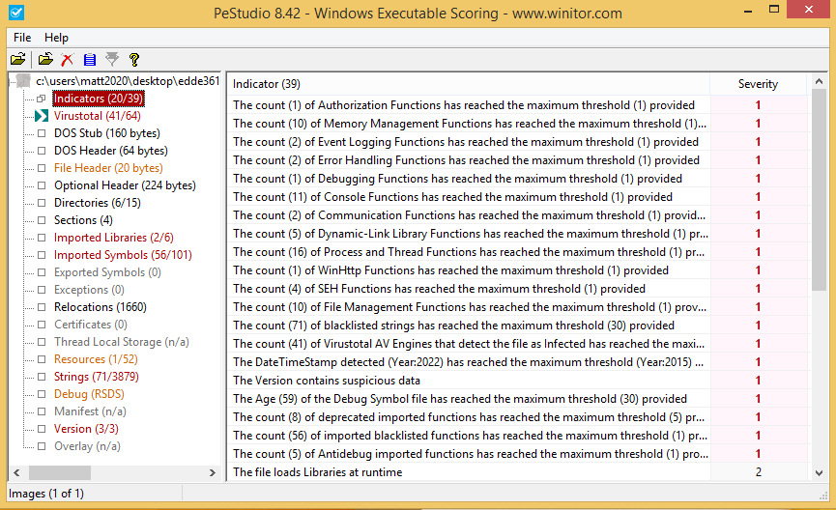  
Figure 4.1.7.1 PeStudio: Analysis Scoring on Malware

PeStudio gives certain indicators that could be indicative of malicious activities. Most of the different sections have been looked at, in greater depth such as the strings, imported libraries and imported symbols (import functions). As such when the results of the previous tools were counter checked against the indicators displayed in PeStudio, no new information was derived. However this tool was still useful in that it is a good way to counter check the progress of the analysis, by looking at all the possible indicators extracted by PeStudio.

### 

### 4.1.8 Basic Static Analysis Conclusion

In conclusion, after performing Basic Static Analysis, we have found out the following information:

1. The malware is generally new based on the time date stamp, but has been analysed on VirusTotal and JoeSandBoxBasic.
2. The malware is a trojan malware and is part of the redline stealer malware family that is sold on underground platforms.
3. The malware is not packed or obfuscated and is compiled using Microsoft Visual C++ 9.0.
4. The malware is able to create and write to files as well as set default proxy servers on the infected computer.
5. The malware is able to query system and debugging information, which could be used for detecting virtual machines environments or debuggers.
6. The malware has the ability to clear and track changes to event log files, which could clear traces of the malware’s activities.
7. The malware is able to terminate and sleep, which could make dynamic analysis harder.
8. The file path “C:\daw.pdb” can be found in the strings, which could be a possible file being created by the malware.

This malware is more sophisticated in nature, thus Basic Static Analysis is unable to derive much information. This is where Basic Dynamic Analysis, Advanced Static Analysis and Advanced Dynamic Analysis comes in, to obtain a full understanding and analysis of the malware.

## 

## 4.2. Basic Dynamic Analysis

While static analysis provides some information about the malware’s functionalities, there is not enough conclusive evidence that shows what the exact purpose of the malware is. Hence, dynamic analysis will be carried out in order to analyse the workings of the malware and how exactly it affects the system.

Before the malware is run, the tools for basic dynamic analysis were run before the malware was executed to capture all its activity on the system.

After first running the malware on the VM, there was no visible action taken by it. No files or programs were opened or closed, so it was suspected that the malware performed some other actions hidden to the user.

### 4.2.1. Network Activity

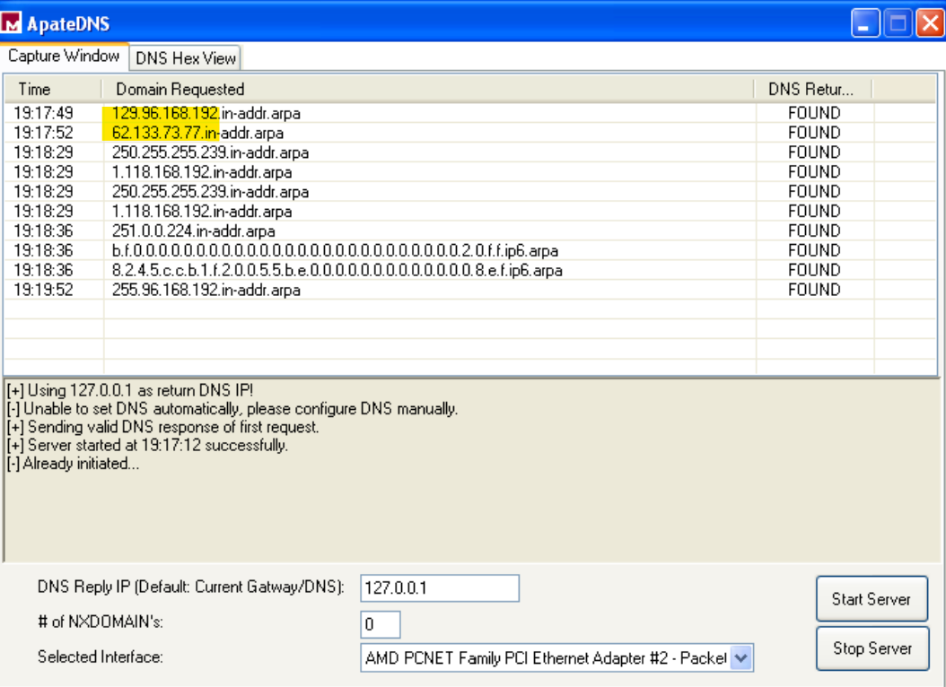

Figure 4.2.1.1. ApateDNS: Connections made by malware

In VirusTotal, there was a list of IP addresses that were detected which the malware was trying to connect. These addresses were compared to the ones found from ApateDNS.

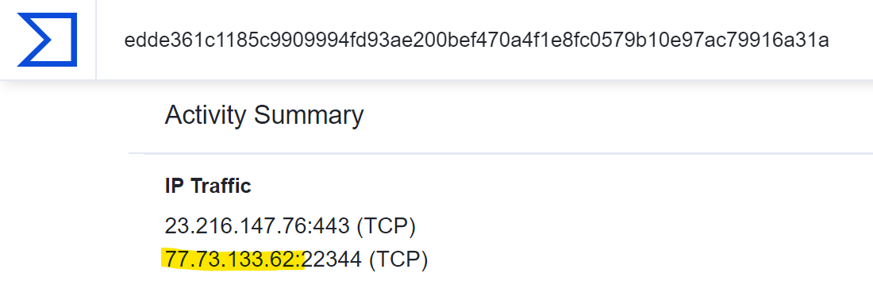

Figure 4.2.1.2. VirusTotal: IP traffic made by malware

It was observed that the second IP address in VirusTotal (77.73.133.62) was the second IP address in ApateDNS (62.133.73.77) but in reverse. This suggests that the other addresses in ApateDNS, such as 129.96.168.192, were also in reverse, which makes more sense as IP addresses nowadays commonly start with 192.xxx.xxx.xxx.

In tcpdump, there were many connections using “ARP request who-has tell”, with one of the same IP addresses found in ApateDNS, which was 129.96.168.192.

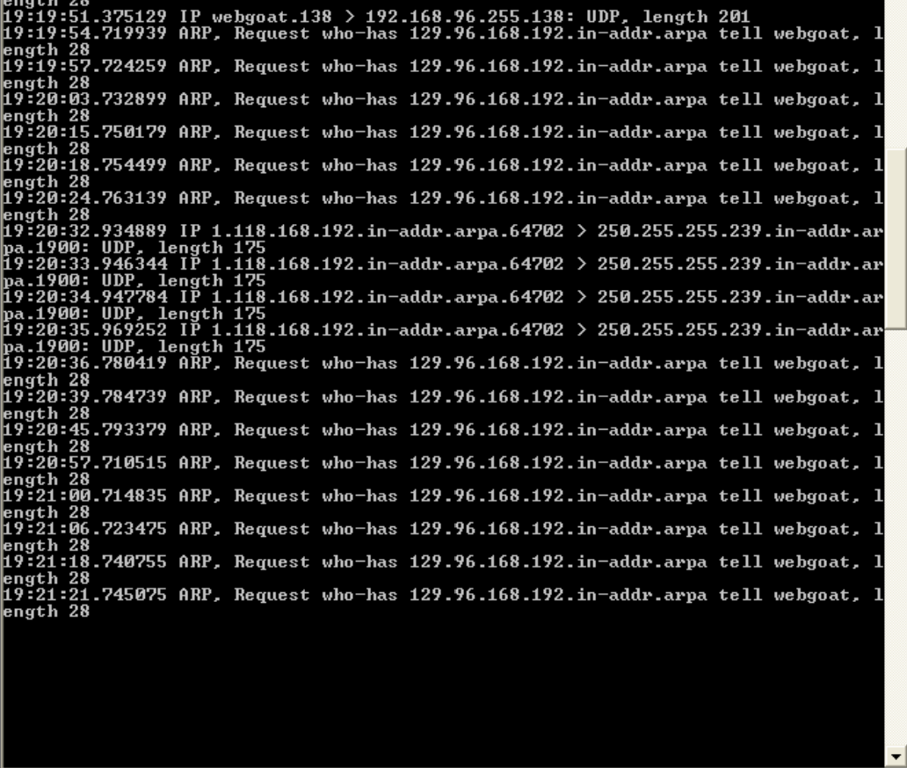

Figure 4.2.1.3. Tcpdump: Network traffic of malware

An ARP request using “who-has” and “tell” allows a device to discover the MAC address that is associated with an internet-layer address, like an IPv4 address. In this case, it seems that the malware is causing the host “webgoat”, which is the name of the virtual machine, to send data of 28 bytes to the IP address 192.168.96.129. But, since the host webgoat does not know the MAC address of the device associated with 192.168.96.129, it must send an ARP request to find out that information.

This IP address was not detected by VirusTotal as malicious and seems to be a local IP address as it starts with 192. It is probably not malicious, but it will still be taken note of.

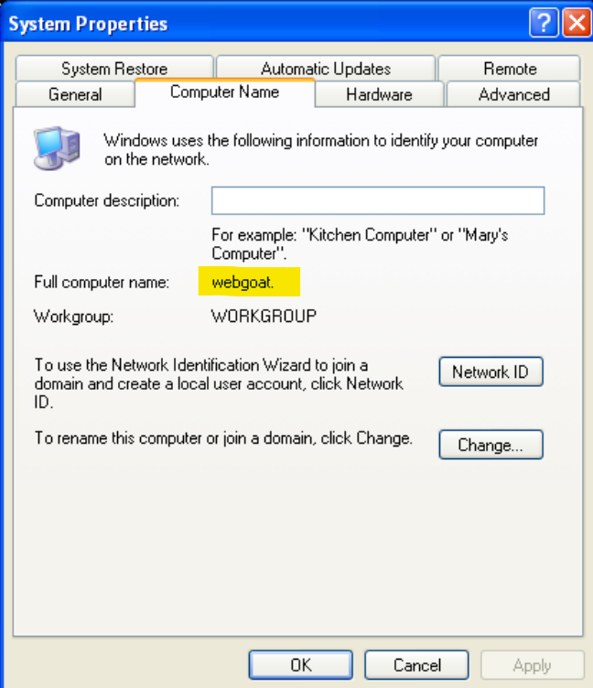

Figure 4.2.1.4. Computer name “webgoat” of virtual machine

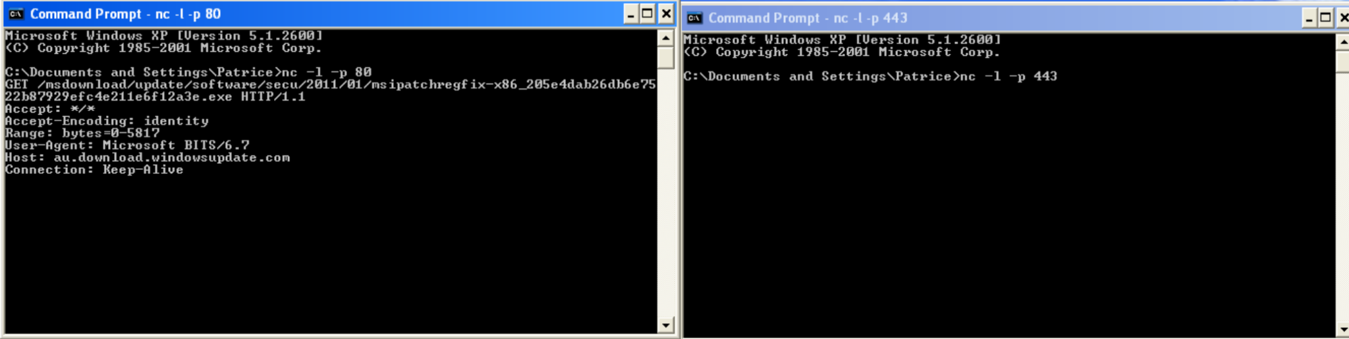

Figure 4.2.1.5. Netcat listeners on ports 80 (left) and 443 (right)

Looking at the netcat connections, no requests were made to the HTTP (80) or HTTPS (443) ports by the malware. The only thing received from the HTTP port was a regular Windows update. From the VirusTotal report of the IP addresses earlier, there was a supposed connection to the IP address 23.216.147.76 through port 443, but nothing was found in the netcat, which was suspicious behaviour.

### 4.2.2. Process and Registry Activity

Next, for the Process Explorer, the malware was observed to be running in the background of the system. Looking into its properties, some changes were observed in the strings of the malware. In the strings, the Memory tab can be viewed, which is the strings after the malware was run in memory. From there, a new string “Richens.exe” appeared twice.

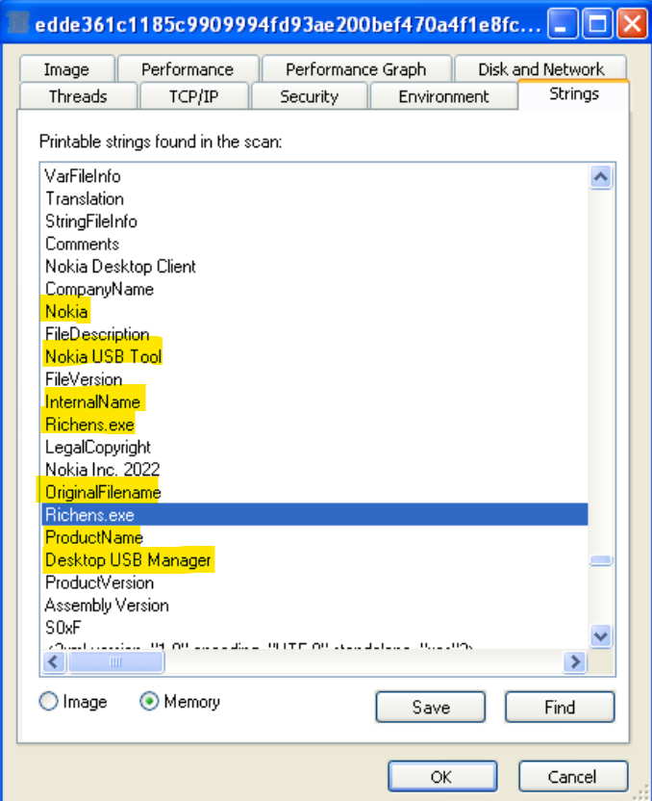

Figure 4.2.2.1. Process Explorer: Strings of malware in memory

Initially, this Richens.exe file was assumed to be a file dropped into the system by the malware. After closer inspection, there were two strings, InternalName and OriginalFilename, above each of the Richens.exe strings. With these strings tied closely together, there is a very high chance that the Richens.exe might have been the internal and original name of the malware executable.

It was also observed that a few lines above the Richens.exe string was another string named “Nokia USB Tool”, with several other strings relating to the company Nokia. There were more strings like “Product Name” and “Desktop USB Manager” below that. These strings were strange, as they indicate that the malware somehow relates to a USB manager application by Nokia. These strings suggest that the malware is attempting to disguise itself as some legitimate USB managing application from Nokia, in order to hide its identity from regular users.

Looking into Process Monitor, as there were many processes shown by it initially, it was filtered to only show the processes done by the malware executable after running it. From Process Monitor, the malware was seen to be creating and reading many files, which were mostly from it importing dlls and reading the registry.

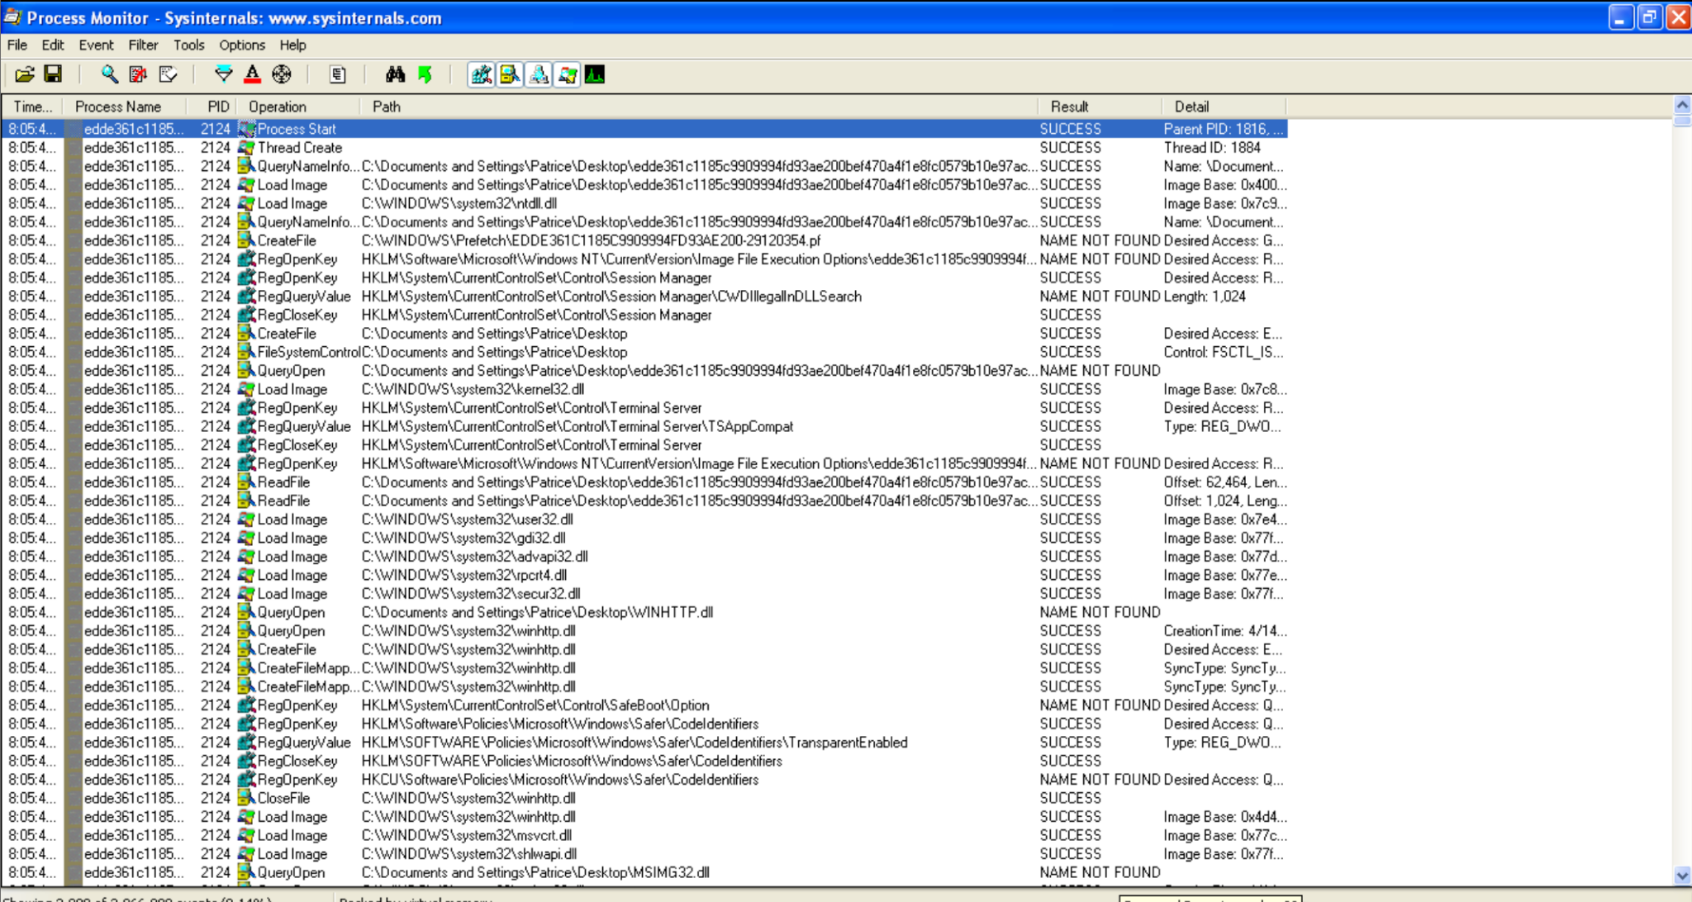

Figure 4.2.2.2. Process Monitor: Viewing processes done by malware

Scrolling further down to see more recent changes made by the malware, a lot of TCP Reconnects and Disconnects were observed after the initial dll imports and other processes. The IP address (62.133.73.77) that the malware was trying to connect to repeatedly was one of the IP addresses observed in ApateDNS earlier.

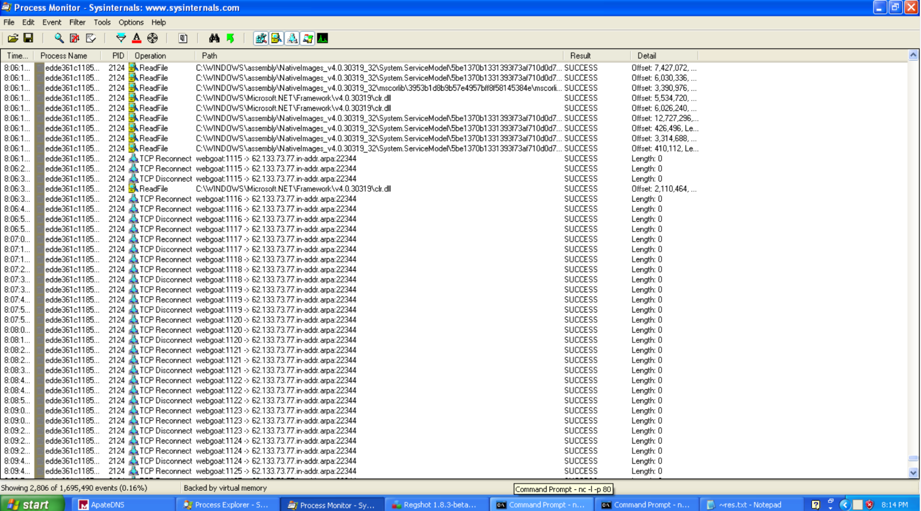

Figure 4.2.2.3. Process Monitor: TCP connections made by malware

Since it was found in Basic Static Analysis that the malware was most likely an information stealer, the processes ReadFile and CreateFile could reveal the malware’s actions. Filtering Process Monitor by “ReadFile” and “CreateFile” operations, there were many dll files and configuration files that were read by the malware. One file that was read was the machine.config file. This file stores configuration settings and information about the system. These might be to check if the malware was being run in a virtual machine.

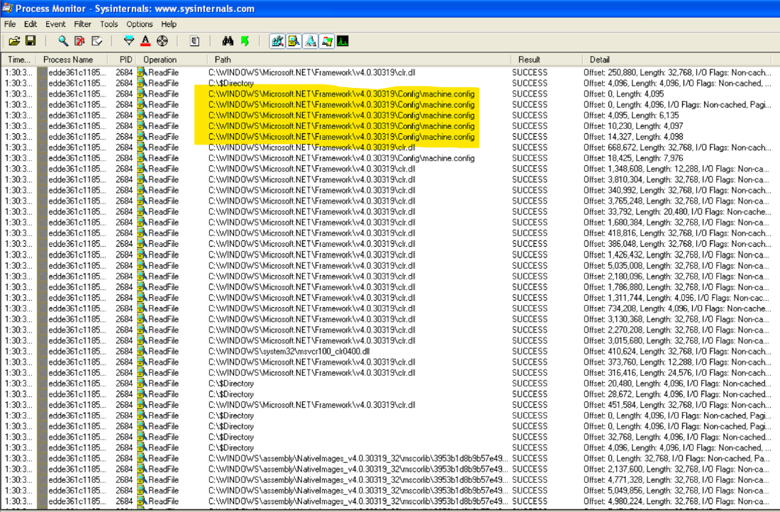

Figure 4.2.2.4. Process Monitor: ReadFile operations by malware

As for the CreateFile operations, there were not any files that were created. The operation was mostly used for executing and reading files such as the dlls in Windows. Overall, there seemed to be no malicious activity shown in the Process Monitor for these two operations.

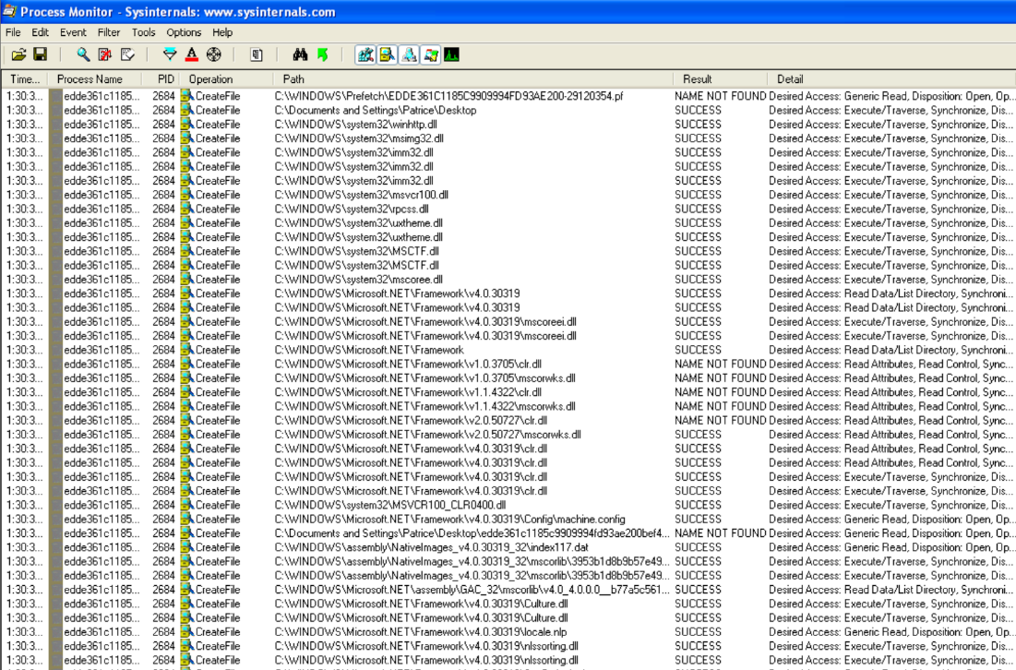

Figure 4.2.2.5. Process Monitor: CreateFile operations by malware

Finally, opening the Regshot changelog for the system, the only thing notable was that the file information stored in the MUICache in Windows. MUICache is a windows resource that acts as a registry key that is responsible for storing information about the executable of each application (OpenMUIFile, n.d.).

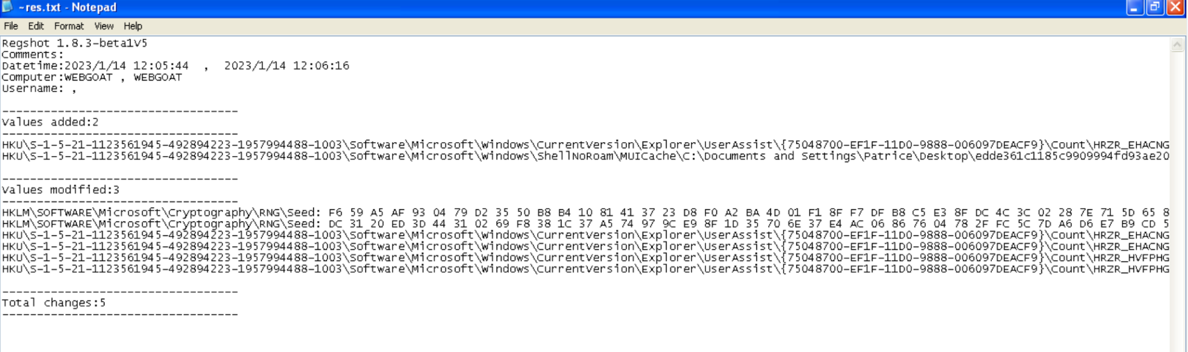



Figure 4.2.2.6. Regshot: Changes made by malware

Looking at the outputs from the tools, it was highly suspected that the malware’s defence mechanisms prevented it from running certain actions, as other than connecting to an IP address, no other malicious actions were identified.

In Basic Static Analysis, a string called “C:/daw.pdb” was found in BinText (refer to Figure 4.1.6.3). This was suspected to be a file that was dropped into the C drive, but there was no such file inside. There was also no indication of this string in the Process Explorer or Process Monitor.

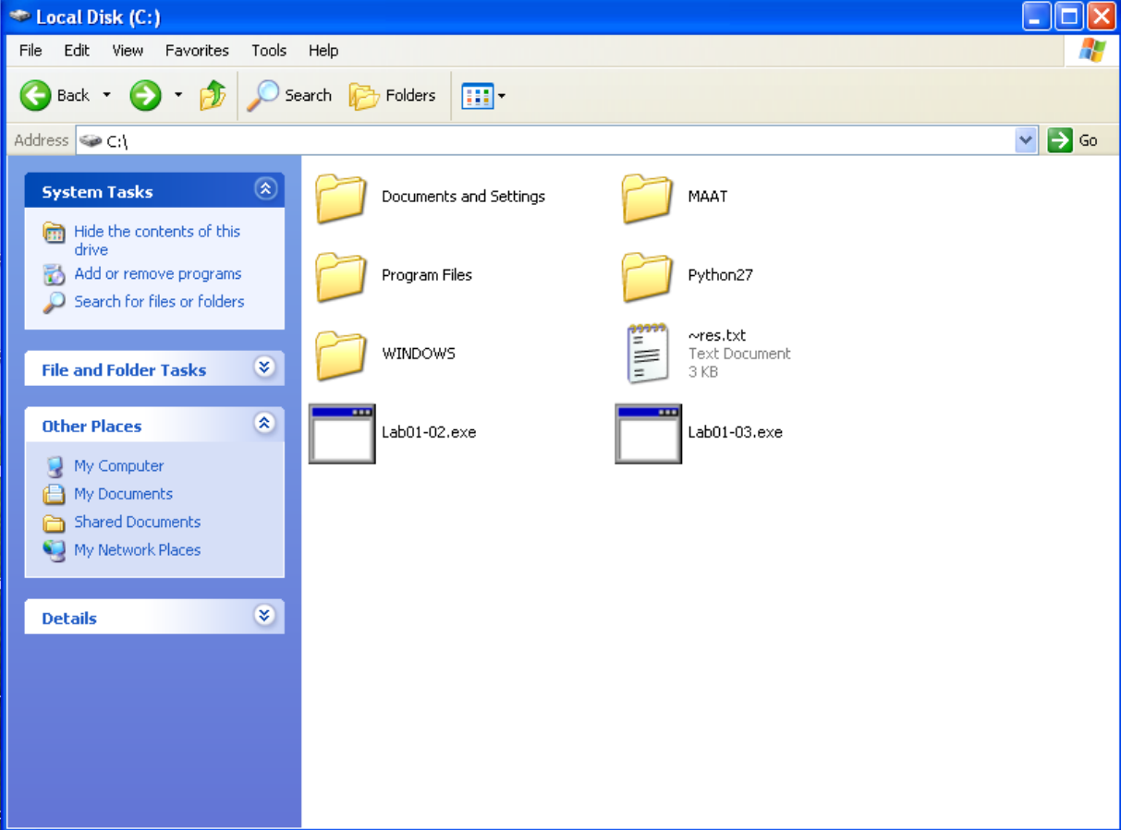

Figure 4.2.2.7. C: drive of the virtual machine.

From here, the virtual machine was left on for slightly more than an hour, to the point where the machine automatically suspended itself to save power. This was to see if the malware would perform any actions after a long period of time due to Sleep functions, or if the machine was rebooted from a suspended state.

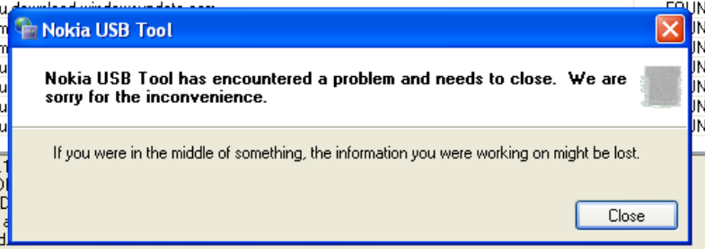

Figure 4.2.2.8. Malware disguised as Nokia USB Tool

When the virtual machine was unsuspended, a popup was observed from “Nokia USB Tool”, indicating that it encountered a problem and needed to be closed. Earlier, in Process Explorer, strings such as “Nokia USB Tool” were found in the memory of the malware, and it was suspected that the malware was disguising itself as a Nokia USB Tool. This popup proves that theory and confirms one of the functionalities of the malware.

When the popup was closed, the malware file in Process Monitor was also observed to be closed, using Thread Exit and Process Exit.

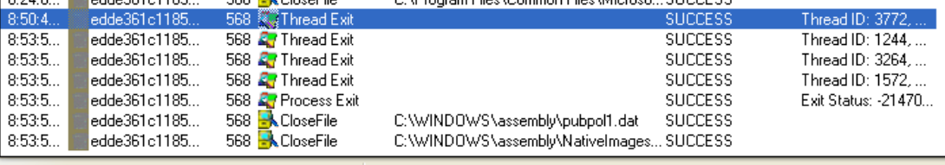

Figure 4.2.2.9. Malware exits process when popup is closed

This further proves that the Nokia USB Tool is in fact the malware executable, and that the malware was using the USB tool to hide its features.

### 4.2.3. Basic Dynamic Analysis Conclusion

From Basic Dynamic Analysis of the malware executable file, a few functionalities were confirmed.

1. The malware repeatedly attempts to connect to IP address 77.73.133.62, possibly to send information to this address.
2. The malware repeatedly sends a DNS query to the machine, possibly for system information, via an ARP request and tries to send information to the IP address 192.168.96.129.
3. The malware’s original file name is most likely Richens.exe.
4. The malware disguises itself as a Nokia USB Tool.

As found in the Basic Static Analysis, the malware contained defence mechanisms, and was able to detect if it was in a virtual machine and sleep to hinder dynamic analysis.

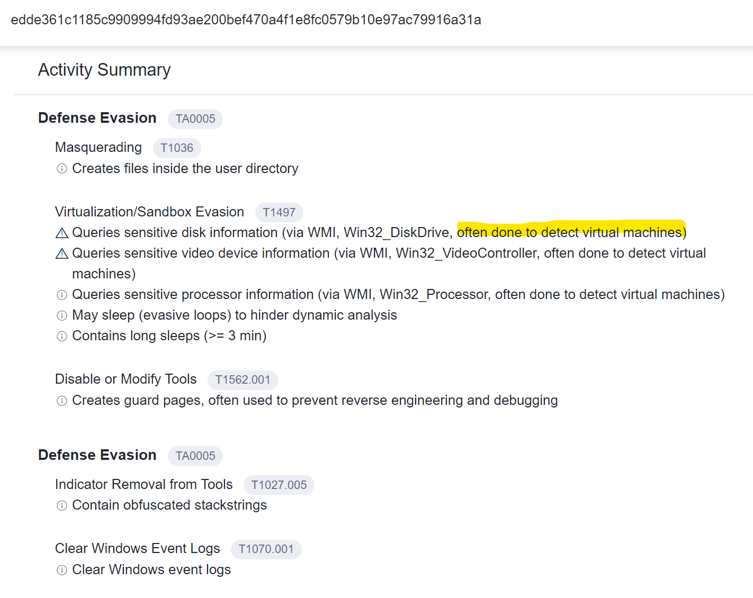

Figure 4.2.3.1. VirusTotal: Defense Evasion

Knowing this information, Basic Dynamic Analysis might not have analysed all the functionalities of the malware as it is purposely trying to avoid analysis. Hence, Advanced Static Analysis will be used in order to analyse these defence mechanisms in the malware, which will lead to Advanced Dynamic Analysis where removing these defences will be attempted.

## 4.3. Advanced Static Analysis

Basic Static Analysis is just looking at the outer frame of the malware, where we can draw some preliminary conclusions but they are generally just clues to what the malware fully does. For example, in Basic Static Analysis, the different import functions of the malware can be found, however there is no way to determine how the import functions are used or if they are being used at all. Basic Dynamic Analysis runs the malware and sees how the malware executes and responds, but if the malware has certain functions obfuscate its behaviour, it will be difficult to draw conclusive conclusions. This means that there needs to be a way to get a more detailed analysis of the malware and its behaviour/functions.

This is where Advanced Static Analysis comes into play. Advanced Static Analysis, or code analysis, breaks down the malware file so that each section can be fully studied, while not executing the malware. The main way of doing this is by using a disassembler or decompiler to translate the machine code to assembly language/code (or other coding languages if a decompiler is being used), which is more legible than machine code, which is in binary. By looking at the disassembled code, we can find out much more concrete information on the malware, instead of just clues in Basic Static Analysis. For example, we are able to see the flow of the malware code, how it goes from one function to another, what are the import functions in each function and even how the import functions are being used.

Through Advanced Static Analysis, a clear picture of the malware can be painted, without the running of the malware. Defensive mechanisms placed in the malware by its author to make analysis harder can also be detected in Advanced Static Analysis, so ways to reverse engineer these mechanisms can be identified as well.

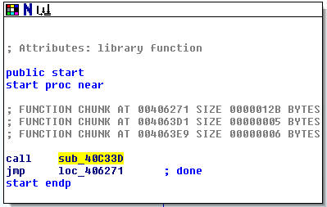  
Figure 4.3.1 IDA Pro Free: Start Process of the Malware

For Advanced Static Analysis, IDA Pro Free will be used first to establish an understanding of the malware code and then Relyze will be used to supplement the understanding as well as cover all grounds, should it be able to find more information than IDA Pro Free. Only portions of interest, such as certain import functions and activities of the malware will be covered.

### 4.3.1 Debugger Trap

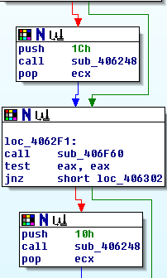

Figure 4.3.1.1 IDA Pro Free: Subroutine 406248 Called Twice

This portion of the code is just slightly below the start portion (Figure 4.3.1), meaning it is part of the main section of the malware. It is interesting as there is a small portion of the code that is an if-else statement where it could jump over the subroutine 406248, and it happens back to back. There’s also a “jnz” check which means that the code will jump to a specified location (in Figure 4.3.2, it is location 406302) should the result of the test function be not zero. Since this subroutine is called twice but can be jumped over, further analysis will be done on this given subroutine to see what it accomplishes.

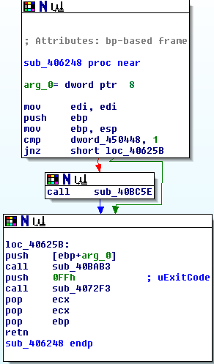

Figure 4.3.1.2 IDA Pro Free: Subroutine 406248 Code

As shown in Figure 4.3.3, there is another if-else statement to subroutine 40BC5E, however subroutine 40BC5E is incredibly complex with many subroutine and function calls so it cannot be analysed efficiently. However it can be ignored as the code can still function without going subroutine 40BC5E. Thus, only the other 2 subroutines at location 40625B will be analysed.

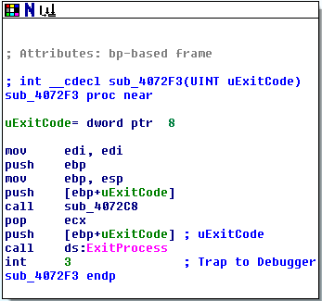

Figure 4.3.1.3 IDA Pro Free: Subroutine 4072F3

This is the second subroutine that is being called at location 40625B. There are 2 main portions of this subroutine. The first is the “ExitProcess” import function, which is being used and the “int 3” portion of the code that has the comment “Trap to Debugger” attached to it. The "ExitProcess” function exits all the processes that the malware is running, which means that this is probably part of the defence mechanisms of the malware. The next portion which is “int 3” as the comment phrases it, a “Trap to Debugger”. “Int 3” is used as a breakpoint in the malware, where the malware’s running will be interrupted, and will not continue. It is a debugger trap as without a debugger, it will not be possible to step over this breakpoint. This means that the operations after this subroutine call at location 40625B, are changes to the malware that should not be occurring. These changes can then be tracked by the malware, and will thus be able to know that a debugger is being used and the behaviour of the malware might change or the malware will be terminated.

This also means that Subroutine 406248, that is in the main portion of the malware, should not be entered when doing analysis as it is a trap to the malware analyst to detect the presence of debuggers in the running of the malware. Since the malware itself does not always enter into this subroutine, it will not cause any issues if it is skipped when doing analysis.

### 4.3.2 File Creation and Writing to File

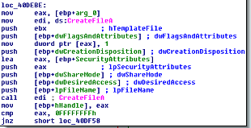

Figure 4.3.2.1 IDA Pro Free: Subroutine 4072F3

In subroutine 40DCB2, it is the only subroutine that contains the create file functionality, that is usually essential to the running of a redline stealer malware. This indicates that this function is likely the main function used to create the file where the malware will then write to, after collecting information about the infected host. The malware will then likely send the collected information over to the attacker. The function also contains extensive error handling when the file is unable to be created, show that if the function is unable to create the file or the function is not functioning as intended, the malware will not be able to function properly. Graph view of function is as shown below, which shows an extensive writing of the function, together with loops to get the code to go down through the error handling again to see if the changes made, was able to allow the code to run as intended.

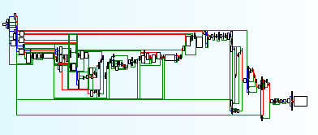  
Figure 4.3.2.2 IDA Pro Free: Graph view of function

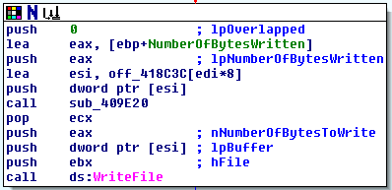

Figure 4.3.3 IDA Pro Free: Portion of Subroutine 40BAB3

In the subroutine call for subroutine 40BAB3 at location 40625B, it can be seen that it calls the import function “WriteFile”. As analysed in section 4.1.5.1, the malware can be writing information to be passed to the attacker, which can be the dropped file as seen in section 4.1.2. So, this will be an essential routine call for the malware to utilise which does not make sense as the origin from a subroutine that can be skipped (Subroutine 406248).

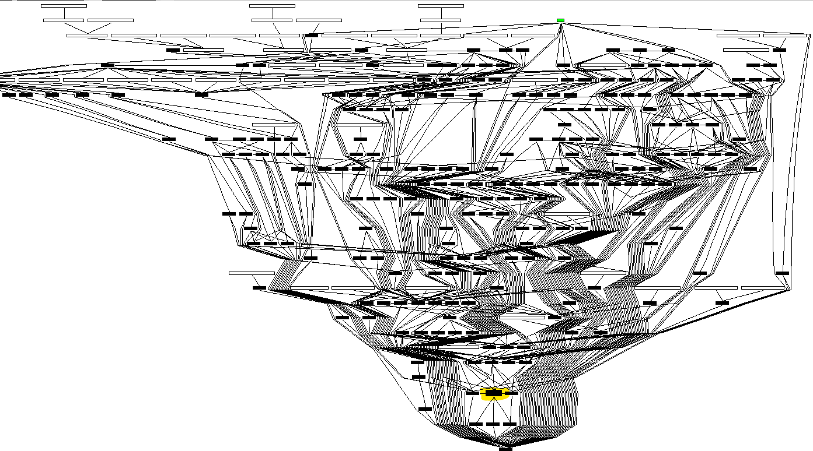

Figure 4.3.4 IDA Pro Free: References to Subroutine 40BAB3

By using IDA Pro’s mapping function, the references to a specified subroutine can be mapped out. As seen in Figure 4.3.4, where the small black box highlighted in yellow is this subroutine, subroutine 40BAB3, there is an incredible number of references to this subroutine. This clearly shows that this subroutine is quite essential to the malware, which is because of the “WriteFile'' function that is in this subroutine. Which means that the subroutine 406248 is just one of the many ways to reach this subroutine and be used by the malware.

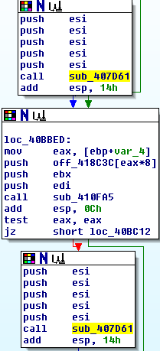

Figure 4.3.5 IDA Pro Free: Subroutine 407D61 Called Multiple Times

In subroutine 40BAB3, subroutine 407D61 is called multiple times, in a similar fashion as Subroutine 406248. This means that this subroutine is probably used to check whenever there are errors or unexpected outputs by the malware code in this subroutine or used for the defence mechanisms in the malware to deter analysis on the malware’s behaviour.

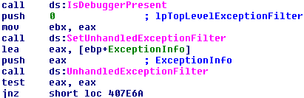

Figure 4.3.6 IDA Pro Free: Inside Subroutine 407D61

This subroutine is fairly long, as such only snippets of the codes will be taken. Here 3 import functions can be seen. The first import function, “IsDebuggerPresent” is used as another layer of debugger checking, above the debugger trap in Subroutine 4072F3. This way the malware analyst will have a harder time doing analysis as there is the constant need to try to reverse engineer the different checks that are in place. The next 2 import functions are for handling exceptions in the malware, when the running of the malware does not go according to plan or errors occurring within the malware causing it to go haywire.

### 4.3.3 Sleep Functions

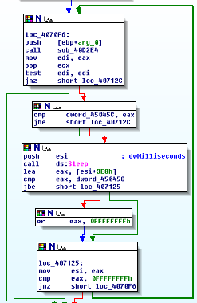  
Figure 4.3.3.1 IDA Pro Free: Sleep Loop in Code

When diving deep into the malware, past many subroutine calls, there are quite a few times that sleep loop that looks similar to Figure 4.3.7 will be called. Sleep functions hinder dynamic analysis by having the malware be inactive and “dormant” in the computer for a certain period of time. Since the sleep function is in a loop, it is likely that the sleep will be called repeatedly, causing a long sleep period, making it annoying to analyse due to the long waiting time in between each time the malware does a malicious action.   
  
However, there is an if-else statement that allows the malware to not enter the sleep loop, which means that the sleep loop is not a mandatory portion of the code that the malware has to enter in order to run normally. This means that the sleep function can be skipped over when doing dynamic analysis. Another alternative that could work is to reduce the sleep length, which could be harder to manipulate but ensure that the values of the different registers will be the intended value when it leaves the loop, which could prevent possible issues later down in the code. So, this is another portion that needs to be noted before Advanced Dynamic Analysis is done, as the code might have to be changed to avoid the long sleeps that is inherently in the malware.

### 4.3.4 Network Related Function

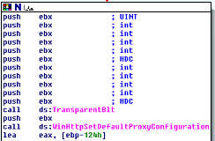

Figure 4.3.4.2 IDA Pro Free: Setting Proxy Function

In subroutine 404E6C, it contains the only function that can allow the malware to establish a connection to the attacker/owner of the malware to send and receive information, which is characteristic of a redline stealer malware. Therefore, this function is likely used to set the default proxy of the infect host to a proxy server owned by attackers, from there the attackers can receive and send information from the infected host.

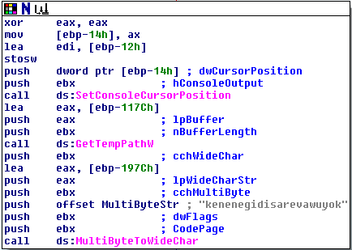  
Figure 4.3.4.2 IDA Pro Free: Strings in Code (1)

### 

In the Basic Static Analysis, there were some strings that were found in the code that looked unreadable (refer to Section 4.1.6). When the strings are unreadable it usually means that it is being obfuscated and will likely be de-obfuscated during the running of the malware, turning these strings that otherwise look useless into crucial portions in the running of the malware. The string in Figure 4.3.4.2 is a good example of such a string, that cannot be understood but the function “MultiByteToWideChar” is used onto the string, likely to partially or fully de-obfuscate the string to get crucial host/network-based indicators., likely in this case, it is being used to obfuscate the file path, since the GetTempPathW function is being used here, it can be assumed the unreadable string shown in the figure above, is related to the function and therefore is a file path.

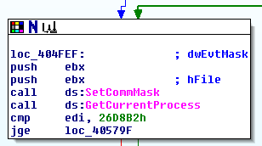

Figure 4.3.4.3 IDA Pro Free: Setting CommMask

As identified previously in section 4.1.5.1, SetCommMask is used to specify the events to be monitored for a network device, which indicates that it is likely to be monitoring events from the connected proxy server to be able to read and send information when the attack requests or send information to the infected host.

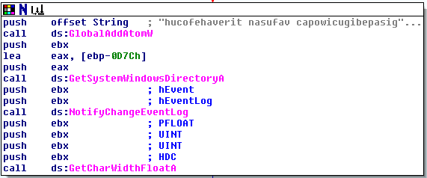

Figure 4.3.4.4 IDA Pro Free: Strings in Code (2)

The string in this figure is first inputted into the GlobalAddAtomW function which maps the string to a value, unique to the string. The function then gets the system directory and proceeds to allow the malware to be able to receive a notification if the event log has been modified. The string could be used to specify the event log, but it is not possible to fully understand the string from just static analysis.

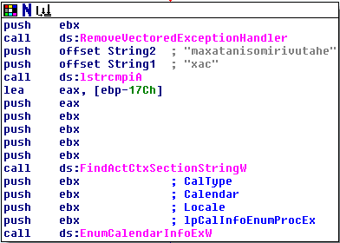

Figure 4.3.4.5 IDA Pro Free: Strings in Code (3)

In Figure 4.3.4.5, there is another set of strings, into the function “lstrcmpiA”, which is meant to do a non-case sensitive comparison of the 2 strings (Microsoft, 2022). The use of this comparison cannot be fully understood from the code and can only be understood to its fullest extent during the Advanced Dynamic Analysis, if this portion of the code can be successfully reached and run, by the debugger. From the code alone, it is not possible to identify what the strings are being used for as the comparison is quite obvious and the return value is most definitely be negative as String1 is much lesser than String2.

### 4.3.5 Clearing Event Logs

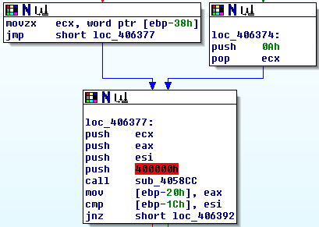  
Figure 4.3.5.1 IDA Pro Free: Subroutine 4058CC

There is a subroutine towards the end of the malware that is where the malware will run which is after an if-else statement. So, a more in-depth analysis will have to be done to examine what the subroutine does, that is essential for the malware, since it will always be entered when the malware is run.

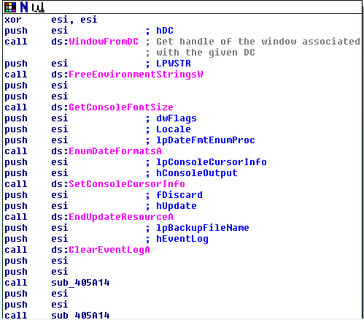  
Figure 4.3.5.2 IDA Pro Free: Inside Subroutine 4058CC

First thing that can be seen in the subroutine is the use of a number of import functions, with the most important being “ClearEventLogA”. As noted in section 4.1.5.2, “ClearEventLogA” can be used to clear a specified event log as well as saving it to a backup file. This means that the malware is clearing its tracks in the Windows event logs, obscuring its actions from being seen by the malware analyst. This is also one of the defence mechanisms that was also covered in VirusTotal (section 4.1.2.3) which helps the malware to be less obvious as event logs are no longer a way to check for malware activity.

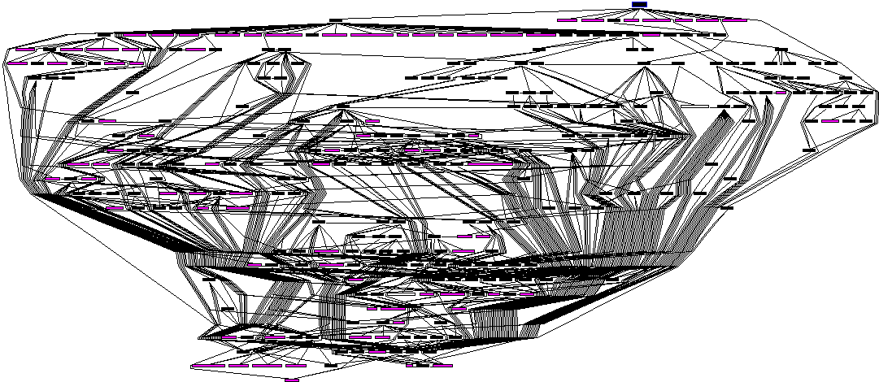  
Figure 4.3.5.3 IDA Pro Free: References from Subroutine 4058CC

To understand what subroutine 4058CC does, there is a need to check the references from the subroutine to see what other functions and subroutines it calls. By using IDA Pro Free’s mapping tool, it can be seen in Figure 4.3.9 that it calls almost every other subroutine in the malware itself. This shows that the malware constantly runs through its defence mechanisms such as the anti-debugger defence mechanisms shown earlier, as well as the sleep functions. This constant cycling of the different defensive subroutines makes it difficult to perform a dynamic analysis as the defensive mechanisms need to be constantly avoided inside the malware. Moreover, since the many different subroutines are interconnected as shown in Figure 4.3.11, knowing where and how the malware will travel down the code, will need to be run step by step as the connection between the subroutines and functions are vast and complicated, making it hard to fully grasp how the malware will run just based on viewing the code alone.

### 4.3.6 Reading Files

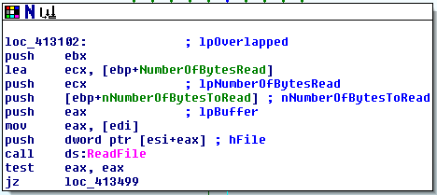

Figure 4.3.6.1 IDA Pro Free: Read File Function

The read file function is being used in the malware. This could likely be for the CnC (command and control) portion of the malware as identified in section 4.1.2.3 during the VirusTotal analysis. The attacker will likely send files for the malware to read, the contents of the file will likely be commands to the infected host to dictate the actions of the host, allow the attacker to gain control over the machine.

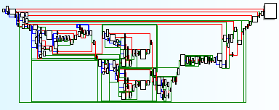

Figure 4.3.6.1 IDA Pro Free: Graph View

As seen in the figure above, the code for the read file function is also extensively written, with multiple checks if the malware is able to read files as intended by the malware author as well as looping functions to force a retry in reading the file after some changes and resets of the variables. All these is done to ensure that the malware is able to read the files sent by the attacker properly to allow the attacker to gain control over the infected host.

## 4.4. Advanced Dynamic Analysis

To find out more on what the malware can do, Advanced Dynamic Analysis will be used to try and reverse engineer the assembly code to bypass some defence mechanisms that might be preventing the malware from fully operating on the virtual machine. To perform Advanced Dynamic Analysis, the virtual machine must first be reverted back to a state before the malware was run. This is so the machine will be in a clean state to observe any new changes from advanced dynamic analysis.

OllyDBG will be used to perform advanced dynamic analysis. This tool can debug the assembly code of the malware and try to bypass any defence mechanisms by manipulating the assembly code. Alongside OllyDBG, IDA Pro will be used in visualising the functions that can be bypassed in the assembly code.

### 4.4.1. Debugging

Firstly, debugging the code will be attempted by using OllyDBG. Debugging is important as it allows analysts to observe the execution flow of the malware, and how functions and subroutines work line-by-line.

As it was found in the Advanced Static Analysis, the malware has anti-debugging mechanisms that prevent analysts from debugging the code (Refer to Figure 4.3.6). Knowing this, the debugger was run before any modification was done to the assembly code. This was to observe the original output of how the debugger would be stopped by the defence mechanisms. A breakpoint was set at a location **loc_40717E** in the assembly, which was a subroutine calling for a sleep function.

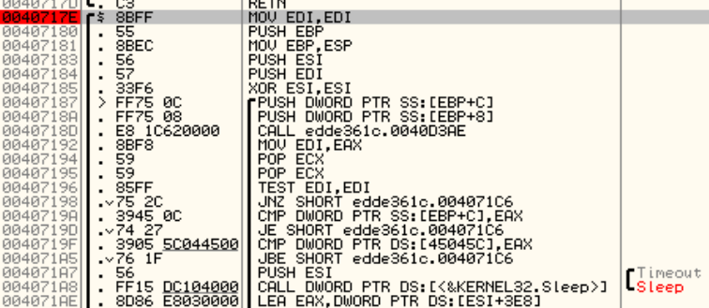

Figure 4.4.1.1. Manual breakpoint set at **loc_40717E**.

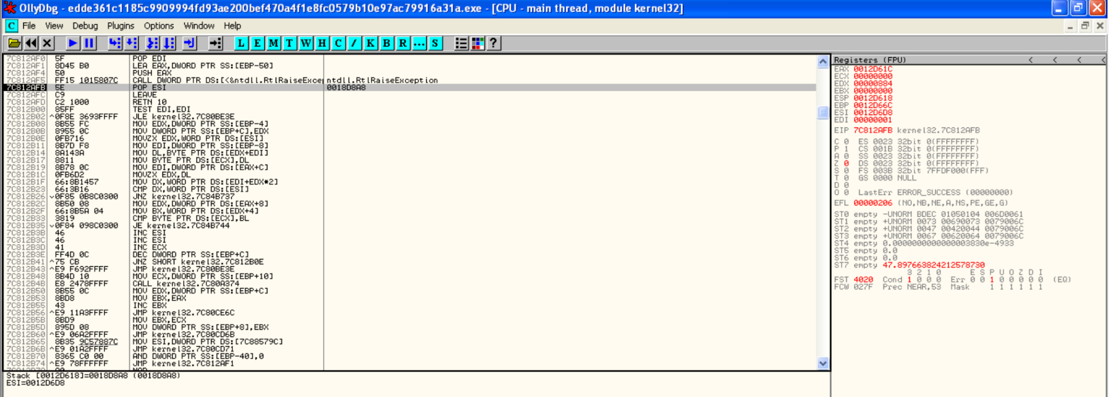

Figure 4.4.1.2. Debugger stopped at POP ESI operation instead of set breakpoint.

Looking at how the debugger was stopped, it did not stop at the allocated breakpoint at **loc_40717E.** Instead, it stopped at a “POP ESI” operation. It was noted that a “RaiseException” operation was run, which gives an indication on which subroutines to find and disable. After stepping over the pause a few times, the debugger was terminated and could not do anything.

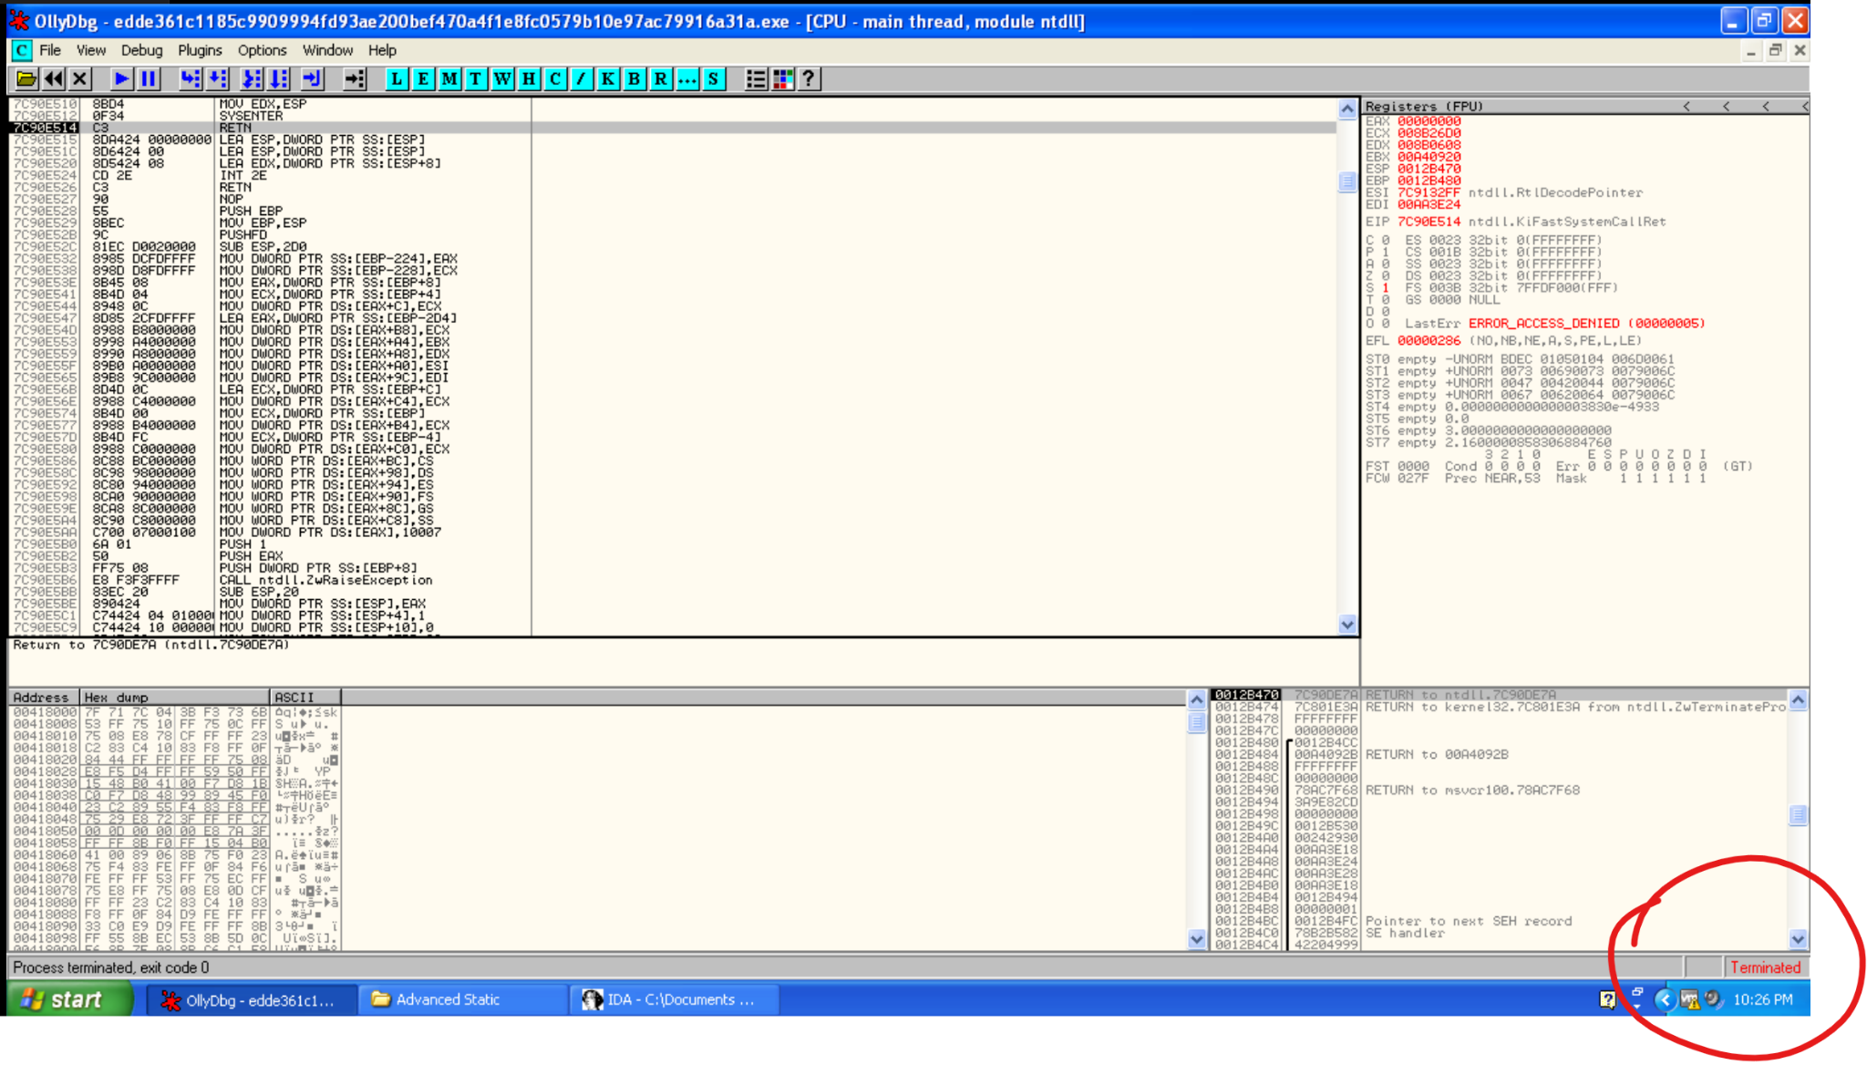

Figure 4.4.1.3. Debugger was terminated after stepping over the breakpoint.

These mechanisms will be removed from the code first. To bypass these anti-debugging functions, they will be replaced with a no instruction operation, or NOP for short. These NOPs carry out no instruction and can be used to skip the functions completely.

First, NOPs will replace the subroutines that are linked to the **RaiseException** function. This is so that the malware can be debugged without any error or stops. Going into IDA Pro, the function “RaiseException” can be searched for in the code.

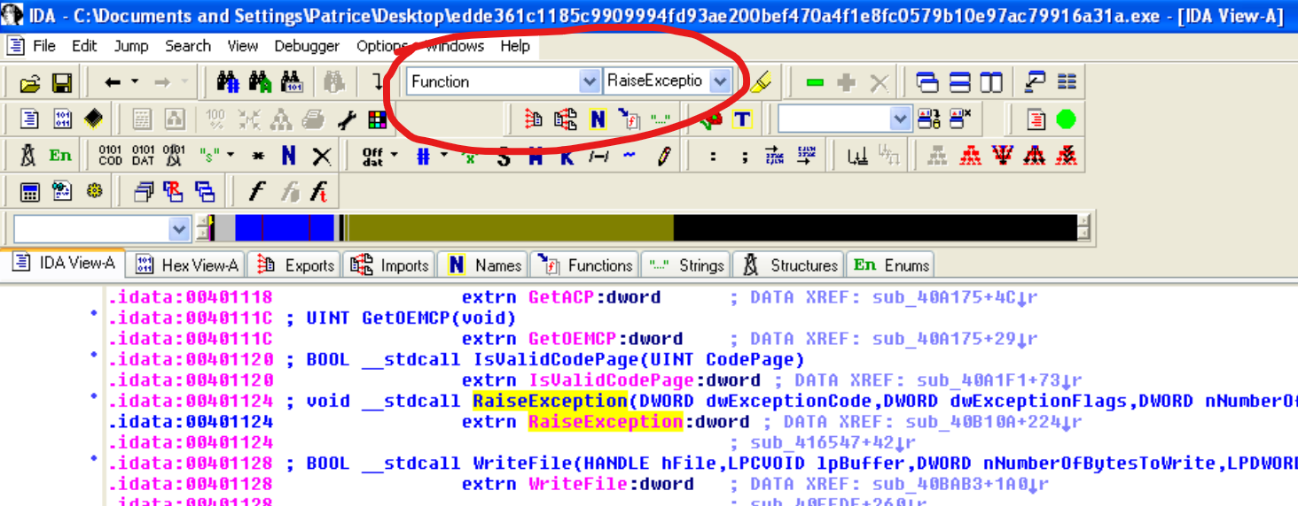

Figure 4.4.1.4. Searching for **RaiseException** in IDA Pro.

From here, the function can be cross-referenced to other subroutines that called for this function in the assembly.

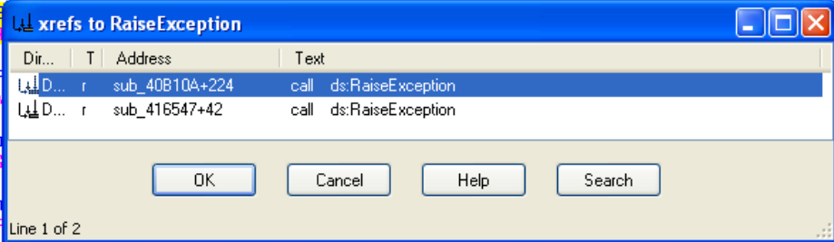

Figure 4.4.1.5. Cross-referencing **RaiseException** function in IDA Pro.

From the image above, it is observed that two subroutines had called for the **RaiseException** function. These two subroutines were analysed to see if they were solely for checking for debuggers, or whether they were important for the malware’s actual functionality.

For the first subroutine, **sub_40B10A,** there seemed to be a lot of conditional jumps and checks in the code, with many “cmp” and “jnz” operations. The **RaiseException** function was only called somewhat near the end of the function.

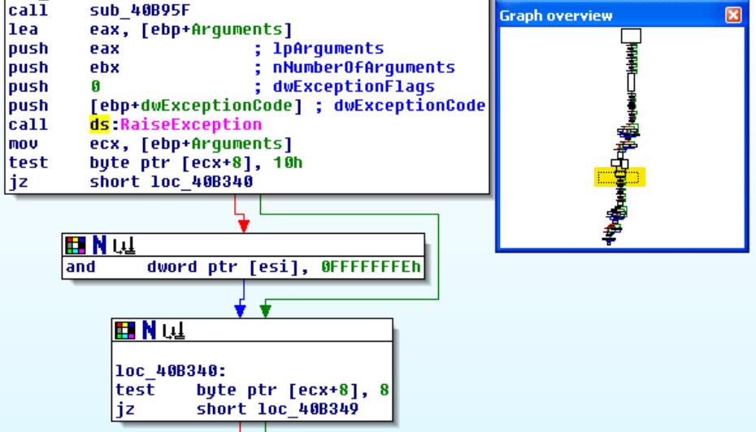

Figure 4.4.1.6. Flowchart of **sub_40B10A.**

From analysing the subroutine deeper, there were no other subroutines in this subroutine that called a specific function like **ReadFile** or **RaiseException**. It was assumed that this long chain of code was the list of checks for what events were considered an exception, so this subroutine was left alone for the time being.

For the second subroutine, **sub_416547**, it was a much shorter subroutine than the previous one, with only a few separate blocks of code linked.

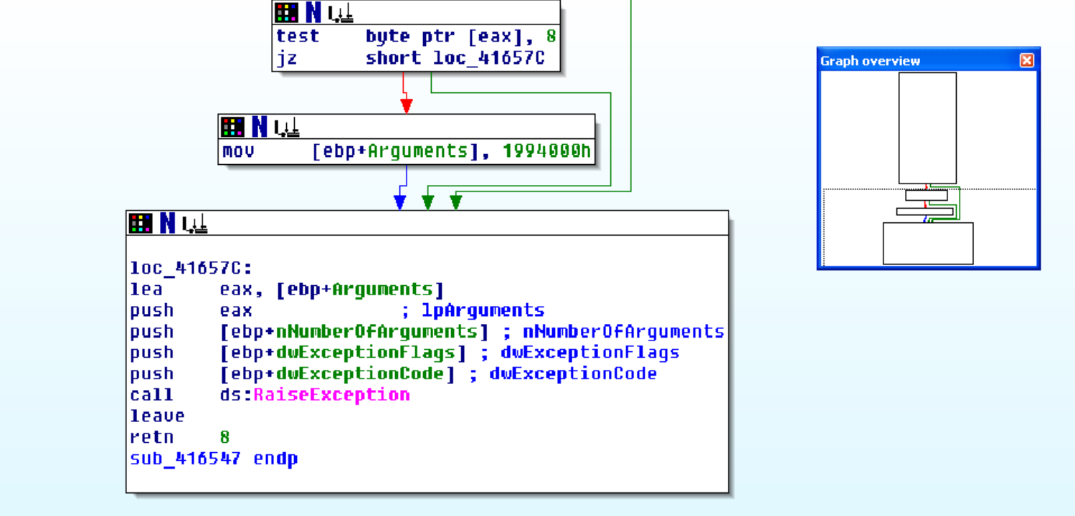

Figure 4.4.1.7. Flowchart of **sub_416547.**

The difference between this subroutine and the previous one is that in this one, after the **RaiseException** function was called, the “leave” and “retn” operations were called, whereas in the previous subroutine more code was run. The assumption was made that this subroutine, **sub_416547,** was an endpoint for the exception to be raised, so it might relate to an anti-debugging mechanism. Tracing further back by cross-referencing the subroutine, it was found that two subroutines called for this subroutine.

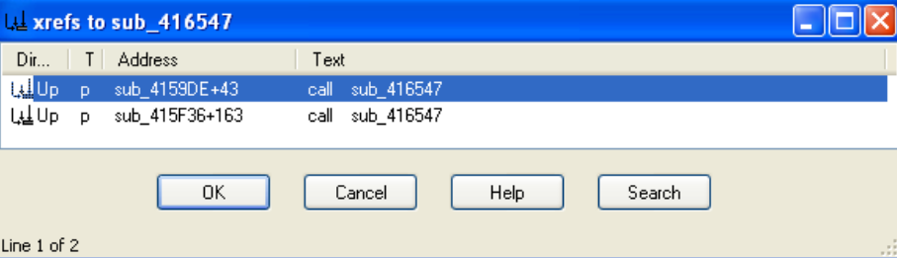

Figure 4.4.1.8. Cross-referencing **sub_416547** in IDA Pro.

Briefly analysing both subroutines that called for **sub_416547**, it was found that both of these were linked to trapping the debugger, so both subroutines will be replaced with NOPs. The first subroutine had called **sub_416547** right before calling “int 3”, which was a debugging trap as it acted as a breakpoint for the debugger.

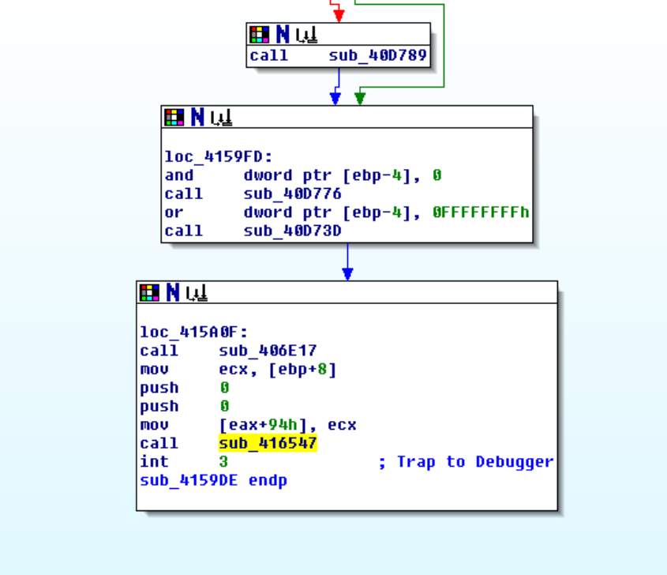

Figure 4.4.1.9. First subroutine calling for **sub_416547** before calling int 3.

In the second subroutine, it was a very complex subroutine with many conditional jumps and other subroutines called, so it was briefly looked through. It was observed that **sub_40D789** was called multiple times. Upon looking into that subroutine, it was found that it contained the same debugger trap that was found in the first subroutine.

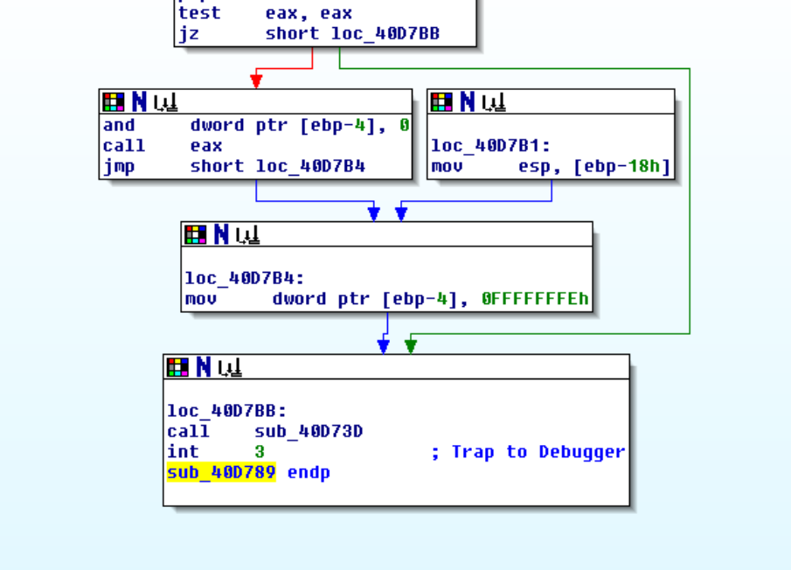

Figure 4.4.1.10. Second subroutine calling for int 3 operation.

NOPs were used to replace the subroutines that were found to trap the debugger. These include **sub_416547**, the two subroutines that referenced it alongside trapping the debugger, **sub_4159DE** and **sub_415F36,** and lastly **sub_40D789,** which contained code to trap the debugger.

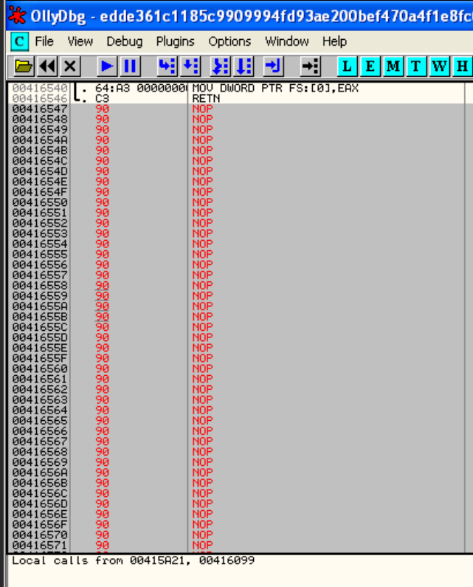

Figure 4.4.1.11. Filling subroutines with NOPs in OllyDBG.

In the Advanced Static Analysis section of the malware, it was found that the subroutine, **sub_406248,** was checking for debuggers and possibly if the malware was in a virtual machine (Refer to Figure 4.3.3). Hence, NOPs will replace **sub_406248** as well, as it was also deduced that it could be bypassed without causing any problems for the malware’s functionality.

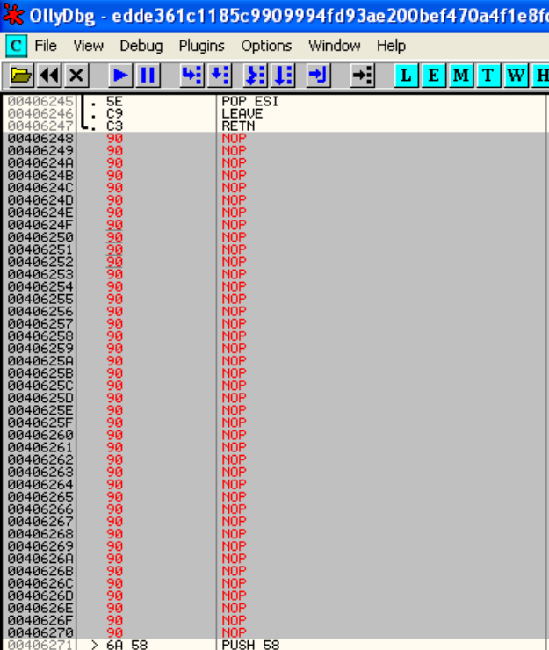

Figure 4.4.1.12. Filling **sub_406248** with NOPs in OllyDBG.

After **sub_406248** was replaced with NOPs, the assembly code was analysed further for any more anti-debugging code. The function **IsDebuggerPresent** was the main function checking for debuggers in **sub_406248**, so that function was cross-referenced in IDA Pro to check if there were any other subroutines that had this function.

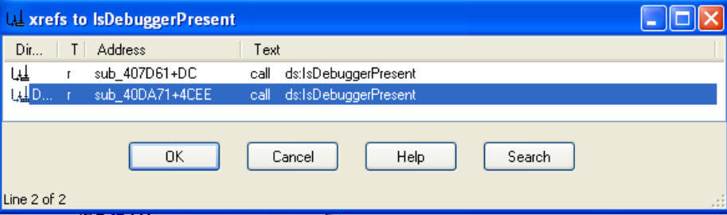

Figure 4.4.1.13. Cross-referencing **IsDebuggerPresent** function in IDA Pro.

From the cross-reference to the function **IsDebuggerPresent**, two subroutines **sub_407D61** and **sub_40DA71**, that also called for **IsDebuggerPresent,** were identified. **Sub_407D61** was already identified to terminate the process after checking for debuggers in Advanced Static Analysis (refer to Figure 4.3.6), so it will be removed. For the other subroutine **sub_40DA71**, this subroutine either returns or jumps to **loc_4126A4**, which contains the same functions as **sub_406248**. Hence, both **sub_40DA71** and location **loc_4126A4** was replaced with NOPs as well.

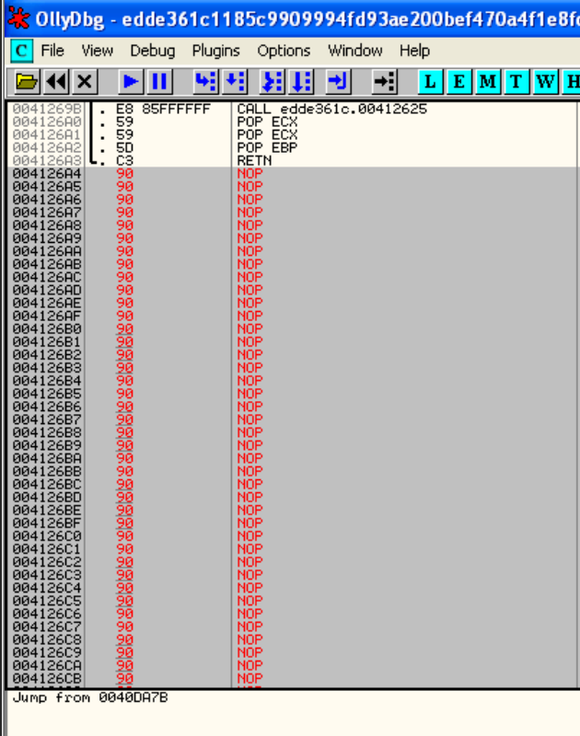

Figure 4.4.1.14. Filling **loc_4126A4** with NOPs.

Before attempting to remove any more debugging functions, the file was saved as a new executable, “debug partial.exe”, which saved all the modifications made to the code. This was so the changes that were previously made would not be changed when the debugger is restarted. After the modifications, the debugger was run in OllyDBG again to see if it could debug the code properly.

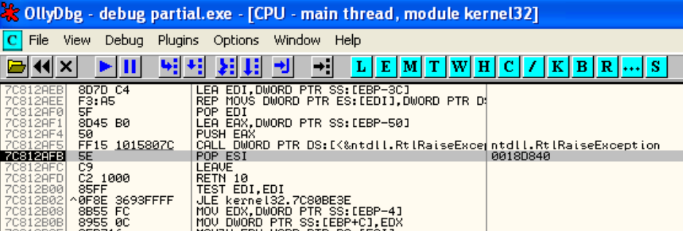

Figure 4.4.1.15. Debugger was terminated at the same point as before in OllyDBG.

The debugger was still stopped at the same function as before, when the debugger was first run without any modifications. This meant that somewhere in the assembly code, there were likely still checks to see if the malware was being debugged.

To try and remove the anti-debugging functions of the malware, stepping over and into the code line-by-line was attempted instead of finding more functions related to anti-debugging. Stepping into is typically performed on functions and subroutines, where it allows the analyst to go into the code that makes up the subroutine and execute it step-by-step. This gives the analyst a better understanding of the execution flow of the function. Stepping over the code refers to executing the entire line without analysing the insides of each function or subroutine. This allows analysts to see the bigger picture of how the malware works.

First, the debugger was restarted to the starting point of the malware. After restarting the debugger, the code was slowly run step by step using the “step into” and “step over” functions. The malware starts the program by calling a subroutine **40C33D** and then performing an unconditional jump to location **loc_406271.**

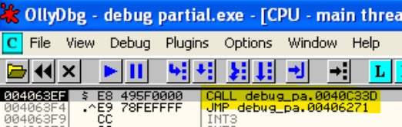

Figure 4.4.1.16. Malware starts by calling for **sub_40C33D** before jumping to **loc_406271**.

The location **406271** was stepped into to try and observe what caused the debugger to stop. The code was then stepped over until a breakpoint was reached by the debugger. The debugger did not give much information on what the variables such as EAX and ECX contained, only showing variables in the form of address locations. It was observed that after stepping over and calling the subroutine **sub_4058CC,** the debugger was at the breakpoint shown after the debugger was first run.

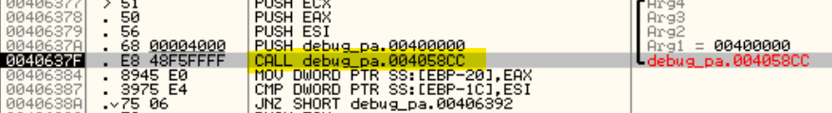

Figure 4.4.1.17. Subroutine **4058CC** called which breaks the debugger.

Hence, the debugger stepped into the subroutine **sub_4058CC** to figure out what was causing the breakpoint. Stepping over several operations inside the subroutine, it was found that another subroutine **sub_404E6C** was sending the debugger to the breakpoint.

In this subroutine, **sub_404E6C,** after stepping over some operations, it was found that the debugger could not step a certain block of code. The code in the block was a loop, where it was stepped over infinitely because of a jump at the end that went back to the start of the loop. The loop was noted to have a **GetProcessHeap** function. In order to keep debugging the code, the jump operation at the end of the loop was filled with NOPs.

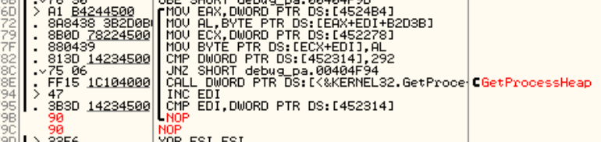

Figure 4.4.1.18. Jump operation at the end of **sub_404E6C** filled with NOPs.

Another loop was found to trap the debugger. After this loop, several more loops were found in the subroutine, which were all filled with NOPs.

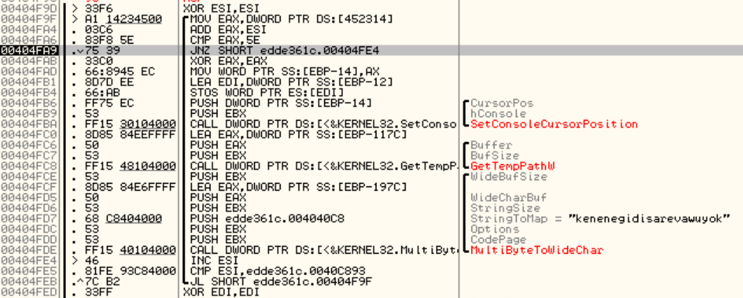

Figure 4.4.1.19. Another loop to trap the debugger found while debugging.

At this point in trying to remove the anti-debugging functions, it was the same cycle of skipping loops and stepping into subroutines to analyse functions. The team decided to skip removing the anti-debugging properties and debugging the malware in general, as it was extremely time-consuming to try and identify and remove all the functions that stop the debugger. Recalling the massive map of operations found in Advanced Static Analysis (Refer to Figure 4.3.4 and Figure 4.3.11), there were most likely going to be many more anti-debugging functions that would take an unreasonably long time to remove.

Hence, debugging the malware will be skipped in general. Since debugging the malware was unsuccessful due to many anti-debugging functions and breakpoints, the next step is to try and modify the code to skip the defence mechanisms in the malware.

### 4.4.2. Bypassing Defence Mechanisms

To bypass the defence mechanisms, OllyDBG will be used again to try and reverse engineer the assembly code, replacing certain parts of the code with NOPs. IDA Pro will be used alongside OllyDBG to help in visualisation of the assembly code’s execution flow.

With the sheer complexity of the malware in terms of its assembly code, it will bevery hard to try and reverse engineer the defence mechanisms. Identifying the defences is a challenge, as there are a large number of subroutines and functions in the malware, so reverse engineering this malware will be difficult to perform. However, reverse engineering will still be attempted on the malware to try and uncover as much information and insights about the malware as possible.

From the Advanced Static Analysis, it was observed that **sub_406248** was checking for debuggers and possibly virtual machines (Refer to Figure 4.3.4). It was also deduced that it was safe to remove, so it was reverse engineered.

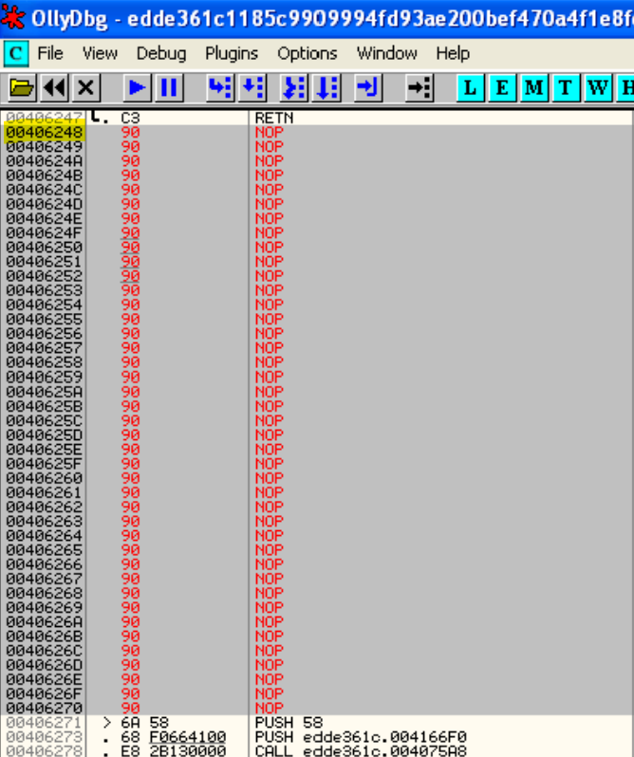

Figure 4.4.2.1. Filling **sub_406248** with NOPs in OllyDBG.

Referring to the VirusTotal report in Basic Static Analysis, it was noted that the malware contained long sleeps, which might be what was causing some malware’s functions to not run during basic dynamic analysis (Refer to Figure 4.1.2.3.3). In Advanced Static Analysis, it was also found that **Sleep** functions were called throughout the assembly (Refer to Figure 4.3.7). In the assembly code, the **Sleep** function can be searched for using IDA Pro and cross-referenced to other subroutines that called it.

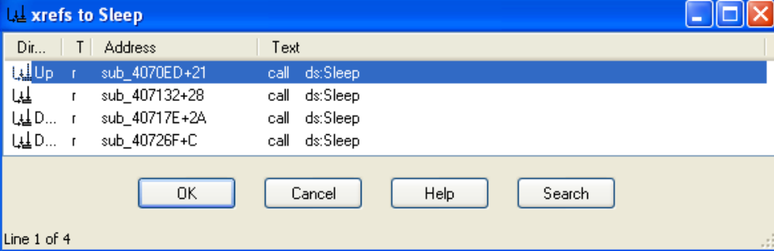

Figure 4.4.2.2. Cross-referencing **Sleep** function in IDA Pro.

Briefly analysing these four subroutines, it was observed that they each have similar structures. From the starting block of code, it will either jump to the end of the code or perform a few checks using operations like **cmp** and **jnz** and call the **Sleep** function. There is also a loop which will go back to near the start of the function and redo the process again. These operations are very similar to an if-else statement in more advanced coding languages such as C++.

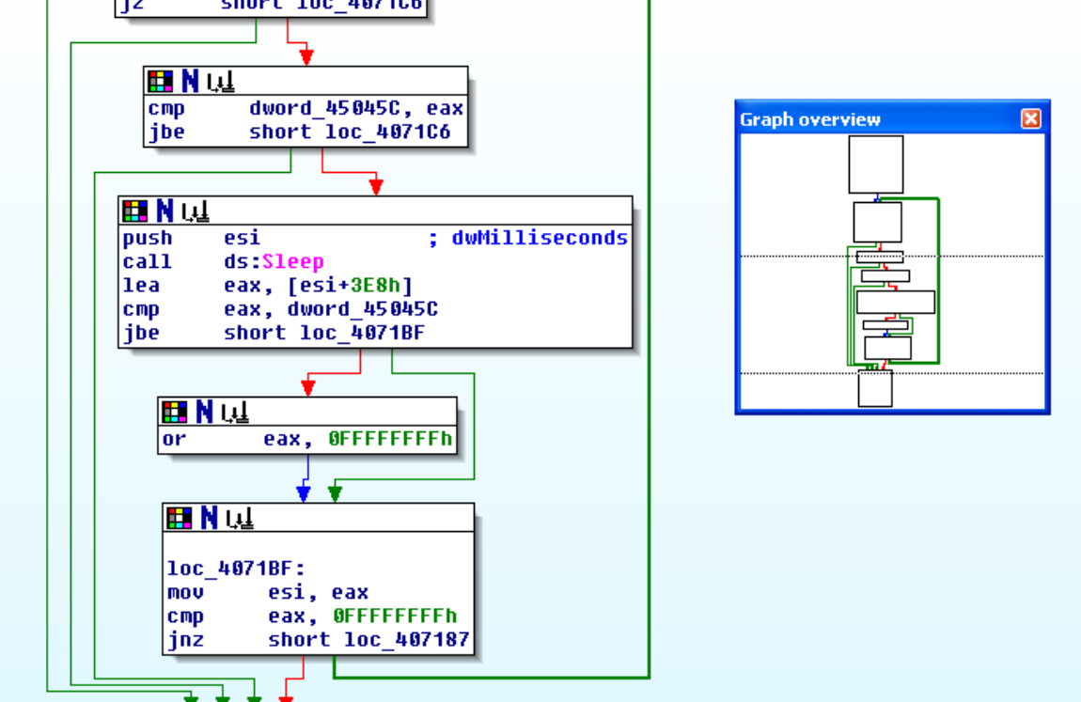

Figure 4.4.2.3. Structure of subroutine which called for **Sleep** function in IDA Pro.

Except for the last subroutine, in the starting block of code, they each called for a subroutine. These subroutines called for similar functions relating to the heap of the code, such as **HeapCreate** and **HeapAlloc.** The heap is used for dynamically allocating memory when running the code, so these subroutines were left untouched as they might affect the malware’s functionality.

To reverse engineer these subroutines, firstly the conditional jump at the starting block of code was made into an unconditional jump, so it would skip the checks and the **Sleep** function completely and go to the end of the subroutine. Then, the middle section of code containing the checks and **Sleep** function will be filled with NOPs, to make sure that they will not run at all.

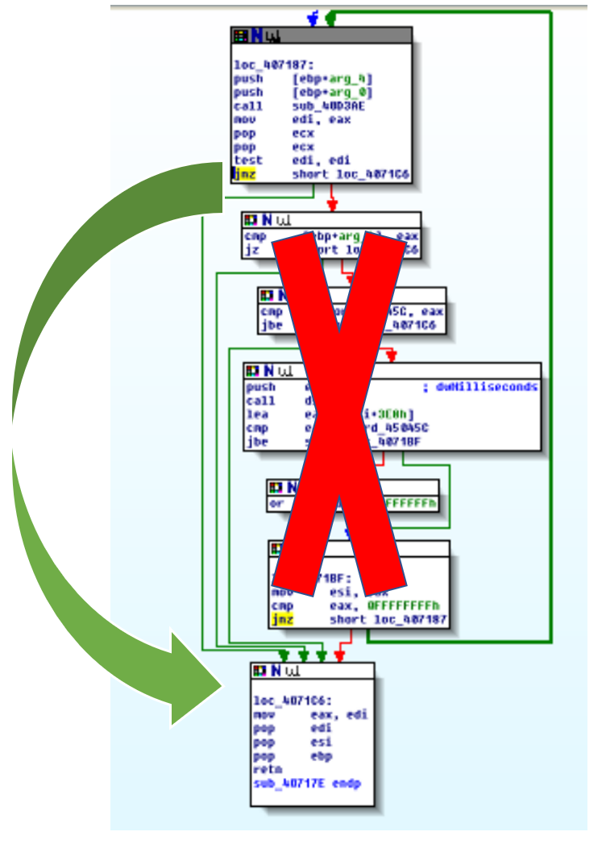

Figure 4.4.2.4. Diagram explaining the process of reverse engineering the subroutines.

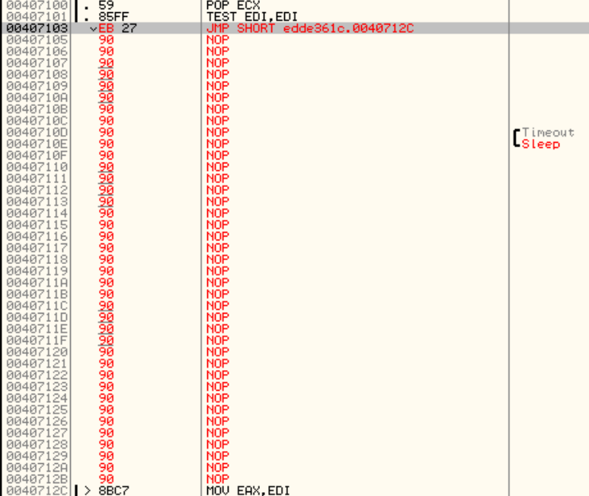

Figure 4.4.2.5. Subroutine containing **Sleep** function filled with NOPs in OllyDBG.

This procedure was performed on all four of the subroutines that were found to call the **Sleep** function. Next, as found in Advanced Static Analysis, the malware was able to clear event logs in **sub_4058CC** (refer to Figure 4.3.5), which might be clearing some of the logs for Process Monitor in Basic Dynamic Analysis. Only the function **ClearEventLogA** was reverse engineered in order to maintain the other functionalities of the malware.

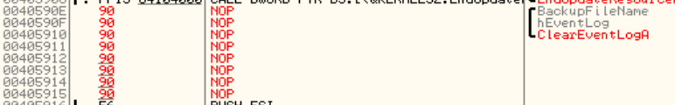

Figure 4.4.2.6. Filling ClearEventLogA function with NOPs.

The changes were patched to a new executable to see if any changes could be observed. The patch will be named as “patch1.exe”.

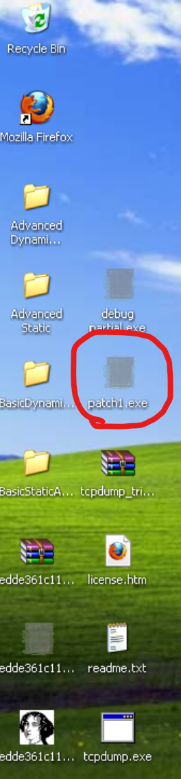

Figure 4.4.2.7. patch1.exe inside the Windows XP VM desktop.

Basic dynamic analysis on the new patch was tested. The same tools (ApateDNS, RegShot, etc.) were used to perform basic dynamic analysis.

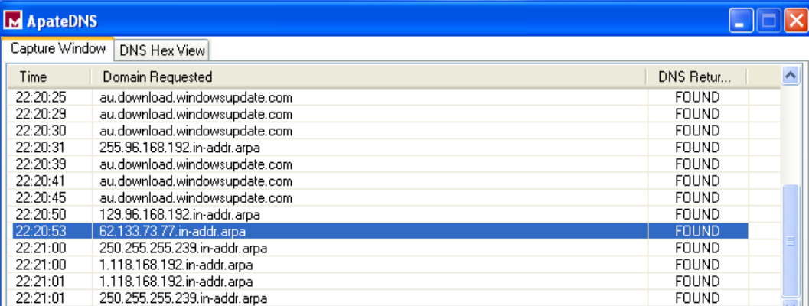

Figure 4.4.2.8. Network connections made by patch1.exe in ApateDNS.

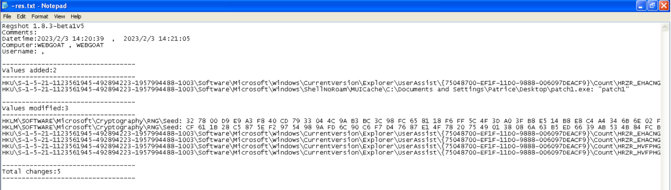

Figure 4.4.2.9. Registry changes made by patch1.exe shown by Regshot.

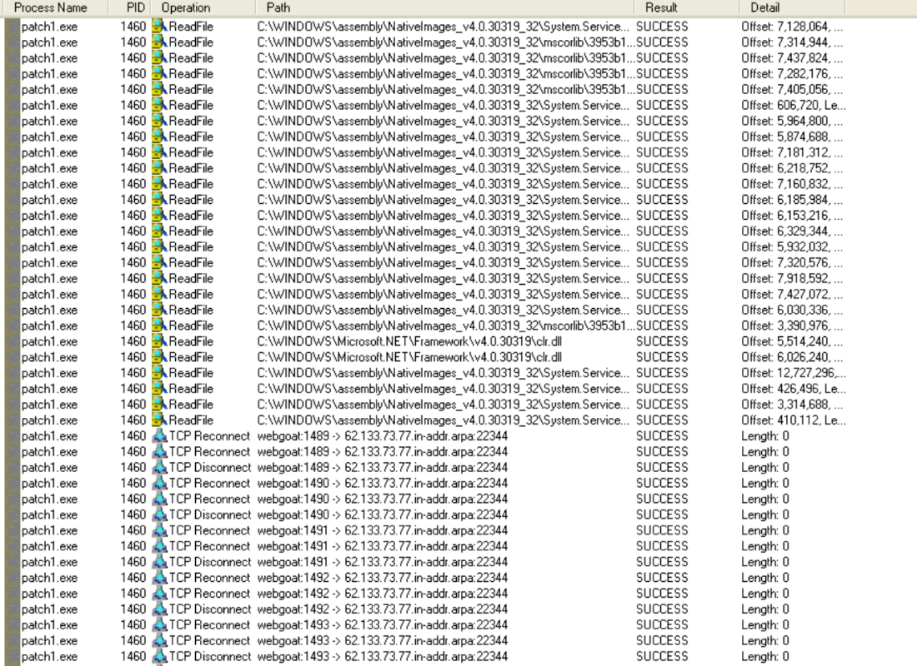

Figure 4.4.2.10. Activities of patch1.exe monitored by Process Monitor.

From ApateDNS, tcpdump, and netcat port listeners, the network connections of this patch were the same as the actual malware itself, showing the same IP addresses 77.73.133.62 and 192.168.96.129.

For Process Explorer, no changes were found in the strings of the patch in memory, and no new processes were found to be running. In Regshot, there was nothing significant being changed in the registry keys, only the executable’s information being updated in the Windows MUICache like the original malware. After thoroughly analysing Process Monitor for any new activity by the malware, such as new ReadFile or CreateFile functions, there seemed to be no difference in the original malware and the new patch.

Overall, reverse engineering was attempted, but there was no new information that could be found. There are most likely more defence mechanisms in the code, but due to the lack of time and the complexity of the malware, it will not be continued.

Since the malware could not be fully analysed due to its defences, Automated Malware Analysis can be performed outside of the virtual machines to analyse the malware’s actual functions.

### 4.4.3. Automated Malware Analysis

Automated Malware Analysis is a malware analysis technique that uses sandboxes, which are virtual environments that dynamically analyse a malware’s functionalities automatically. There are websites online that provide such sandboxes which will give detailed reports on the malware’s activity.

Since it was not possible to analyse all the malware’s functions using the team’s own setup, the results of the malware analysis from the sandboxes will be compared with the VirusTotal report and the findings in this report. By cross-referencing the results, more information about the malware can be obtained, and hence a clearer picture of the malware’s functionality can be achieved.

In the VirusTotal report for the malware, under the Community section, there are links to various reports from automated malware analysis tools that were used to analyse the malware. These reports were automatically generated when scanning the malware using VirusTotal, and will be referred to for this report.

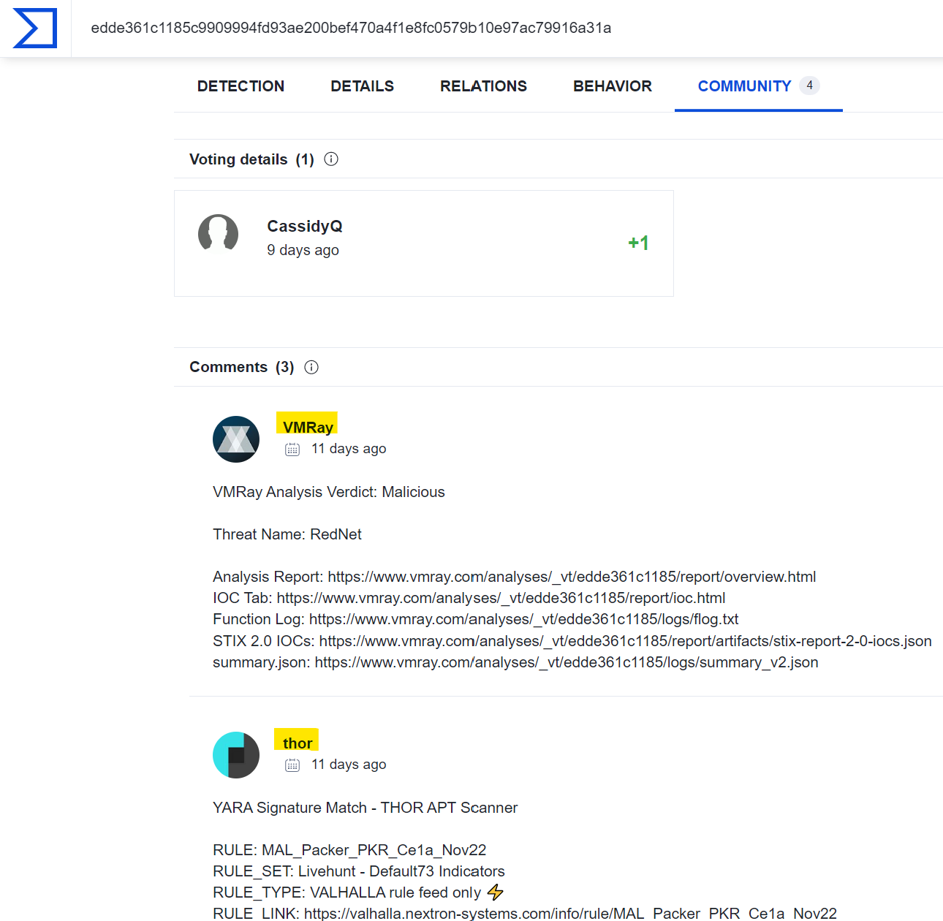

Figure 4.4.3.1. VirusTotal community section.

#### 4.4.3.1. JoeSandbox

One of the automated malware sandboxes that scanned the malware was JoeSandbox. The malware was run in a sandbox and automatically analysed inside of it. Its report on the malware can be read from the following link:

<https://www.joesandbox.com/analysis/782572/0/html>

### 

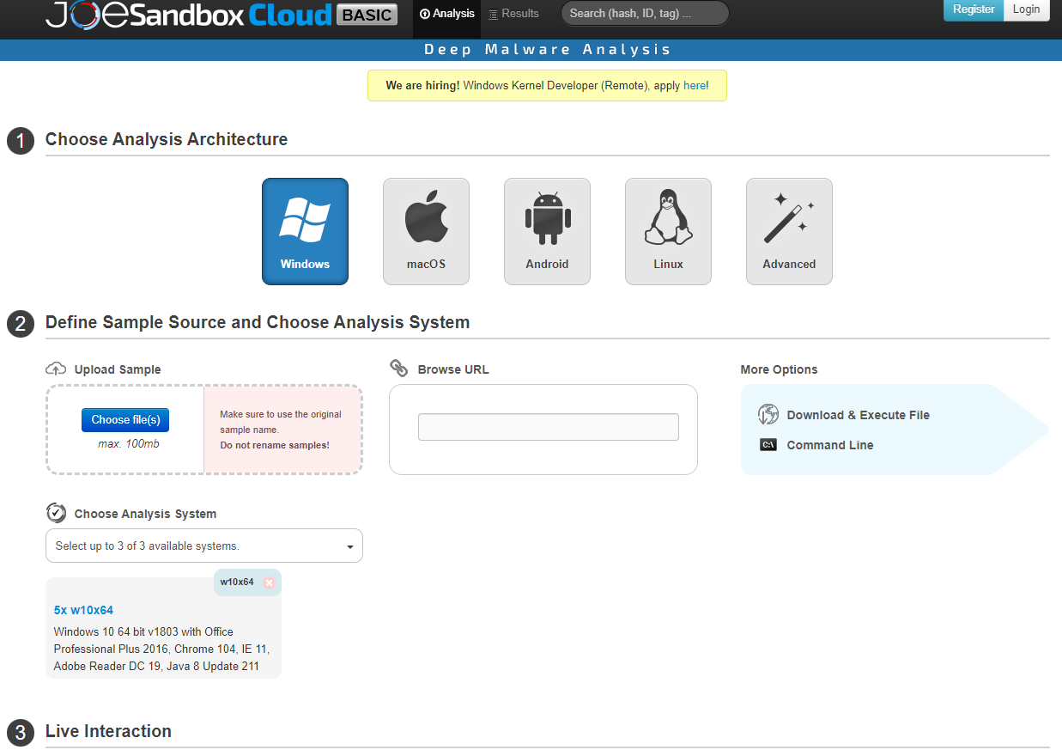  
Figure 4.4.3.2. JoeSandboxCloudBasic: Website Interface

JoeSandboxCloudBasic, or JoeSandbox for short, is an online malware analysis platform that allows users to upload malware samples and choose analysis architecture like the operating system to perform malware analysis. It also allows users to search for malware using the malware fingerprint to see if the malware has been analysed before.

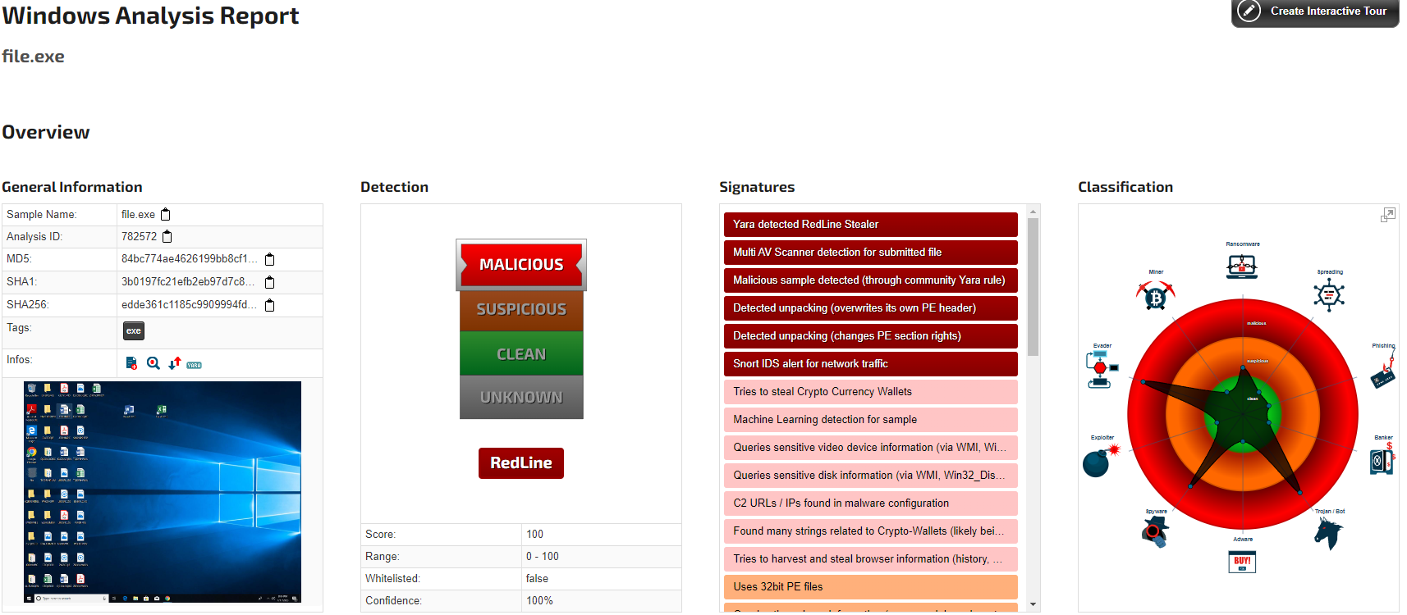  
Figure 4.4.3.3. JoeSandBoxCloudBasic: Sample Report

Once the malware analysis is done, a report will be generated. The report will host all the information on the malware. There will also be classification done, together with all the malware signatures. It will also have a detection portion which scores the malware and gives a confidence percentage. The higher the confidence level, the more likely the analysis is accurate.

From the front page of the JoeSandbox report, there is an overview of the malware analysis, such as whether it was considered malicious or not, and what type of malware it was classified as, e.g, trojan, ransomware, etc. In the Signatures section of the overview, the first signature mentioned was that the malware was a RedLine Stealer. The RedLine Stealer malware can harvest the user’s system details, browser information such as saved credentials, and even cryptocurrency (Malpedia, n.d.). This information corresponds to the VirusTotal report, where it was also classified as a RedLine stealer under the crowdsourced IDS section (refer to Figure 4.1.2.1.2). Hence, this malware can be confidently classified as a variant of the RedLine Stealer malware.

Looking further into the report, Snort Signatures were detected by the malware. Snort is an IDS which monitors network traffic and uses a series of rules that help define malicious network activity (Snort, n.d.). It discovered only 1 IP address, which was 77.73.133.62, and no other IP addresses were discovered.

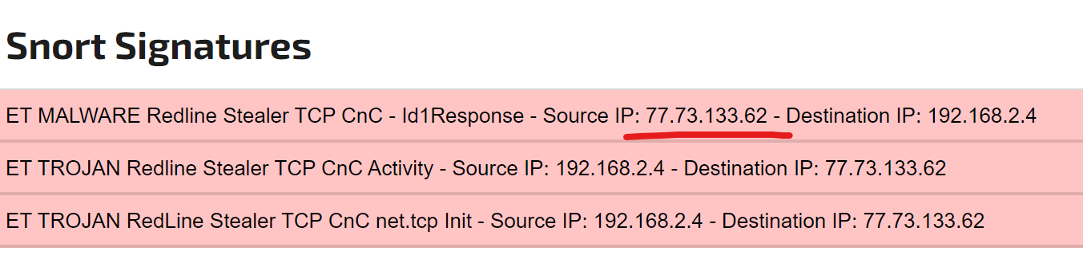

Figure 4.4.3.4. Snort Signatures in JoeSandbox showing malicious network activity.

In VirusTotal’s contacted IP addresses and during Basic Dynamic Analysis (Refer to Figure 4.2.1.1), this IP address 77.73.133.62 was also found. However, in VirusTotal, there was another IP address 23.216.147.76 contacted via port 443 which was not detected by JoeSandbox or Basic Dynamic Analysis. This IP address had a very low detection rate and was not detected by JoeSandbox as malicious, so it might have bypassed JoeSandbox’s detection systems but not VirusTotal which might have different network monitoring systems.

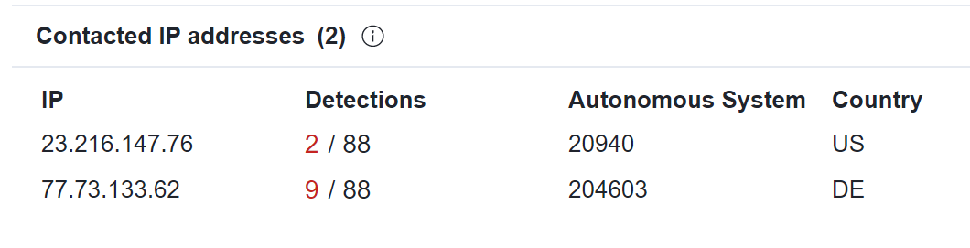

Figure 4.4.3.5. VirusTotal’s list of contacted IP addresses.

In the report, the Signatures section contains all the different signatures of the malware, which is essentially the malware’s different functionalities. Under the **System Summary** section, the general features of the malware executable file were listed.

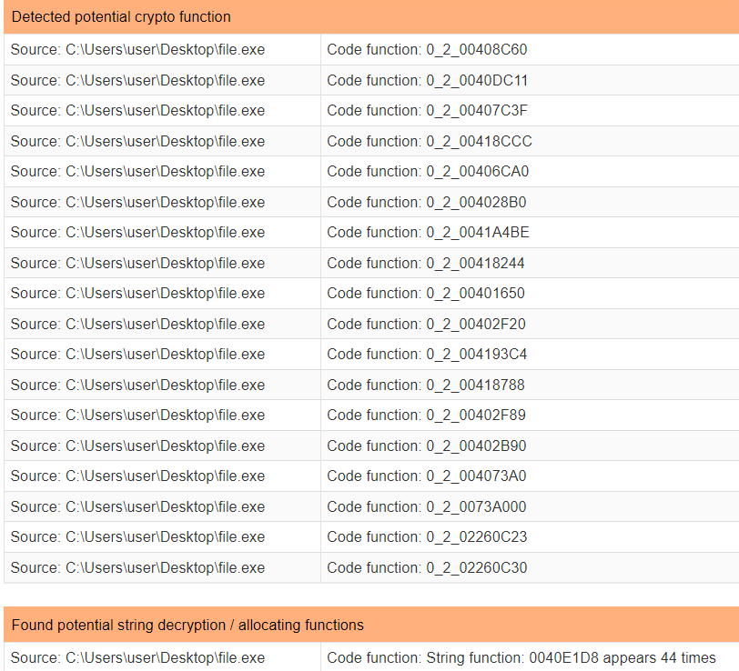

Figure 4.4.3.6. Detected potential crypto functions in the malware by JoeSandbox.

There were detected potential crypto and string decryption functions, which might have something to do with stealing crypto-related data.

It was also found that the malware sample was different from the original file name in the version information, where it was originally “Richens.exe”.

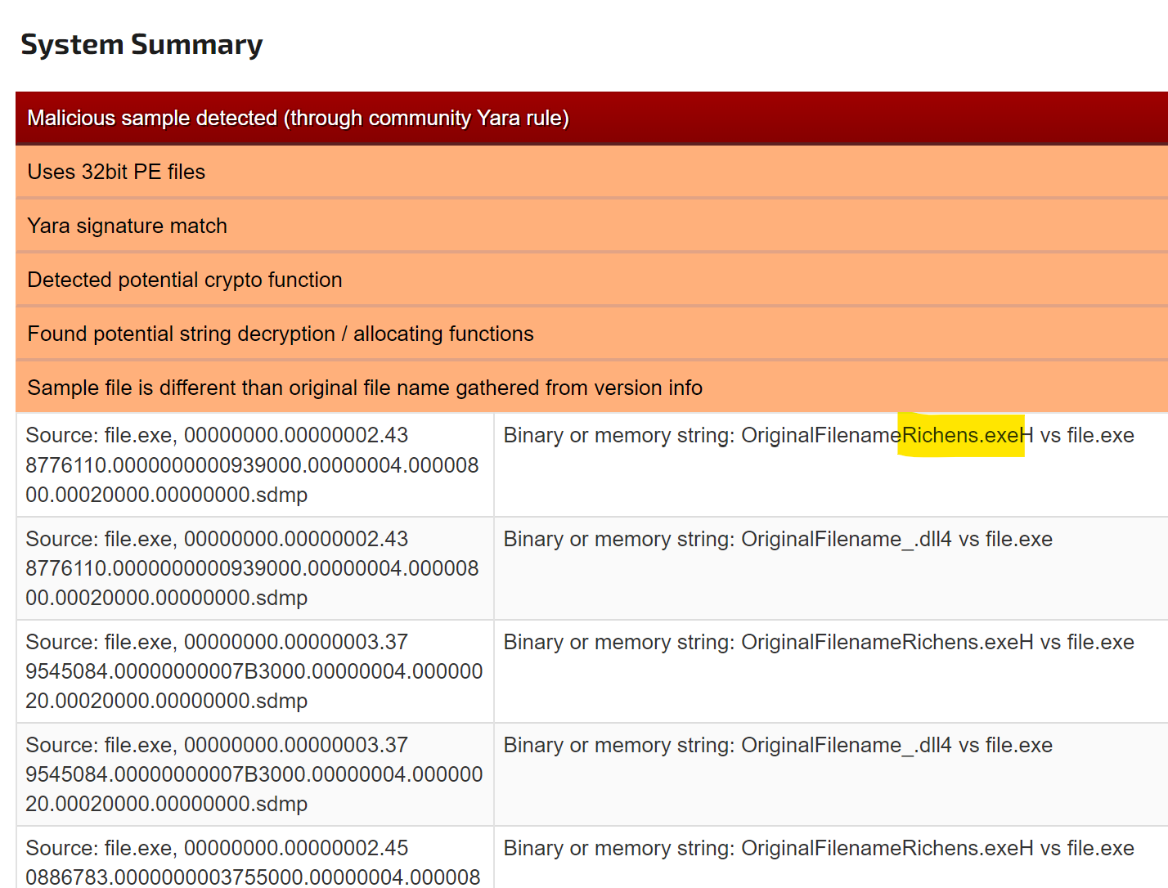

Figure 4.4.3.7. JoeSandbox detected a different original file name from the sample file name.

In Basic Dynamic Analysis, it was also observed that in Process Explorer, there was a string named “Richens.exe” in the memory of the malware, which was assumed to be the original file name of the malware (refer to Figure 4.2.2.1). This analysis in JoeSandbox also agrees with that theory and can show that the malware’s original name was Richens.exe.

The malware contained signatures for **Data Obfuscation**. The point of data obfuscation in malware is to purposely hide or conceal information in order to make analysis of the malware a lot harder to perform, as the analyst would need to go through several steps to de-obfuscate the malware in order to make sense of the information.

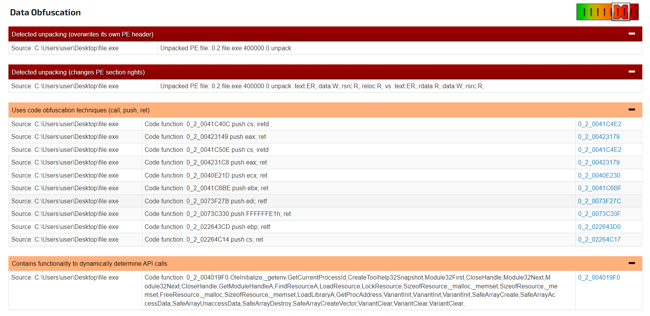

Figure 4.4.3.8. JoeSandbox detecting Data Obfuscation techniques used by the malware.

In the two most malicious signatures detected by JoeSandbox, indicated by the red colour, the malware was detected to be unpacking itself, which led to changes in its PE information that would make static analysis harder. This did not coincide with the Basic Static Analysis of the malware, as it was determined that the malware was unpacked (refer to Section 4.1.3) in the report. This malware was more complex than initially thought and managed to fool some techniques for packing detection.

There were also other code obfuscation techniques relating to the assembly code of the malware, where many call, push, and return functions were observed during the Advanced Dynamic Analysis of the malware. Functionality to dynamically determine API calls was also shown with the many cmp and conditional jump operations in the Advanced Dynamic Analysis.

As identified from the malware’s defensive mechanisms, it also contained signatures for **Malware Analysis System Evasion**. There were several methods that the malware used to evade dynamic analysis. The first was to use Windows Management Instrumentation (WMI) queries to obtain the system information. WMI is the infrastructure for management data and operations on Windows-based operating systems (Microsoft, 2021). These queries were to obtain system information and detect if it was a virtual machine or not.

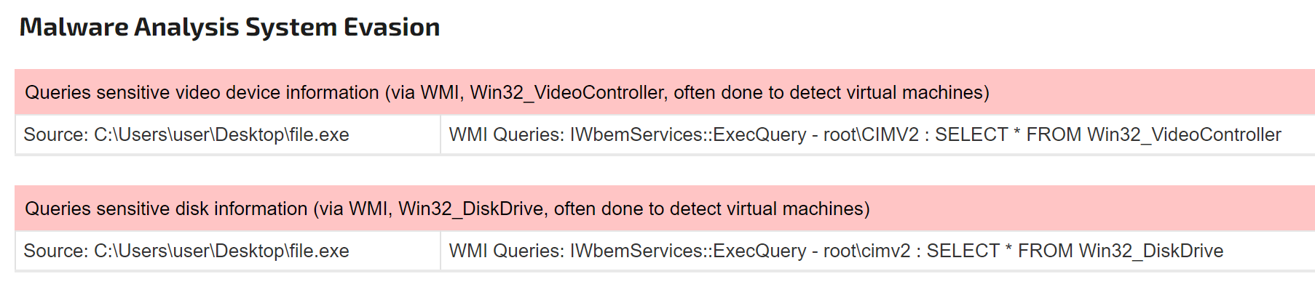

Figure 4.4.3.9. JoeSandbox detecting the malware’s analysis evasion techniques.

The malware also evaded analysis by sleeping, which coincides with the **Sleep** functions that were identified in the Advanced Static and Dynamic Analysis (refer to Figure 4.3.7) and were removed from the assembly using reverse engineering. It also checked for the process IDs of the system, which was most likely to check if dynamic analysis tools like Process Explorer were running.

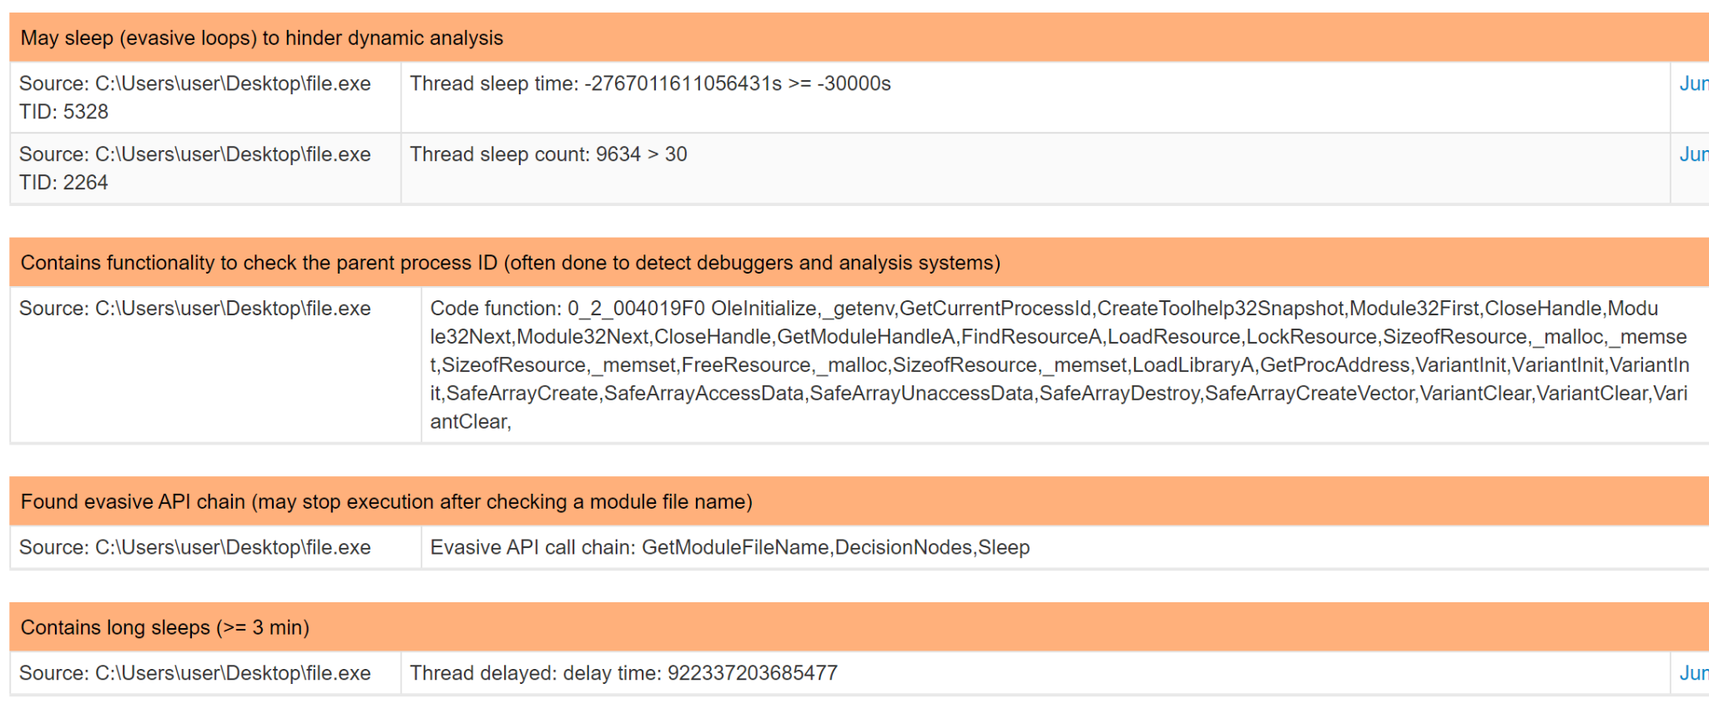

Figure 4.4.3.10. JoeSandbox detected the malware’s sleep functions that hinder dynamic analysis.

The malware was also observing the Window and User API management in the virtual machine, which might have detected user behaviour. This might explain why the malware had the Nokia USB Tool popup after about an hour of idle activity on the virtual machine (refer to Figure 4.2.2.6).

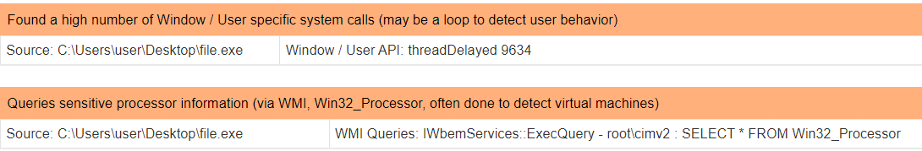

Figure 4.4.3.11. JoeSandbox detecting the malware’s techniques to identify user behaviour.

The malware contained signatures for Anti-Debugging, which was to prevent the analyst from debugging the malware code.

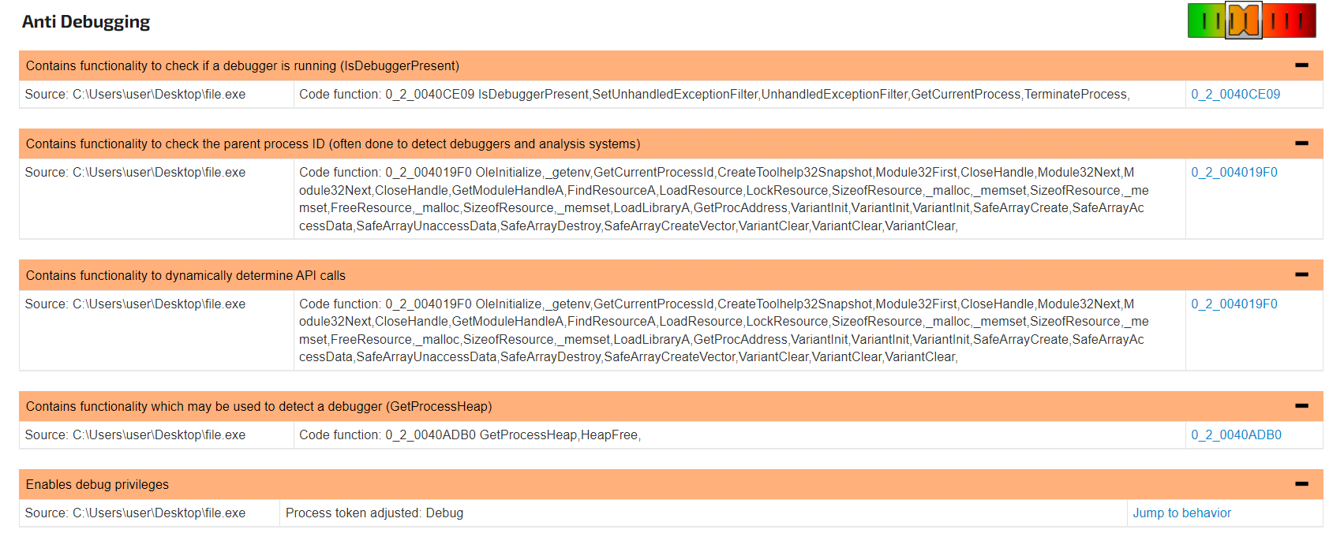

Figure 4.4.3.12. JoeSandbox detecting techniques used by the malware to prevent debugging.

Several functions such as **IsDebuggerPresent** were found during Advanced Static Analysis (refer to Figure 4.3.6), where they were removed in Advanced Dynamic Analysis (refer to Section 4.4.1). There were many more processes that were detecting for debuggers, as seen from the second and third signatures in the image above. Many functions such as **GetCurrentProcessId** and **GetProcessHeap** were used to prevent debugging.

Since the malware was detected as a RedLine Stealer, it contained signatures for the **Stealing of Sensitive Information**. It managed to steal various types of information on the host machine, such as crypto-currency wallets and user credentials.

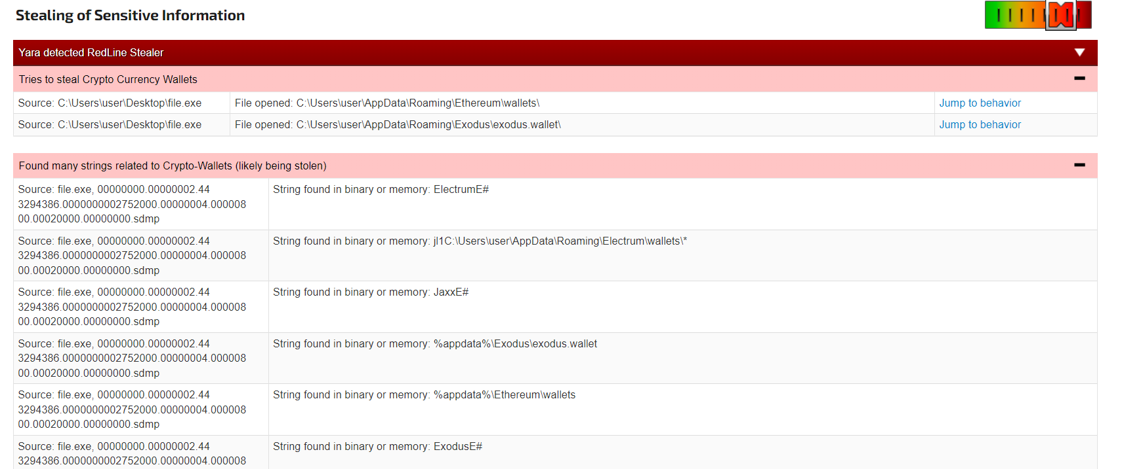

Figure 4.4.3.13. JoeSandbox showing malware stealing crypto-currency from the user.

For the stealing of crypto-currency wallets, these functionalities were not detected during Basic Dynamic Analysis. This might be because the defence mechanisms in the malware prevented these from occurring. Another reason might be because the virtual machine did not contain any directories for any crypto-currency wallets, such as Ethereum or Exodus, so the strings in the malware did not show these indicators of compromise.

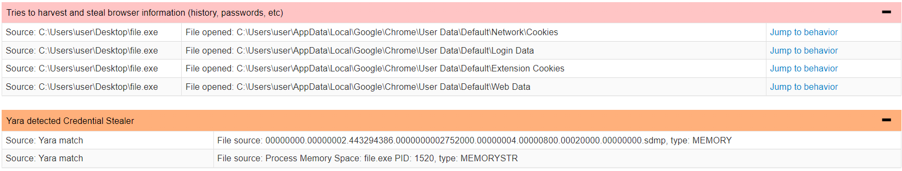

Figure 4.4.3.14. JoeSandbox shows the malware stealing browser information.

The malware also tried to access the user’s data in Google Chrome, which included the cookies, login data, and web data of the user. Again, these indicators were not shown in any analysis tools during Basic Dynamic Analysis.

It is hard to know if the malware would be able to steal information from any other browser such as Firefox. The virtual machine used for Basic Dynamic Analysis contained both Firefox and Internet Explorer, but Process Monitor did not show any indication of the malware accessing any browser information. This could be either because of the defensive mechanisms in the malware or the fact that certain browsers were not included in the code, so it is difficult to arrive at a conclusion from the information given.

Moving on from the signatures, JoeSandbox detected files created and dropped into the system by the malware. From its analysis, only one file was dropped into the system, which it detected as malicious. This might indicate that the malware is a trojan.

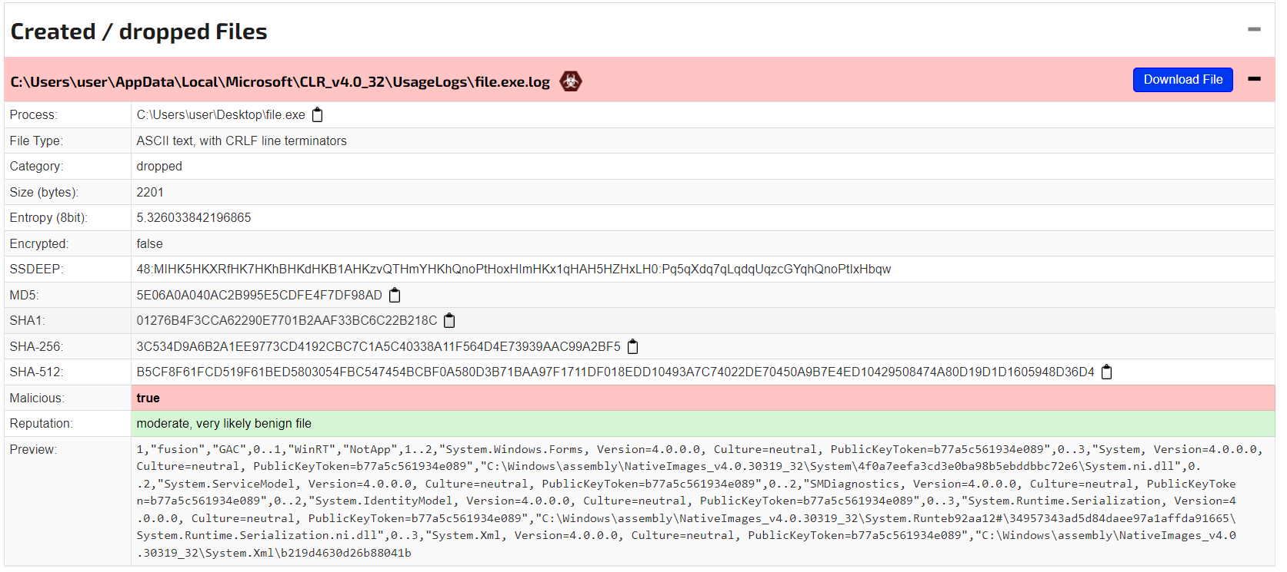

Figure 4.4.3.15. JoeSandbox detecting a file dropped into the system by the malware.

This was a .log file that was dropped into Microsoft’s usage logs, which might indicate that the malware was trying to hide this file. By dropping it somewhere that is not commonly checked by users and filled with many other log files, it is very discrete and hard to find for non-malware analysts. By performing this action, the malware obtains persistence in the system.

Looking at the hash values of the dropped file, none of them match with the original malware executable’s hashes, so this .log file is not an exact copy of the original malware file. Hence this new file might have different functionalities from the original file.

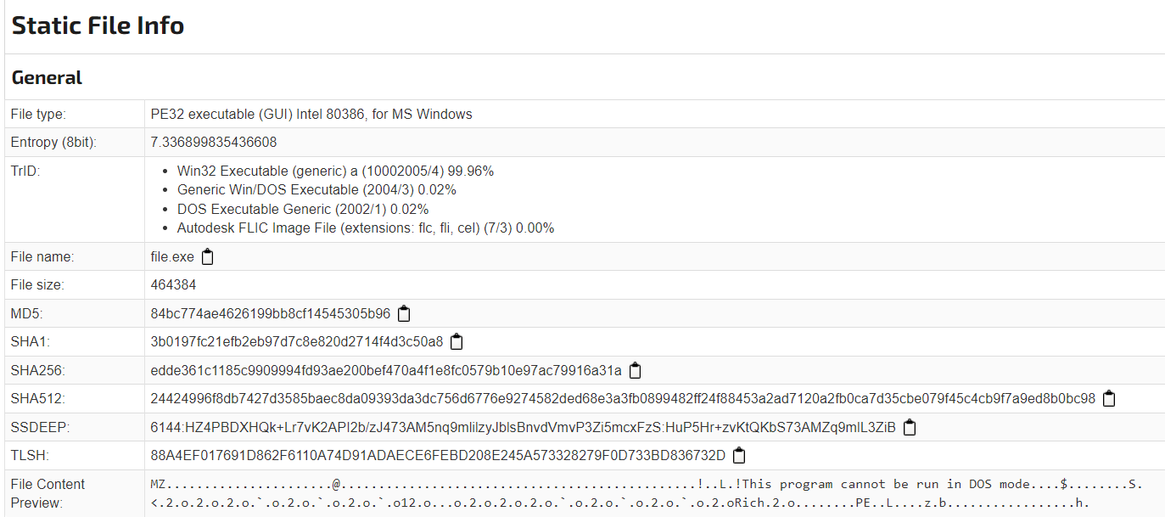

Figure 4.4.3.16. Hash values of the original malware provided by JoeSandbox.

An analysis of the dropped file can be done, as JoeSandbox provides a download link to the file. The file will be transferred to a clean state of the Windows XP virtual machine, where it would be analysed using the same tools used to analyse the malware.

To download the file, an account must be created and registered with JoeSandbox, and the user needs to be part of a corporate business. Unfortunately, since none of the team members doing this project were part of an actual corporate business, a JoeSandbox account could not be created, and hence the file could not be analysed.

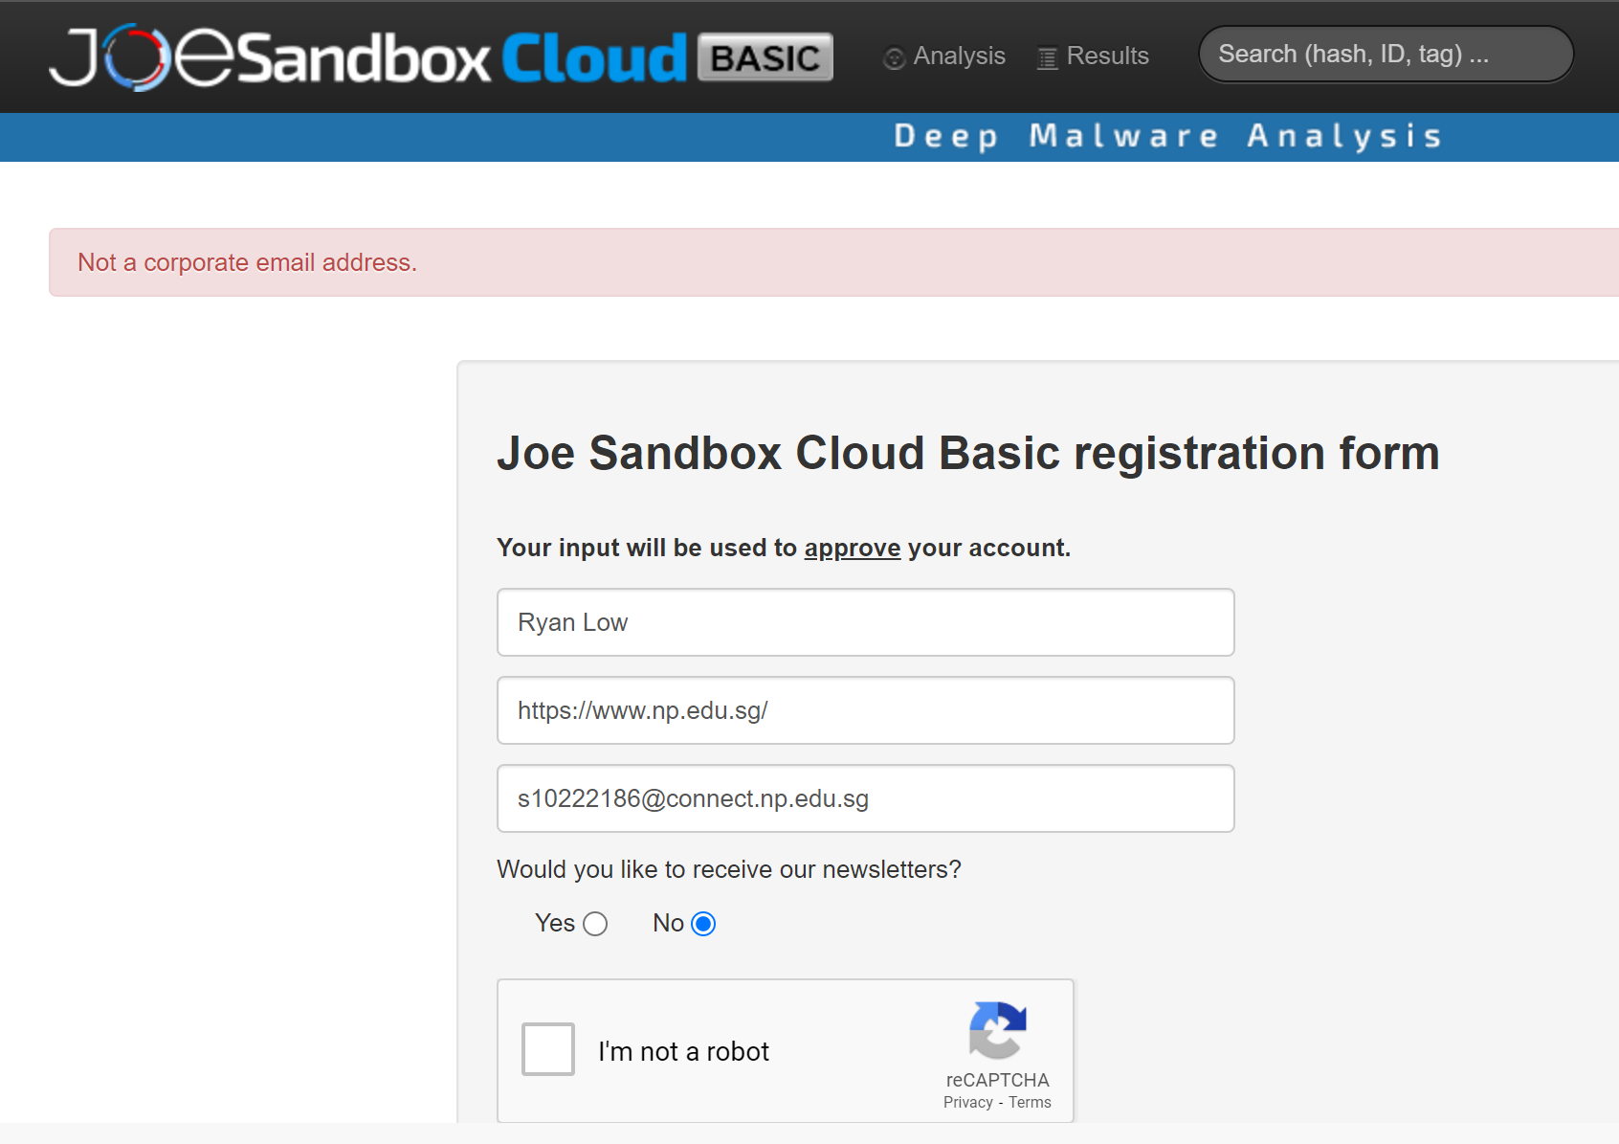

Figure 4.4.3.17. Unable to register account on JoeSandbox to analyse the dropped file.

In the JoeSandbox analysis, it also showed that a folder was created in the Microsoft folder alongside the log file.

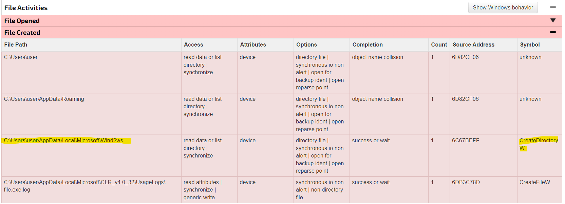Figure 4.4.3.18. JoeSandbox showing files created by the malware.

This might have been a folder to store more dropped files by the malware, but no other files were detected. It looks suspiciously like a fake Windows folder, replacing the “o” to possibly a strange character that was not rendered properly in JoeSandbox. In any case, this folder should still be taken note of.

JoeSandbox provides a lot more information on the malware’s functionalities and goes into detail about its activities in the system, such as listing all the registry keys opened, memory activities, and more. However, those will not be covered in this report, as the more important features of the malware were already covered in the Signatures section of the JoeSandbox analysis report. The Signatures already give more than enough information to obtain a definitive conclusion on what the malware does.

## 4.5. General Analysis

In summary, the malware executable that was analysed in this report, named “edde361c1185c9909994fd93ae200bef470a4f1e8fc0579b10e97ac79916a31a.exe”, is a variant of the infamous RedLine Stealer malware, which was designed to steal information from a system, including user credentials, browser data, crypto-currency information, and more. The malware tries to connect to one or two IP addresses, which is most likely to send the stolen information to those addresses. It contains many defensive mechanisms to evade malware analysis techniques, and disguises itself as a Nokia USB Tool to sound like a legitimate application to users to reduce suspicion. The malware is likely a trojan as well, as it was found to drop a malicious file into “C:\Users\user\AppData\Local\Microsoft\CLR_v4.0_32\UsageLogs”, which is the directory that stores logs used by Microsoft. Overall, this malware is very harmful to a system and should not be run on any computer.

## 4.6. Malware Removal

This malware should not be run on any system, as it is able to steal a lot of information on the computer which can be used for malicious purposes. The best way to prevent this malware from ever infecting a computer is to never let it get into the system in the first place. This is what anti-malware or antivirus softwares are designed for, which is to protect the computer against any malicious files or software and remove them automatically. In Windows systems, there is already built-in antivirus software that is automatically enabled, which can be found by searching for “Virus and threat protection” in the search bar.

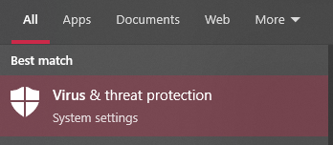

Figure 4.6.1. Virus & threat protection system setting in Windows.

In the case that the antivirus is not already enabled, it is highly recommended to turn on “Real-time protection”, which is the most important setting to protect the system as it automatically scans for malware in real-time and will act when malware is detected.

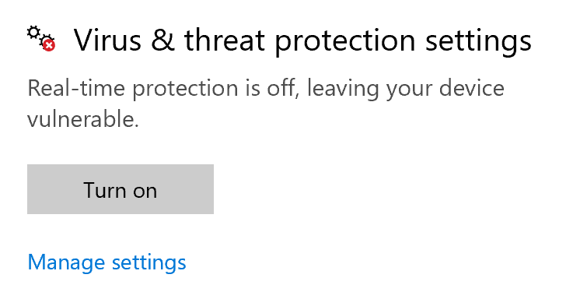

Figure 4.6.2 Real-time protection setting turned off in Windows.

For users who do not think that the Windows antivirus software is enough protection, they can choose to opt for external antivirus software made by other companies. This can work well or sometimes even better than the Windows antivirus, as some products can contain extra features to enhance the security or performance of the system. A list of the few most trusted antivirus software by the public are the following:

* AVG
* Avast
* Bitdefender
* McAfee
* Malwarebytes
* Norton

However, in the case that the malware is installed and run on the computer, there is a way to remove this malware with the steps as shown below.

1. Run Task Manager/Process Explorer and terminate the malware process immediately.
2. Delete the malware executable file from the system.
3. Open the malware’s information registry key “HKU\{SID}\Software\Microsoft\Windows\ShellNoRoam\MUICache\C:\Documents and Settings\User\Desktop\malware.exe” using a registry editor and delete it.
4. Find the malicious log file stored in Microsoft’s logs folder “C:\Users\user\AppData\Local\Microsoft\CLR_v4.0_32\UsageLogs\malware.exe.log” and delete it.
5. Find the fake Windows folder “C:\Users\user\AppData\Local\Microsoft\Wind?ws” and delete it.
6. Remember to delete the removed files in the Recycle Bin.

After these steps, an antivirus scan on the whole computer is recommended in order to fully get rid of any other malicious software on the system.

# Analysis of Malicious Document

The other type of malware that was analysed was a malicious document. Malicious documents often come in PDFs or Microsoft documents as malicious scripts or macros can be stored in the documents to be executed on the victim’s computer. These malicious documents also employ social engineering tactics to trick the victims into executing the malicious code for if the victims do not execute the code themselves, the malware would be ineffective.

The malicious document’s details were as follows:

|  |  |
| --- | --- |
| **File Name** | efe51c2453821310c7a34dca3054021d0f6d453b7133c381d75e3140901efd12 |
| **File Type** | Unknown |
| **MD5 Hash** | 4dbe9dbfb53438d9ce410535355cd973 |
| **Download Link** | https://github.com/InQuest/malware-samples/blob/master/2019-04-TeamViewer/efe51c2453821310c7a34dca3054021d0f6d453b7133c381d75e3140901efd12 |

The malicious document did not come with a file extension, so further analysis was needed to reveal the file type.

## Basic Static Analysis

Static analysis is an important first step in analysing malware. It allows us to learn more about the malware without executing it. By analysing the metadata and string contents of the malicious file, we can make educated assumptions on the functionalities and features of the malware. With static analysis, we would be better prepared to run and have a more comprehensive analysis of the malware, as compared to running the malware blind. Hence, performing static analysis is a pivotal step in being able to analyse malware well.

### VirusTotal

VirusTotal is an online virus scanner. It allows a user to submit a suspicious file to the website, where the file will undergo analysis. VirusTotal makes use of many Anti-Virus scanners to end up with a reliable conclusion to whether the file is dangerous or not. Furthermore, VirusTotal provides informative details about the file and its metadata, such as the hash values, file type, and whether the file is packed.

As seen from Figure 5.1.1.1, below, 44 out of 65 scanners used by VirusTotal flagged the file as malicious. The scanners also seemed to agree that the file was a trojan and a dropper/downloader.

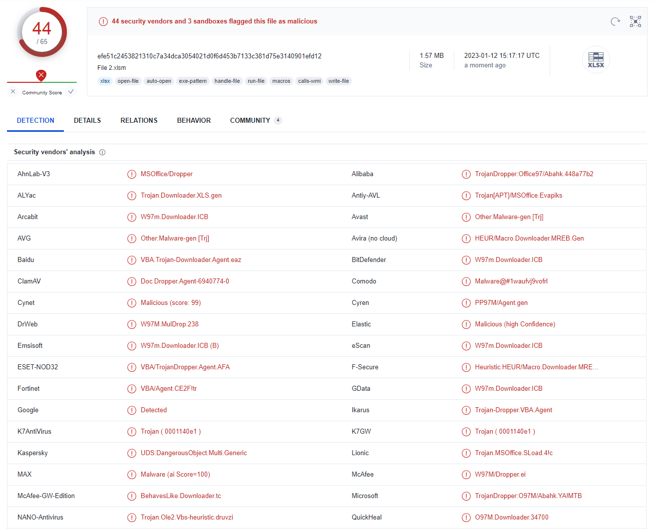

Figure 5.1.1.1. VirusTotal DETECTION tab

VirusTotal also calculated the hash values of the file using different hash functions. More importantly, it identified the unknown file type to be Office Open XML Spreadsheet (.xlsm). With this information, the malicious file was renamed to Malware.xlsm so that the file can be opened with Microsoft Excel.

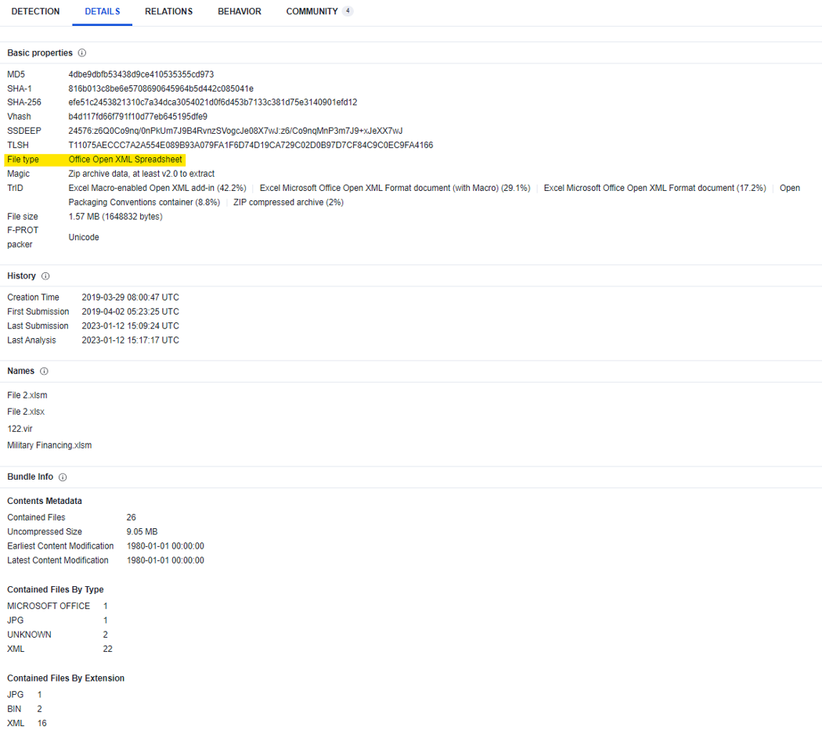

Figure 5.1.1.2. VirusTotal DETAILS tab

Under the Relation tab, VirusTotal identified some of the functions of the document. It can be seen that the document attempts to connect to an IP address 185.70.186.145 through the internet. It can also be seen that the document uses macros as there is a vbaProject.bin found, and that the document downloads files such as AutoHotkeyU32.ahk and AutoHotkey.exe. AutoHotkey is a free, open-source scripting language for Windows that allows users to easily create small to complex scripts for all kinds of tasks such as: form fillers, auto-clicking, macros, etc (AutoHotkey, n.d.). AutoHotkey.exe by itself is not a malicious program as it relies entirely on the script it runs. As such, it is highly likely that the .ahk file, which is the script that the AutoHotkey executable runs, is the file that contains the malicious code.

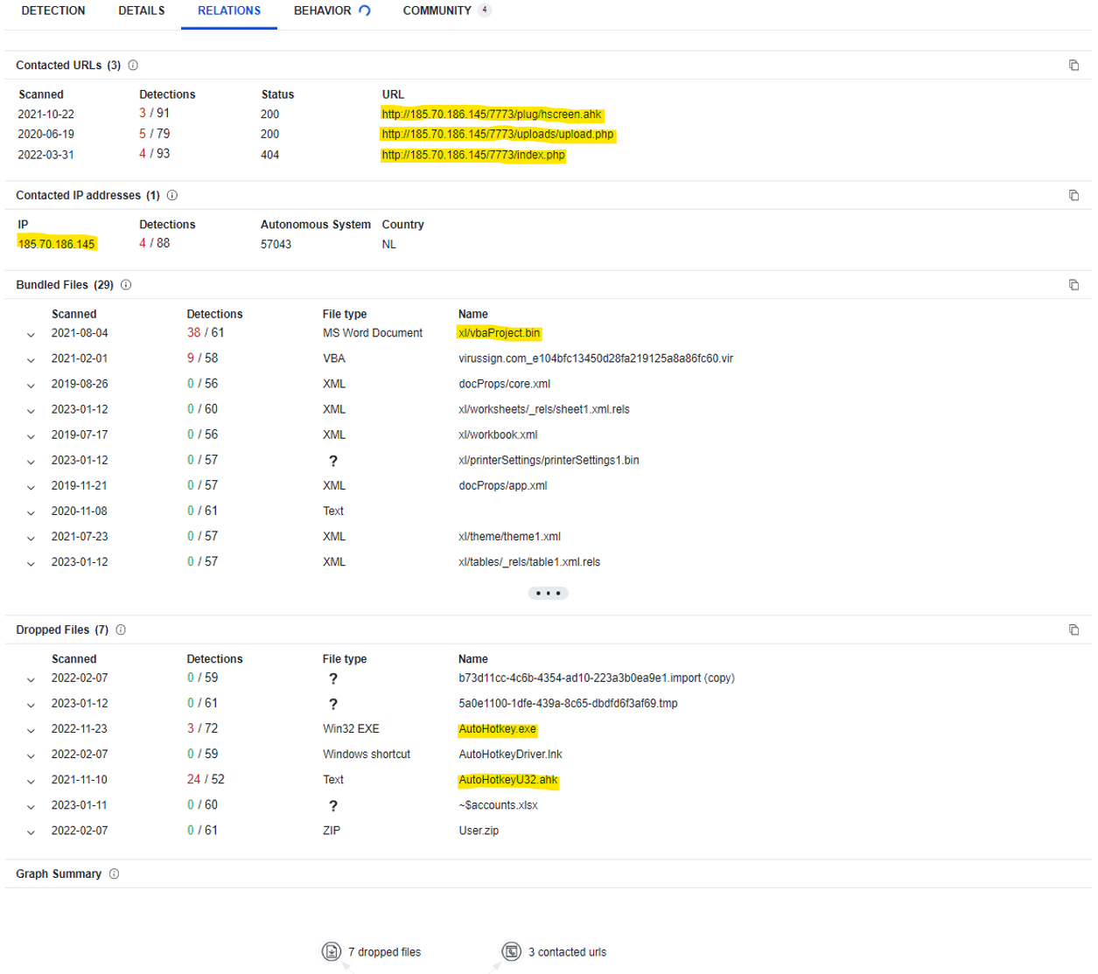

Figure 5.1.1.3. VirusTotal RELATIONS tab

Hence, VirusTotal provided us with a lot of useful information about the malicious document which allowed us to know what to look out for when analysing it.

### Malware Fingerprinting

Malware fingerprinting is an important step in analysing malware. It involves using hash functions to uniquely identify a piece of malware. If the malware were to be altered in even the slightest way, the resulting hash value would be different from the original. As such, malware fingerprinting ensures the integrity of the malware sample we are about to analyse. Furthermore, it is also useful as it allows us to share the fingerprint of the malware on the internet to allow others to easily identify and spread awareness about the malware.

WinMD5 was the tool used to generate the MD5 hash of Malware.xlsm. As seen from Figure 5.1.2.1, the generated MD5 hash value was identical to that seen from VirusTotal. This guaranteed that Malware.xlsm was authentic and its integrity was preserved.

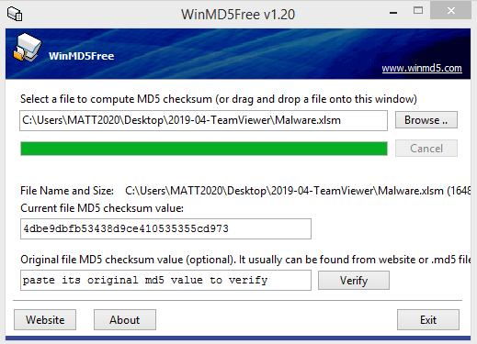

Figure 5.1.2.1. MD5 result

### Unpacking

Unpacking malicious documents is important as it allows us to discover the scripts and/or macros that exists within it.

The oleid command was first used on Malware.xlsm. This command was used to identify certain properties of Malware.xlsm. Firstly, it agreed with VirusTotal that the file was an .xlsm file. More importantly, it showed that the file contained VBA macros where the malicious code was highly likely to be.

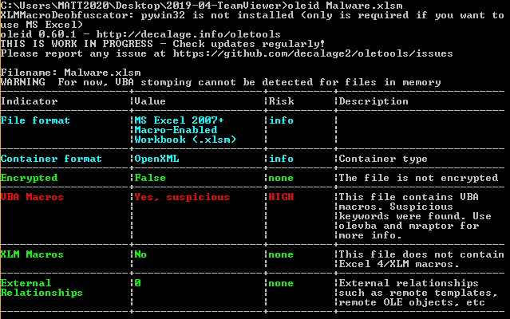

Figure 5.1.3.1. oleid Malware.xlsm result

Next, olevba was used to extract the VBA macro code, which can be seen from Figure 5.1.3.2. The code contained host-based indicators such as AutoHotkeyU32.exe and AutoHotkeyU32.ahk, both of which were previously seen from VirusTotal. After analysing the code, it was concluded that its purpose was to execute both AutoHotkeyU32.exe and AutoHotkeyU32.ahk as there was a Shell() function call at the end of the code, and the parameters supplied into the function call were the file paths of the .exe and .ahk files.

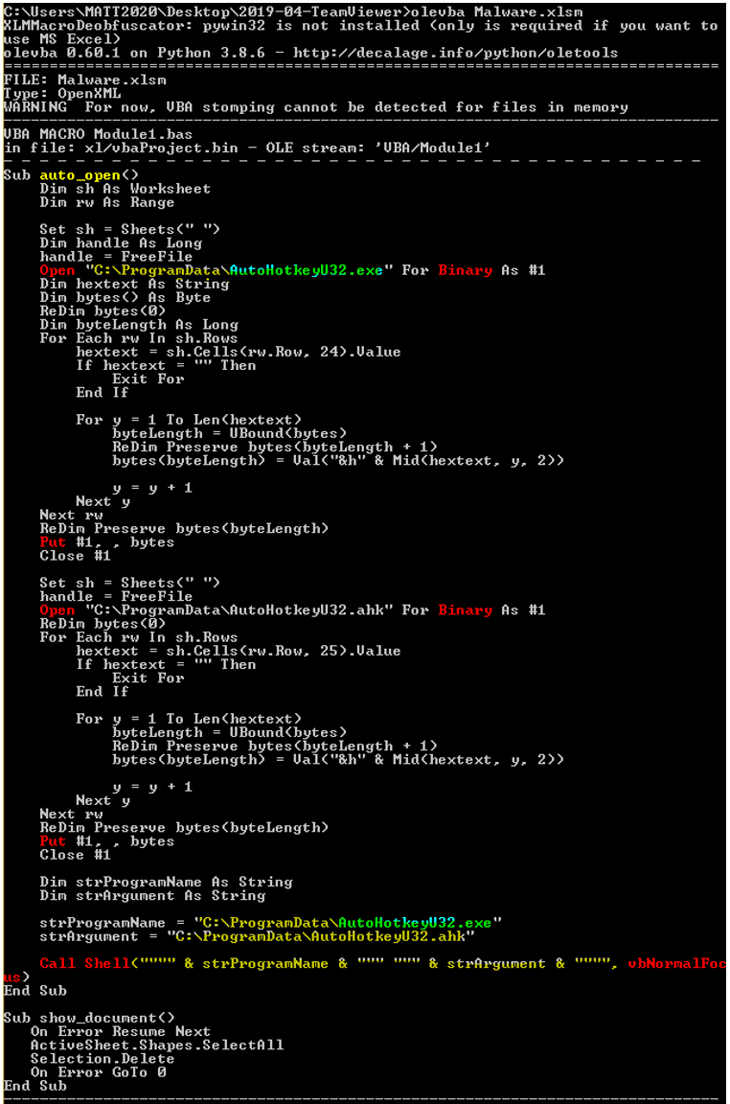

Figure 5.1.3.2. olevba Malware.xlsm result

OfficeMalScanner was another tool that was used to discover the VBA macro code.

Firstly, to identify the contents of Malware.xlsm, the command “OfficeMalScanner Malware.xlsm inflate” was used. It highlighted 2 files, vbaProject.bin and printerSettings1.bin. printerSettings1.bin was opened using Notepad as seen in Figure 5.1.3.4. It did not contain anything suspicious, so it was ignored.

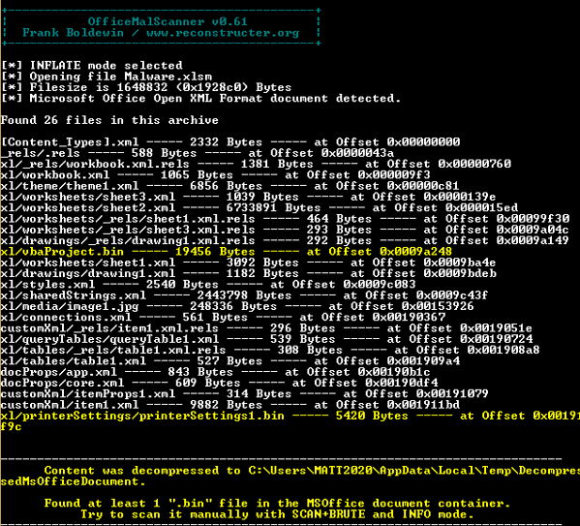

Figure 5.1.3.3. OfficeMalScanner Malware.xlsm inflate result

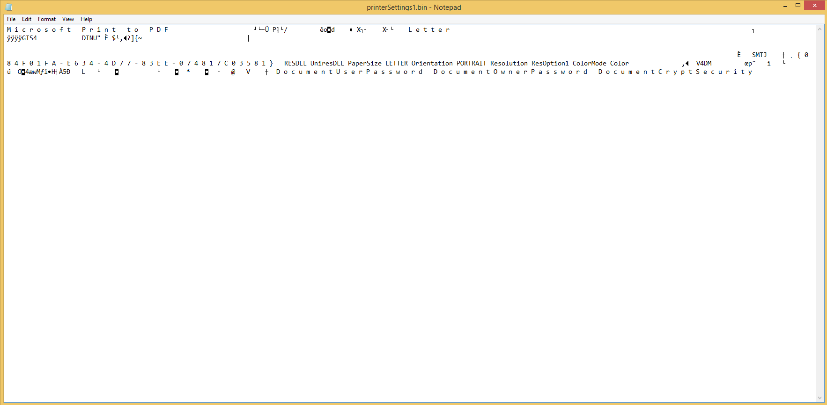

Figure 5.1.3.4. printerSettings1.bin file

Next, to extract the macros from vbaProject.bin, the command “OfficeMalScanner vbaProject.bin info” was used. It revealed 6 macros.

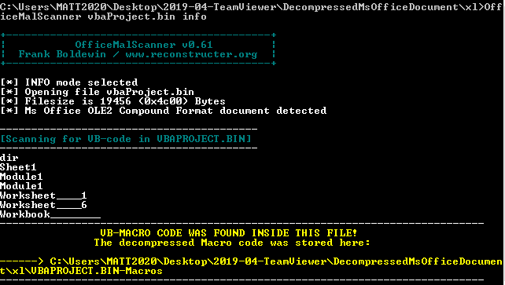

Figure 5.1.3.5. OfficeMalScanner vbaProject.bin info result

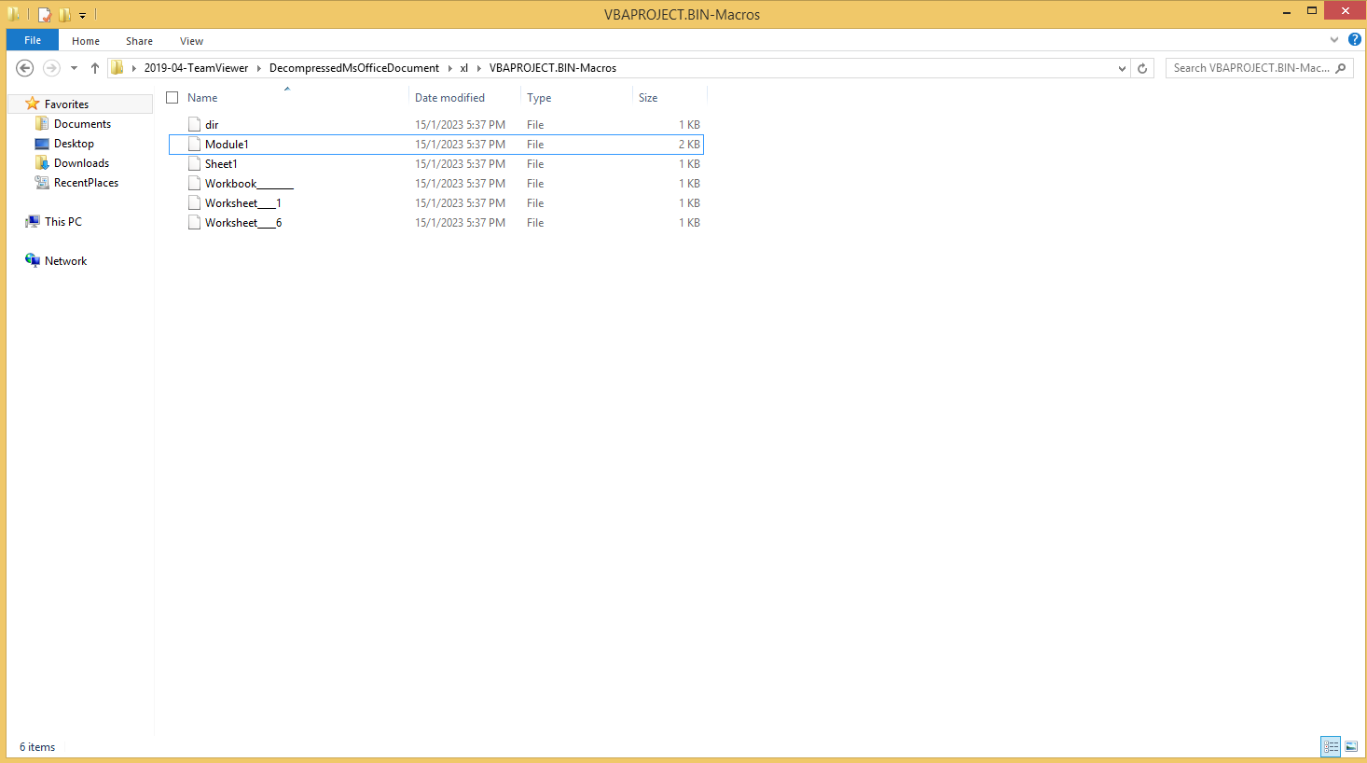

Figure 5.1.3.6. vbaProject.bin macros

After looking through each macro file, it was found that only Module1 contained code. The code was identical to that seen from when olevba was used.

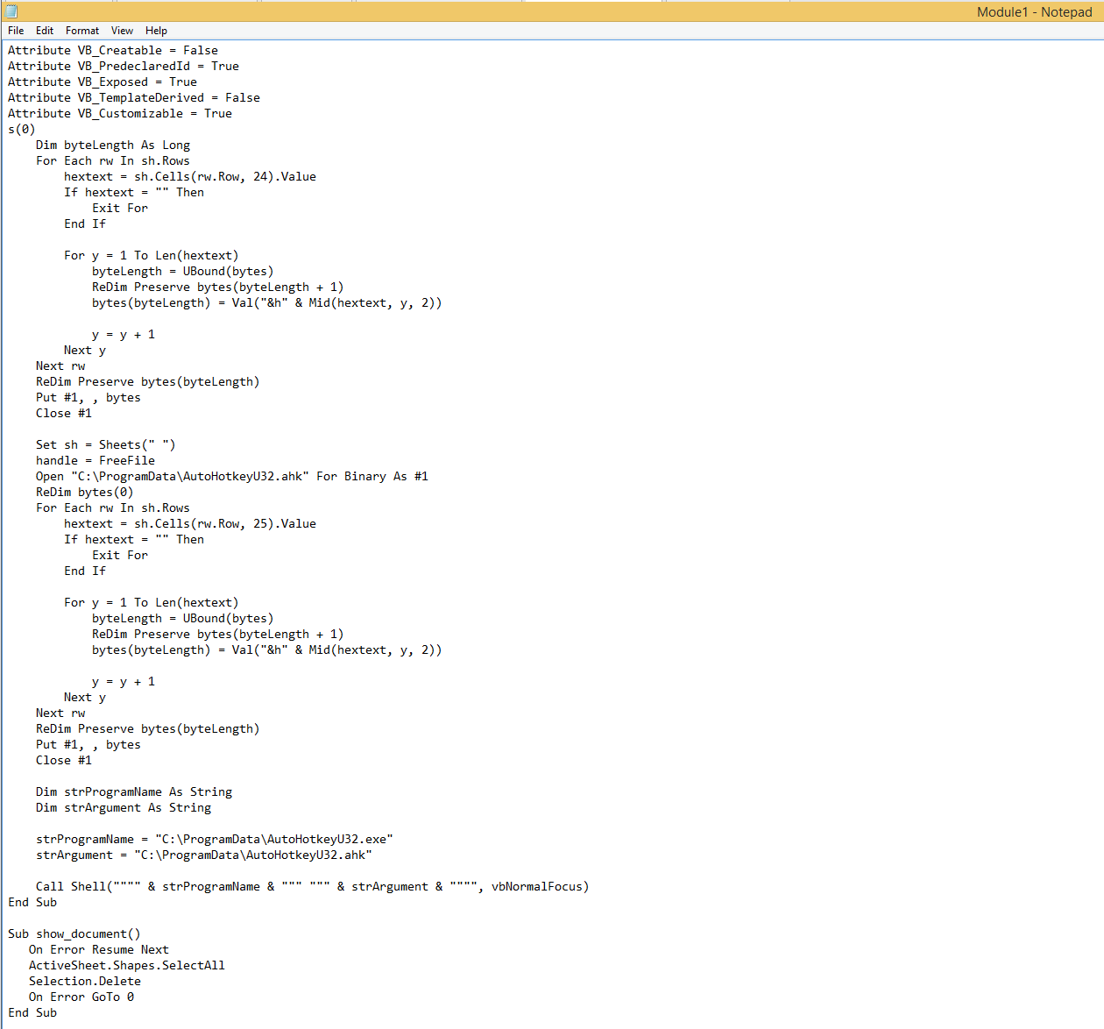

Figure 5.1.3.7. Module1 macro code

Hence, by unpacking Malware.xlsm, we were able to discover and analyse the macro code that was hidden within the malicious file. With the uncovered code, we were able to better understand the intentions of the malware.

### String Analysis

String analysis is another crucial step in analysing malware as it allows us to discover any important or suspicious strings that the malware may contain. These strings might then allow us to learn more about the malware.

BinText was used to perform string analysis on Malware.xlsm. BinText is a software that returns all the strings contained within a file or program. Figure 5.1.4.1 shows a portion of the strings from Malware.xlsm that BinText returned.

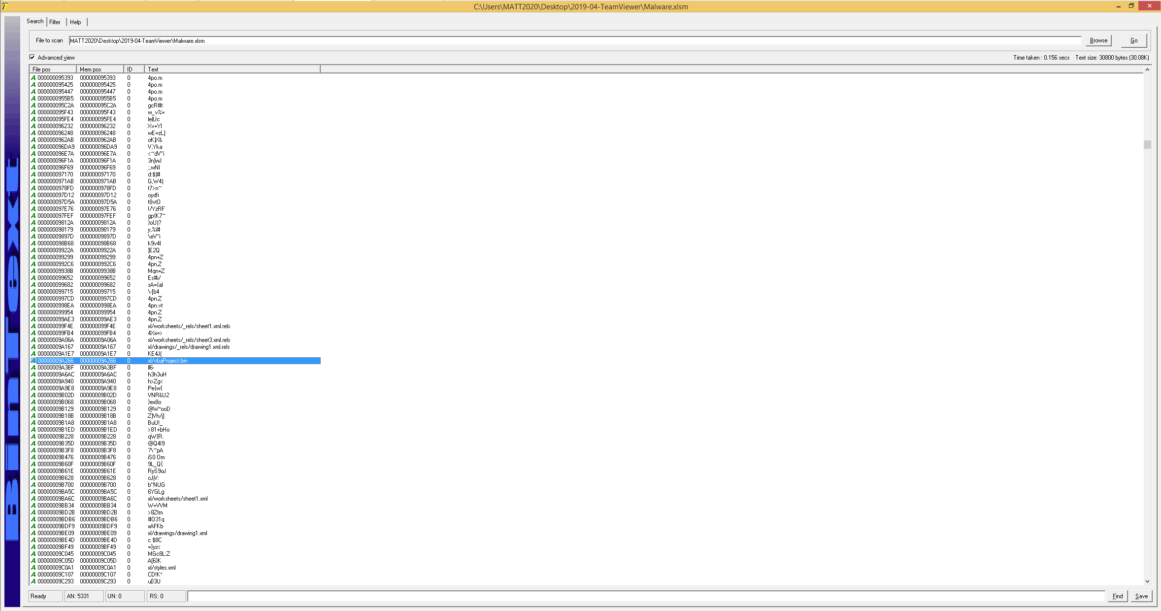

Figure 5.1.4.1. BinText of Malware.xlsm

After manually scanning through all the strings, there were no new suspicious strings that were found. However, important strings like xl/vbaProject.bin could still be seen. Hence, although no new information was gained about Malware.xlsm through string analysis, it allowed us to be more confident in our analysis used on Malware.xlsm thus far as we did not miss out on any crucial information.

### Summary of Basic Static Analysis

We were able to understand the main purpose of Malware.xlsm. We discovered that it contained a VBA macro called Module1 which contained the malicious code. The malicious code aimed to execute 2 files, AutoHotkeyU32.exe and AutoHotkeyU32.ahk. Hence, through basic static analysis, it was concluded that Malware.xlsm likely was a malware downloader.

## Basic Dynamic Analysis

Basic dynamic analysis is a core step in analysing malware after performing basic static analysis. Basic dynamic analysis is the process of understanding the functionalities of malware by running it and observing its behaviour. When malware is run, it often makes changes to the computer for various reasons such as allowing it to persist on the computer through registry changes, or creating new processes to run its malicious code in the computer’s background. All these behaviours can be observed using a variety of tools, with each tool having its own unique purpose.

### General Dynamic Analysis

Upon opening Malware.xlsm, a document is shown.

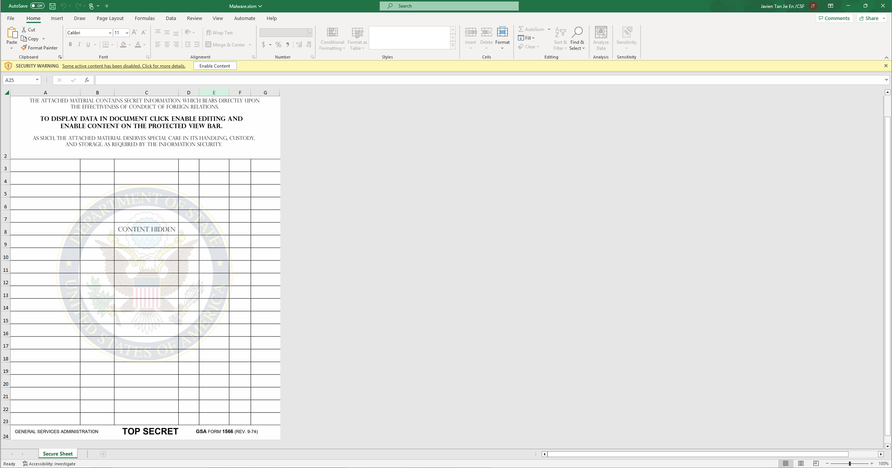

Figure 5.2.1.1. Malware.xlsm

The document claims that it contains secret information which bears directly upon the effectiveness of conduct of foreign relations for the United States of America, and the way to display the document’s data is to click on “Enable Content”. However, this document is fake and it is merely a jpg image.

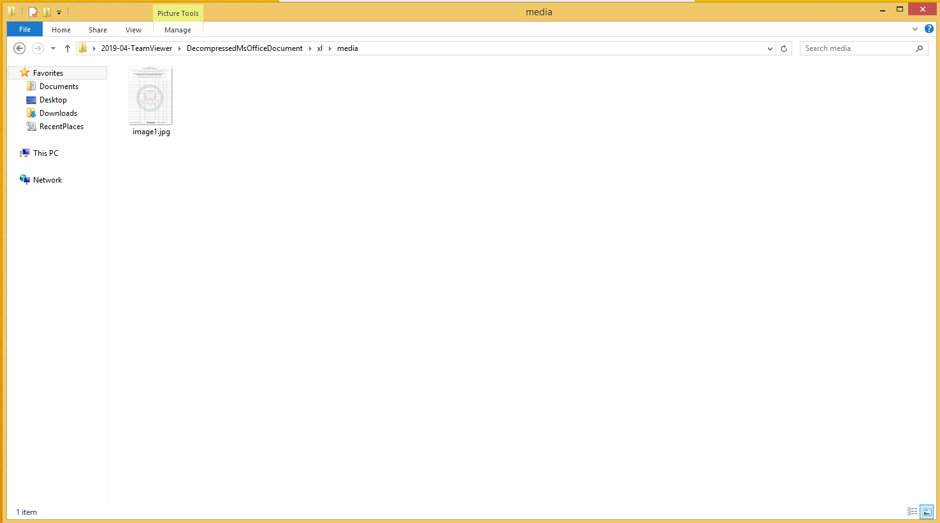

Figure 5.2.1.2. Image used in Malware.xlsm

This is the malware author’s social engineering method to trick the user into enabling the file’s content. Unfortunately for the user, doing so would trigger the malicious macros and result in the user’s computer being infected with the malware.

After clicking “Enable Content”, no visible changes to the computer or the excel file could be seen.

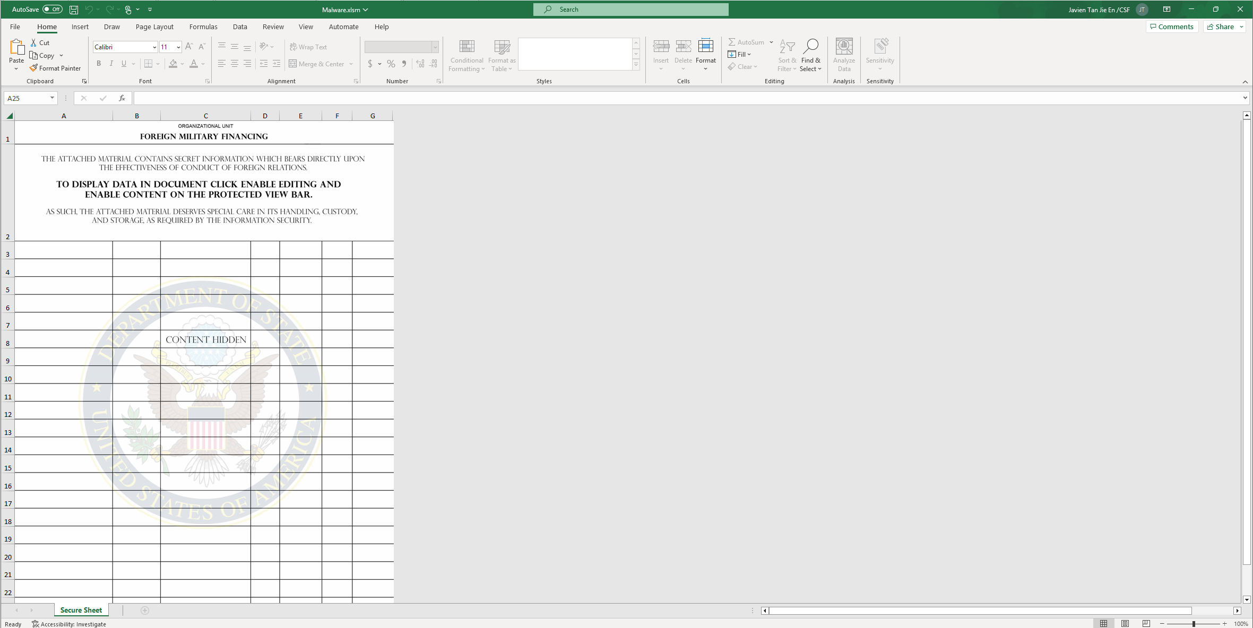

Figure 5.2.1.3. Malware.xlsm after enabling content

This is because the malicious excel file does not want the user to know that it contains malware and that their computer has been infected with the malware. As such, dynamic analysis tools would be needed to allow us to analyse the behaviour of this malware.

### Registry Analysis

Analysing the computer’s registry is important in analysing malware. This is because malware often makes changes to the registry to allow it to persist in the victim’s computer even after shutdown. Changing the registry also allows the malware to make more critical changes to the computer, allowing the malware to be more effective and efficient. Since there were no visible changes after enabling the content of Malware.xlsm, it is highly likely that registry changes were made.

The tool used to analyse the registry changes was RegShot. RegShot is a tool that captures the state of the computer’s registry before and after malware execution, and shows the changes in the registry. Figure 5.2.2.1 shows the captured registry changes.

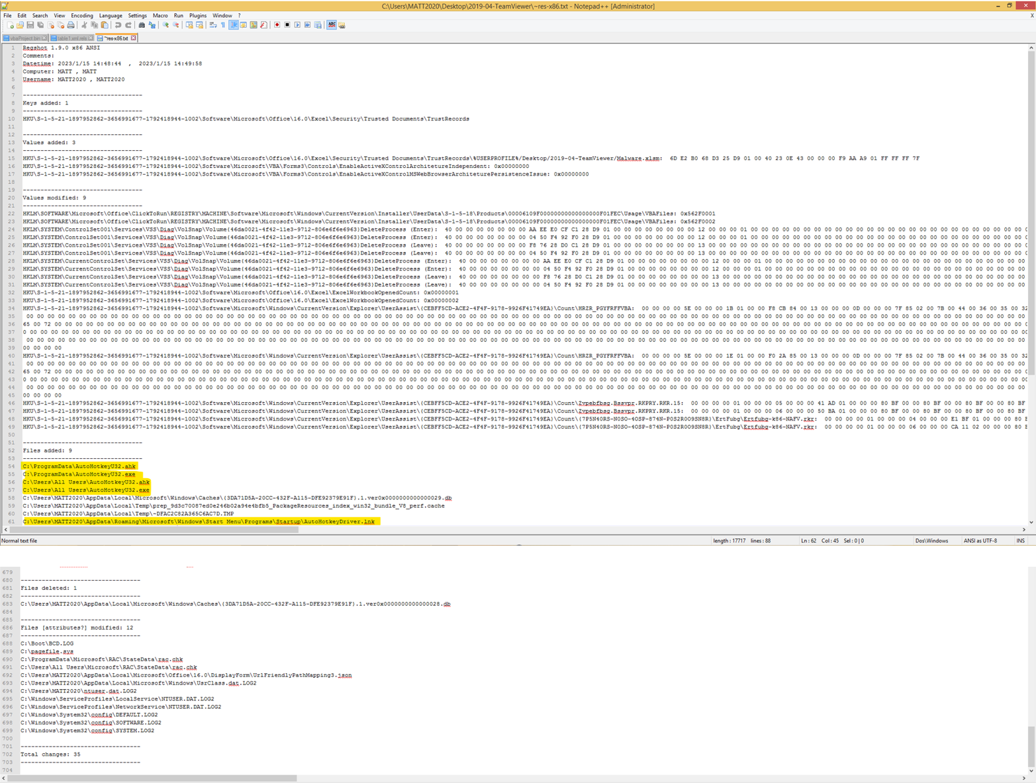

Figure 5.2.2.1. RegShot result

It can be seen that new files were added, being AutoHotkeyU32.ahk and AutoHotkeyU32.exe. These files were previously discovered in static analysis. These files were added in the ProgramData folder. By default, the ProgramData folder is hidden from view, which shows that this is another method the malware uses to try to conceal itself. As previously mentioned in VirusTotal, AutoHotkey is not a malicious software. To ensure that AutoHotkeyU32.exe was genuine, it was ran through VirusTotal. Figure 5.2.2.2 shows the VirusTotal output. Only 2 out of 71 security vendors flagged the executable as malicious, which likely meant that it was a false positive and that the .exe file was not malicious.

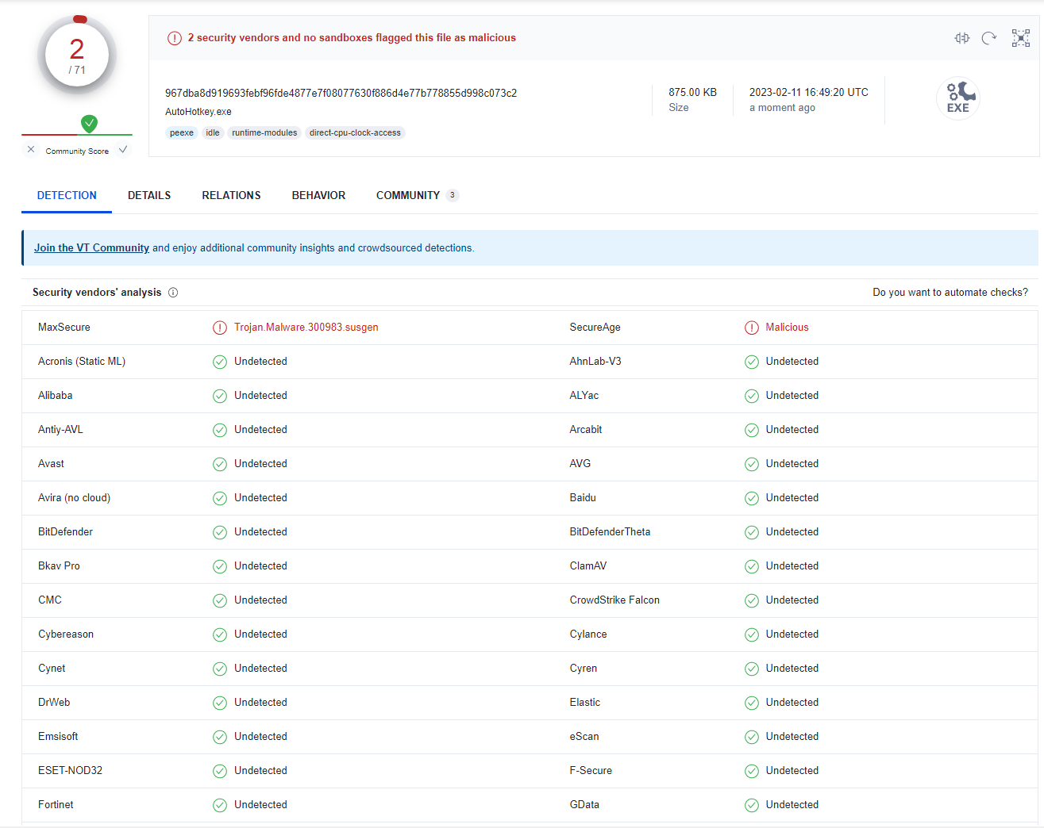

Figure 5.2.2.2. VirusTotal result for AutoHotkeyU32.exe

Apart from the creation of these 2 files, the malware is persistent on the system due to AutoHotkeyDriver.lmk being added to the Startup folder. When added to the Startup folder, the .ahk file will be executed each time the computer starts up.

Hence, by analysing the registry changes the malware makes, we could discover how the malware makes changes to the system.

### Process Analysis

Process analysis allows us to observe processes running on the computer. This is important because malware often creates new processes to run their malicious code, and these processes would be invisible to the user without using process monitoring tools.

Process explorer was the tool of choice. After looking at the running processes, AutoHotkeyU32.exe was seen. This is the program executing the malware because it was already known that AutoHotkey was being used to run the malicious .ahk script.

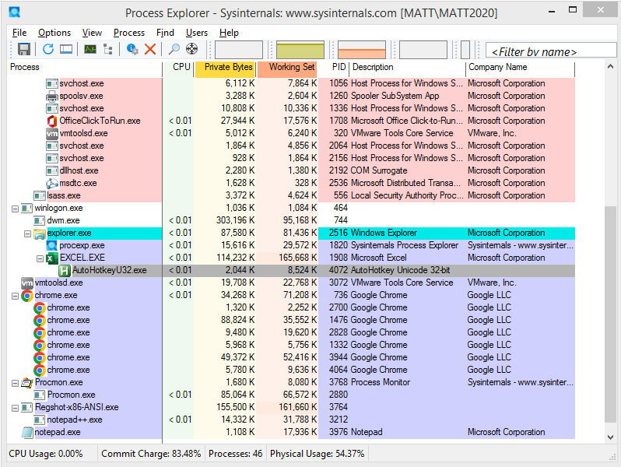

Figure 5.2.3.1. AutoHotkeyU32.exe in process explorer

Upon looking at the properties of the process, it was seen that it executed a command line. This command line was the Shell() function call from the Module1 macro file that was previously discovered. As expected, it runs the .exe and .ahk file of the malware.

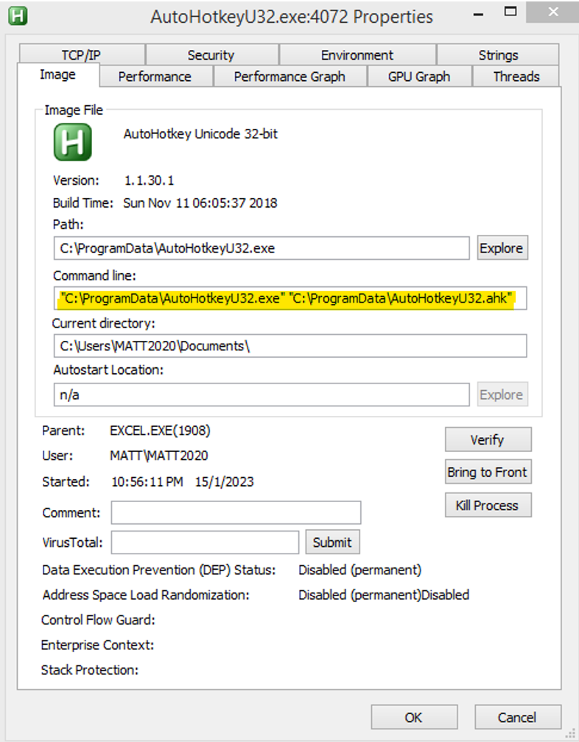

Figure 5.2.3.2. AutoHotkeyU32.exe properties

The strings of the program, both in image and in memory, was analysed. Suspicious strings like “ABCDEFGHIJK…..+\” were seen. This suggests that the program hooks the user’s keyboard and listens for input, which could mean that the malware is a keylogger.

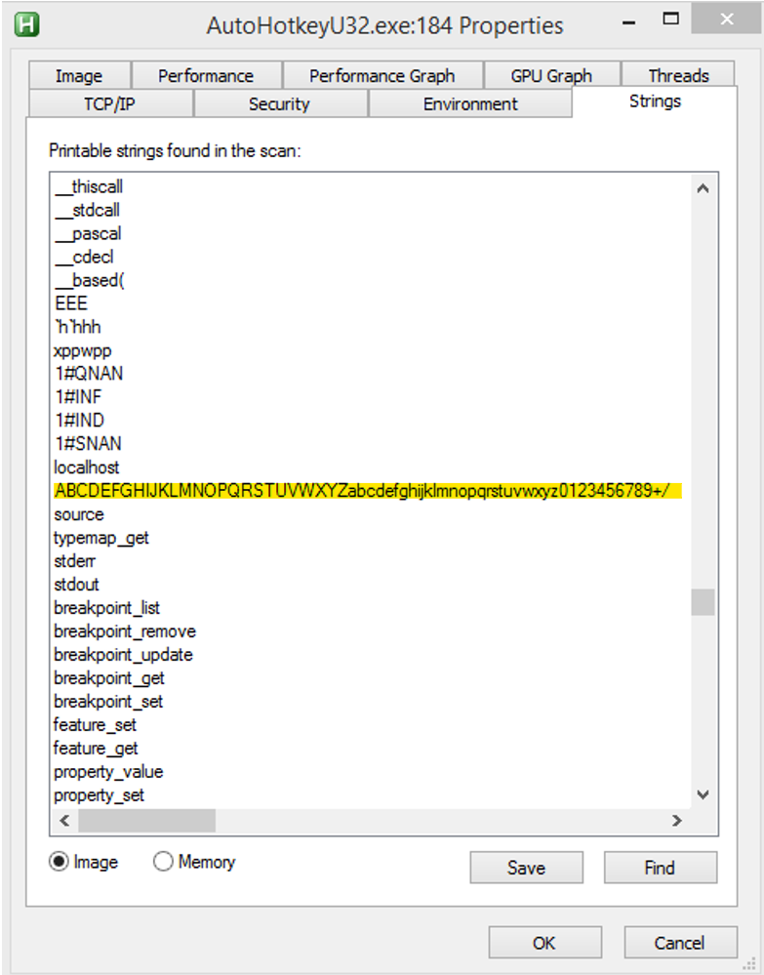

Figure 5.2.3.3. Strings of AutoHotkeyU32.exe in image

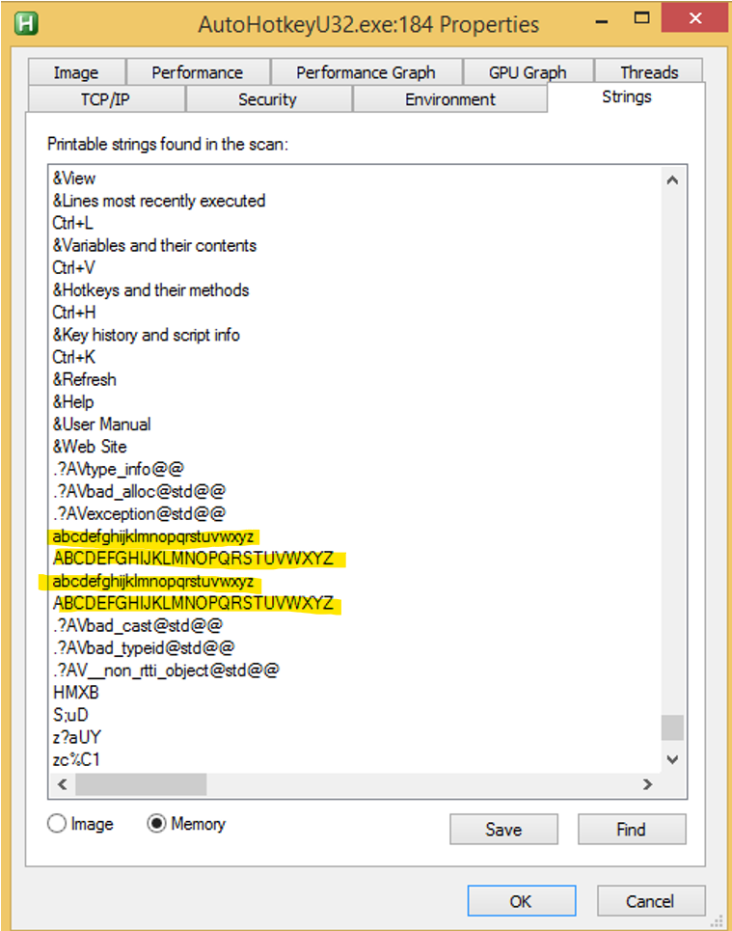

Figure 5.2.3.4. Strings of AutoHotkeyU32.exe in memory

Hence, through process analysis, we were able to discover the command that the program executes and the malware potentially being a keylogger.

### Network Analysis

Network analysis is important as it allows us to find out what external connections to the internet the malware tries to establish to. ApateDNS was the tool used for this purpose.

After executing the malware, a connection to 185.70.186.145 could be seen. This IP address was previously seen from VirusTotal. This was an important network-based indicator as it likely meant that the malware was trying to exchange data with this IP address.

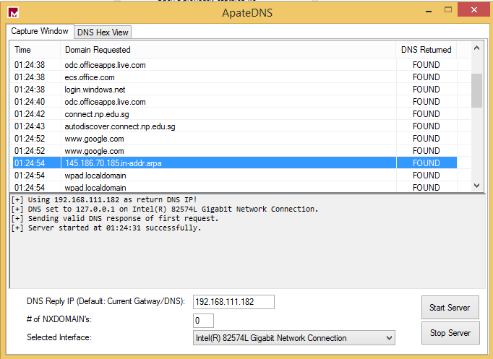

Figure 5.2.4.1. ApateDNS result

A manual connection to the IP address was attempted, but it was found that the website was no longer up.

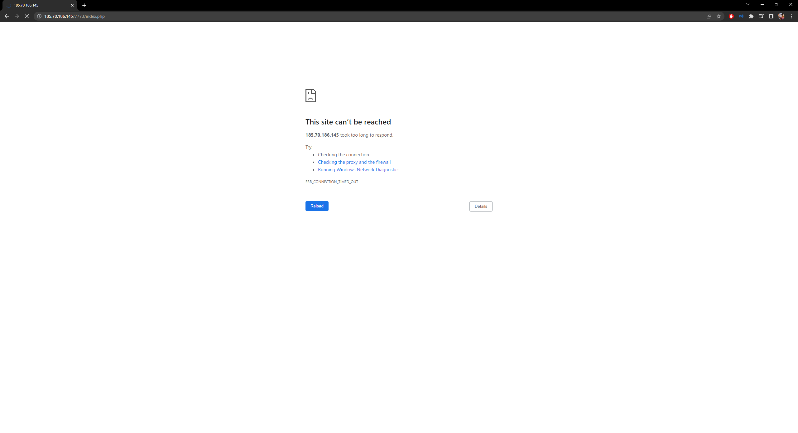

Figure 5.2.4.2. Connection result to 185.70.186.145

It was hence believed that the malware was trying to establish a connection to 185.70.186.145 but was unable to. Process monitoring was then carried out to confirm this belief.

### Process Monitoring

Process monitoring is a step in malware analysis where events that the malware program produces are analysed. This was used to try to gather more information regarding the malware’s network connections.

The tool used for process monitoring was Process Monitor. Figure 5.2.5.1 shows the result of AutoHotkeyU32.exe’s process events.

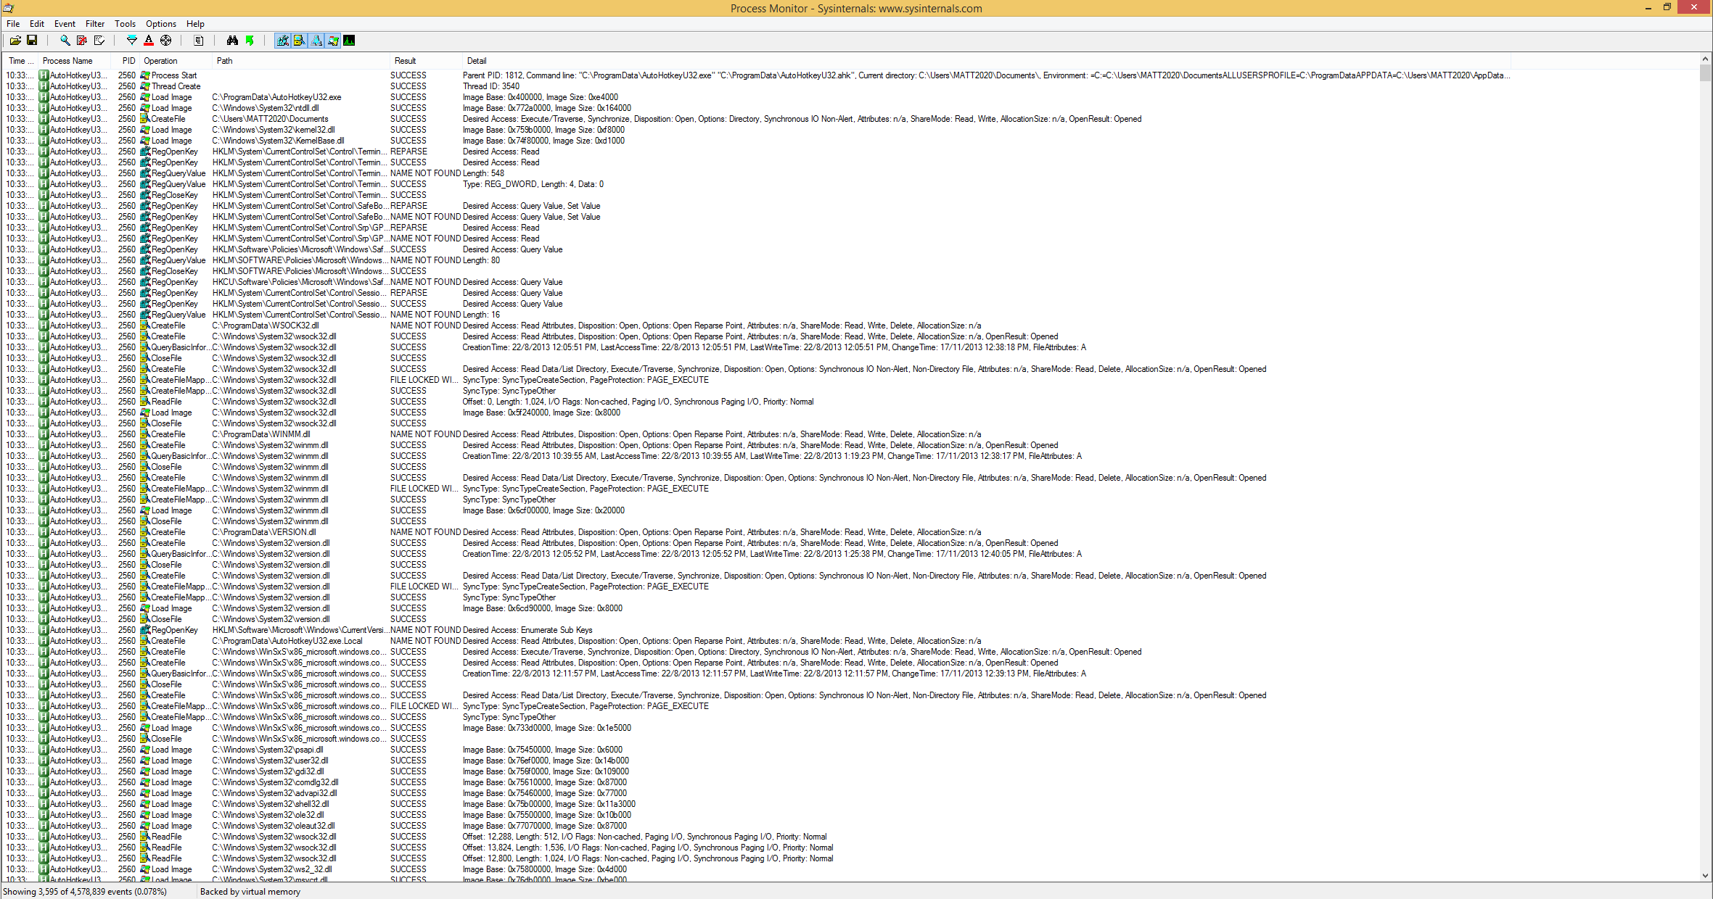

Figure 5.2.5.1. Process monitoring result

The process events were analysed, and it was found that the only TCP-related operations were “TCP Disconnect”. This was an unsurprising result and hence guaranteed that the website was no longer working. A filter for “TCP Disconnect” was then applied.

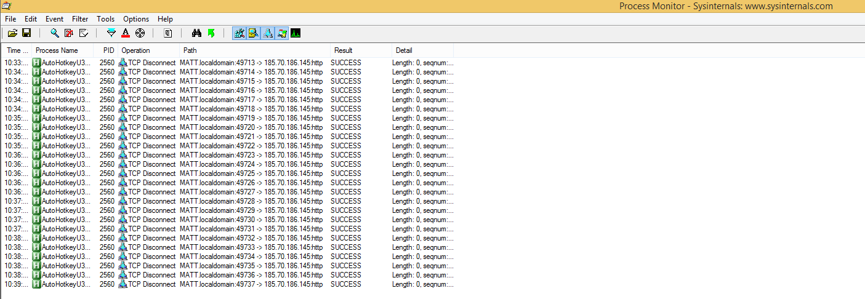

Figure 5.2.5.2. "TCP Disconnect" filter applied

It was found that the program periodically attempted to connect with the previously seen IP address of 185.70.186.45. This process monitoring step hence concluded that the malware was unable to exchange any data with the requested URL.

### Analysing the .ahk File

As previously discovered in Registry Analysis, the malware created an .ahk file and .exe file in the ProgramData folder. As mentioned previously, the .exe file itself was not malicious and was instead only used to run the .ahk file. Hence, only the .ahk file’s contents needed to be analysed. Figure 5.2.6.1 shows the contents of the .ahk file.

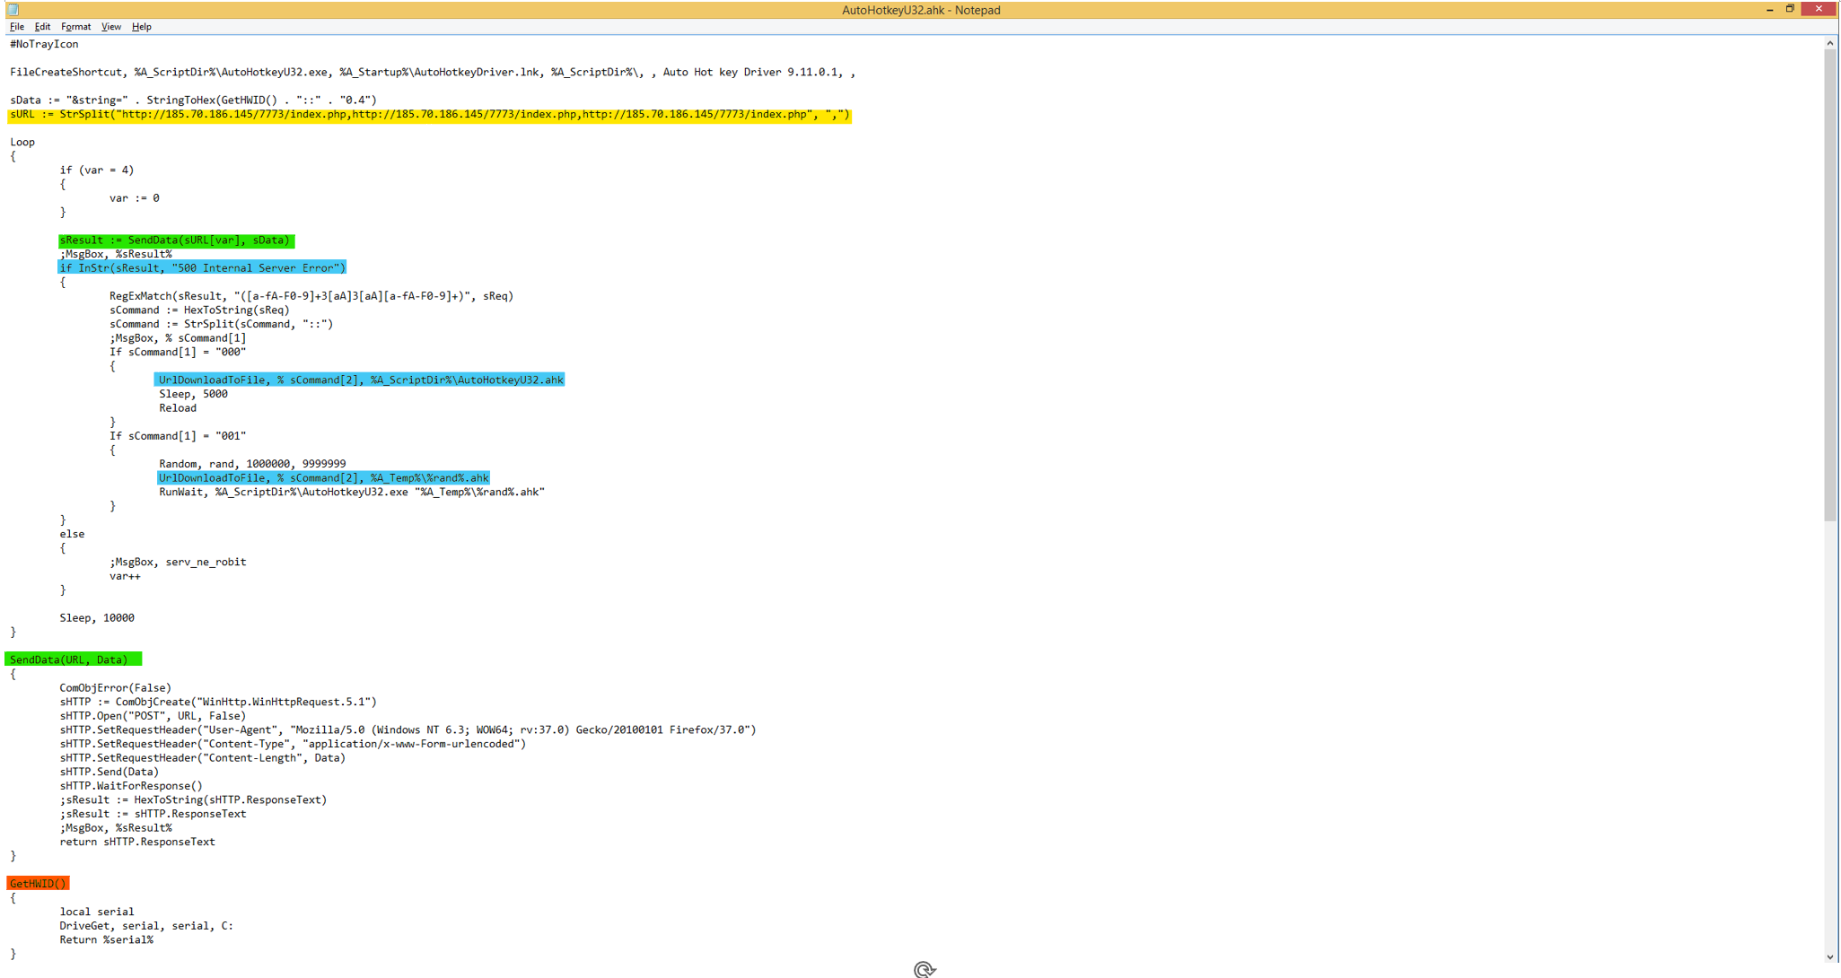

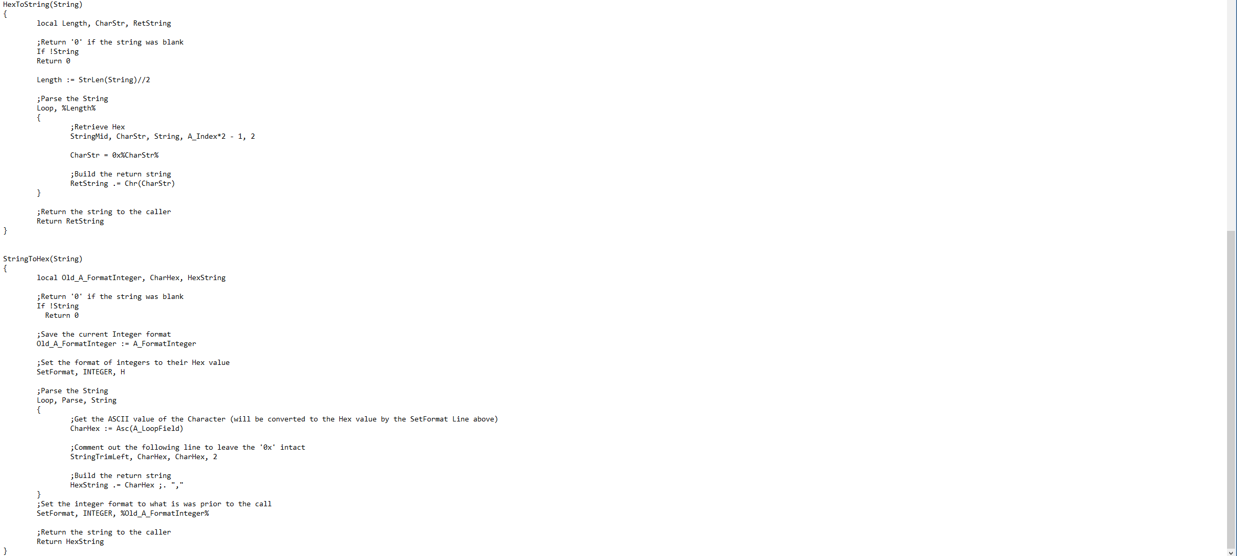

Figure 5.2.6.1. AutoHotkeyU32.ahk code

A URL with an IP address 185.70.186.145 could be seen as highlighted in yellow, which meant that this was the code that tried to establish the internet connections seen previously.

The code consists of a loop function, which is the main part of the code that runs, and a few functions defined below it. The most important function is the SendData(URL, Data) function (highlighted in green). Its function is to send data to an external connection over the internet via HTTP protocol. This function was used in the loop of the code, where the URL of the IP address was supplied into the function. Furthermore, if SendData results in the connection to the URL failing due to “500 Internal Server Error”, then an “if” statement gets executed (highlighted in blue). Depending on other conditions that occur within the “if” statement, an .ahk file would be downloaded from the URL.

As discovered in Network Analysis, the URL the malware tried to connect to was no longer operational. Hence, it was not possible to retrieve and analyse the .ahk files that AutoHotkeyU32.ahk tried to download.

Another important function is the GetHWID() function (highlighted in orange). This function returns the hardware ID of the victim’s computer. In the code, the computer’s hardware ID was supplied into the SendData function as the data to be sent.

Although the malware attempted to send data about the hardware ID of the victim’s computer to the URL, it did not seem to send any other form of data. Hence, it is highly likely that this malware’s purpose is to be a downloader to download other malicious .ahk scripts from the URL to be ran on the victim’s computer.

### Summary of Basic Dynamic Analysis

From the basic dynamic analysis, we were able to determine the purpose of Malware.xlsm. The tools used to carry out this analysis were pivotal in this process because as proven in General Dynamic Analysis, nothing seemed to change when “Enable Content” was clicked. We were able to determine that the malware creates and runs a malicious AutoHotkey script which acts as a downloader for more scripts which were likely to also be malicious.

## Summarization of Malicious Document Analysis

This section summarizes the basic static and basic dynamic analysis that were performed on Malware.xlsm, as well as how to permanently remove the malware on a computer should the computer become infected.

### Malicious Document Functionalities

Using VirusTotal, it was determined that the unknown file type for the malware was Office Open XML Spreadsheet (.xlsm).

The excel file used social engineering tactics to trick users into enabling the VBA macros that resided within it. The macros would be activated upon clicking “Enable Content”.

Once the macros have been enabled, AutoHotkeyU32.exe and AutoHotkeyU32.ahk would be generated into “C:\ProgramData”. AutoHotkeyU32.exe was not a malicious program, but AutoHotkeyU32.ahk was a malicious script. The malware achieved persistence by adding the file AutoHotkeyDriver.lnk into the file path “C:\Users\MATT2020\AppData\Roaming\Microsoft\Windows\Start Menu\Programs\Startup\”. This results in AutoHotkeyU32.ahk running on computer start-up.

AutoHotkeyU32.ahk acted as a malware downloader which connected to a URL with the IP address 185.70.186.145 to download more malicious .ahk scripts.

In the end, it was concluded that Malware.xlsm was a malware downloader.

### Malicious Document Removal

The simplest method to prevent a computer from being infected with Malware.xlsm is to not allow the file to execute its malicious code. Microsoft Defender Antivirus is effective enough to detect Malware.xlsm as a malicious file and automatically render it useless. Figure 5.3.2.1 shows the alert that the antivirus gives when it detected Malware.xlsm. Figure 5.3.2.2 shows that once Malware.xlsm had been detected, it could no longer be opened, which meant that the malware could no longer infect the computer.

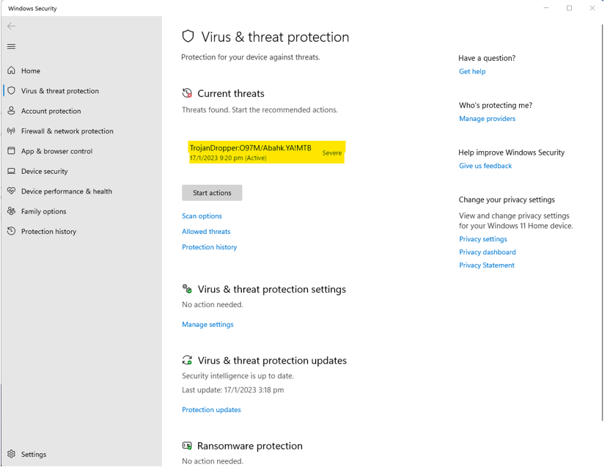

Figure 5.3.2.1. Microsoft Defender Antivirus detected threats

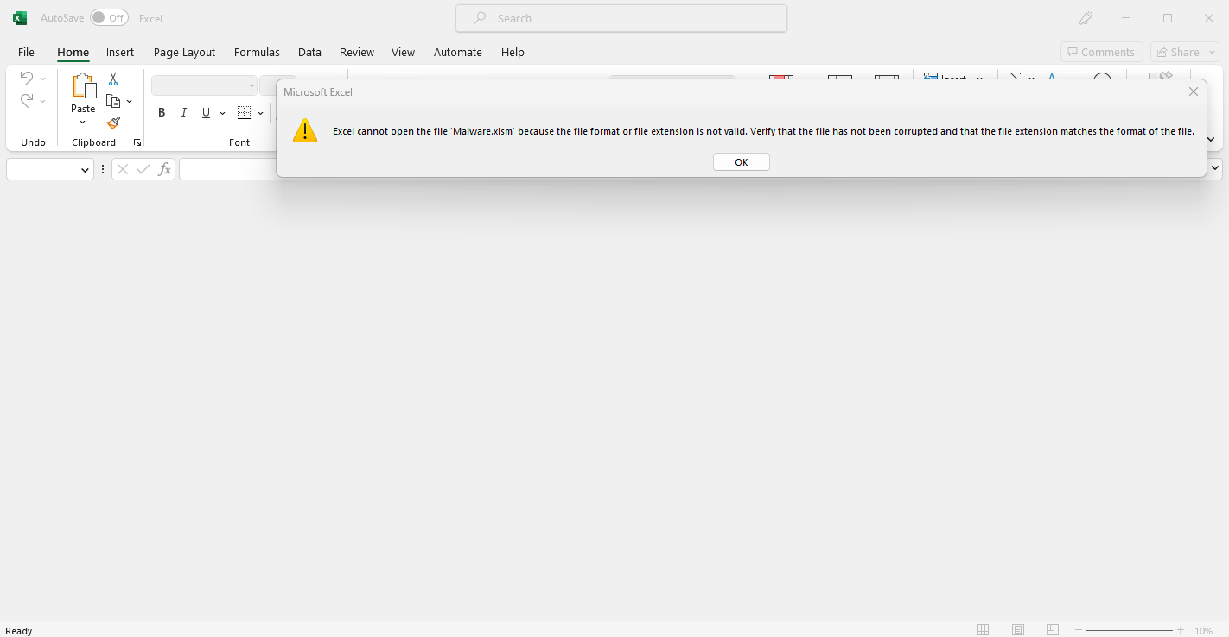

Figure 5.2.3.2. Malware.xlsm could no longer be opened

However, should the computer’s antivirus software fail to detect Malware.xlsm, and the computer gets infected with the malware, there are steps that can be taken to manually remove the malware.

The steps are as follows:

* Delete Malware.xlsm from the computer
* Terminate the AutoHotkeyU32.exe process
* Delete AutoHotkeyU32.exe and AutoHotkeyU32.ahk from C:\ProgramData folder
* Delete AutoHotkeyDriver.lnk from the file path “C:\Users\<user>\AppData\Roaming\Microsoft\Windows\Start Menu\Programs\Startup\”

With these steps, the malware would not be able to persist on the computer and instead be permanently deleted.

# 6. Video Submission Links

|  |  |
| --- | --- |
| **Video** | **URL** |
| Introduction | <https://youtu.be/3KchkmLgBZ4> |
| Malware Executable Static Analysis | <https://youtu.be/_wgBLPbaAJk> |
| Malware Executable Dynamic Analysis | <https://youtu.be/bV0V9bkAWtE> |
| Document Analysis | <https://youtu.be/4GZ07tHGeKE> |
| Conclusion & Reflections | <https://youtu.be/Dik_LStClmw> |

# 7. References

Aldeid. (2020, April 11). *BinText*. aldeid. Retrieved January 26, 2023, from https://www.aldeid.com/wiki/BinText

Aldeid. (2020, April 11). *PEiD*. aldeid. Retrieved January 26, 2023, from https://www.aldeid.com/wiki/PEiD

Audit My PC. (n.d.). *mscoree.dll - mscoree, Microsoft .net Runtime Execution Engine, Delete and Removal Information!* Audit My PC. Retrieved January 26, 2023, from https://www.auditmypc.com/mscoree.asp

Brain Knowledge. (2014, February 11). *What does “arp who-has tell” means?* Brain Knowledge. Retrieved February 1, 2023, from https://stressdbrain.wordpress.com/2014/02/11/what-does-arp-who-has-tell-means/ https://osqa-ask.wireshark.org/questions/5412/what-does-arp-42-who-has-19216811-tell-192168133-mean/

Chheda, R., & Moerschel, G. (2022, August 10). Retrieved January 26, 2023, from https://assets.sentinelone.com/mitre-engenuity/mitre-mania-your-gui?utm_content=white-paper&utm_medium=paid-display&utm_source=gdn-paid&utm_campaign=apj-t1-en-g-pmax-competitors&utm_term=%7Bdemo-request%7D&utm_campaignid=19242249269&gclid=CjwKCAiA5sieBhBnE

Dependency Walker. (n.d.). *Dependency Walker 2.2*. Dependency Walker (depends.exe) Home Page. Retrieved January 26, 2023, from https://www.dependencywalker.com/

Fox, N. (2021, October 6). *PeStudio Overview: Setup, Tutorial and Tips*. Varonis. Retrieved January 26, 2023, from https://www.varonis.com/blog/pestudio

Internet Engineering Task Force (IETF). (2013, February). *RFC 6762: Multicast DNS*. Multicast DNS. Retrieved February 1, 2023, from https://www.rfc-editor.org/rfc/rfc6762.html#section-3

Malpedia. (n.d.). *RedLine Stealer (Malware Family)*. Malpedia. Retrieved February 1, 2023, from https://malpedia.caad.fkie.fraunhofer.de/details/win.redline_stealer

Microsoft. (2021, June 29). *IsDebuggerPresent function (debugapi.h) - Win32 apps*. Microsoft Learn. Retrieved January 26, 2023, from https://learn.microsoft.com/en-us/windows/win32/api/debugapi/nf-debugapi-isdebuggerpresent

Microsoft. (2021, October 9). *Windows Management Instrumentation*. Microsoft. Retrieved February 2, 2023, from https://learn.microsoft.com/en-us/windows/win32/wmisdk/wmi-start-page

Microsoft. (2021, October 13). *SetCommMask function (winbase.h) - Win32 apps*. Microsoft Learn. Retrieved January 26, 2023, from https://learn.microsoft.com/en-us/windows/win32/api/winbase/nf-winbase-setcommmask

Microsoft. (2021, October 13). *WinHttpSetDefaultProxyConfiguration function (winhttp.h) - Win32 apps*. Microsoft Learn. Retrieved January 26, 2023, from https://learn.microsoft.com/en-us/windows/win32/api/winhttp/nf-winhttp-winhttpsetdefaultproxyconfiguration

Microsoft. (2022, February 7). *Performance Counters - Win32 apps*. Microsoft Learn. Retrieved January 26, 2023, from https://learn.microsoft.com/en-us/windows/win32/perfctrs/performance-counters-portal

Microsoft. (2022, July 27). *ClearEventLogA function (winbase.h) - Win32 apps*. Microsoft Learn. Retrieved January 26, 2023, from https://learn.microsoft.com/en-us/windows/win32/api/winbase/nf-winbase-cleareventloga

Microsoft. (2022, July 27). *GetSystemDirectoryA function (sysinfoapi.h) - Win32 apps*. Microsoft Learn. Retrieved January 26, 2023, from https://learn.microsoft.com/en-us/windows/win32/api/sysinfoapi/nf-sysinfoapi-getsystemdirectorya

Microsoft. (2022, July 27). *lstrcmpiA function (winbase.h) - Win32 apps*. Microsoft Learn. Retrieved January 26, 2023, from https://learn.microsoft.com/en-us/windows/win32/api/winbase/nf-winbase-lstrcmpia

Microsoft. (2022, September 23). *Sleep function (synchapi.h) - Win32 apps*. Microsoft Learn. Retrieved January 26, 2023, from https://learn.microsoft.com/en-us/windows/win32/api/synchapi/nf-synchapi-sleep

Nirsoft. (n.d.). *HashMyFiles: Calculate MD5/SHA1/CRC32 hash of files*. NirSoft. Retrieved January 26, 2023, from https://www.nirsoft.net/utils/hash_my_files.html

Open MUI File. (n.d.). *What is a MUICache?* Open MUI File. Retrieved February 1, 2023, from https://openmuifile.com/muicache.html

Oracle. (2010). *IPv6 Multicast Addresses in Depth*. System Administration Guide: IP Services. Retrieved February 1, 2023, from https://docs.oracle.com/cd/E19253-01/816-4554/ipv6-overview-201/index.html#:~:text=The%20IPv6%20multicast%20address%20provides,any%20number%20of%20multicast%20groups.

Quora. (2022, September). *Who responds to ARP requests?* Quora. Retrieved February 1, 2023, from https://www.quora.com/Who-responds-to-ARP-requests

Radburn, W. J. (2022, January 16). *WJR Software - PEview (PE/COFF file viewer),...* WJR Consulting. Retrieved January 26, 2023, from http://wjradburn.com/software/

Reddit. (2019, January 19). *domain 3.0.0.0.1.0.0.0.0.0.0.0.0.0.0.0.0.0.0.0.0.0.0.0.0.0.0.0.2.0.f.f.ip6.arpa ???* Reddit. Retrieved February 1, 2023, from https://www.reddit.com/r/pihole/comments/ahcny0/domain_300010000000000000000000000020ffip6arpa/

Snort. (n.d.). *Snort - Network Intrusion Detection & Prevention System*. Snort. Retrieved February 1, 2023, from https://www.snort.org/

Techopedia. (n.d.). *What is Kernel32.dll? - Definition from Techopedia*. Techopedia. Retrieved January 26, 2023, from https://www.techopedia.com/definition/3379/kernel32dll

Wireshark. (2011, August 2). *What does arp 42 who has 192.168.1.1? tell 192.168.1.33 mean?* Wireshark. Retrieved February 1, 2023, from https://osqa-ask.wireshark.org/questions/5412/what-does-arp-42-who-has-19216811-tell-192168133-mean/

Wojner, C. (n.d.). *Show*. CERT.at - Show. Retrieved January 26, 2023, from https://www.cert.at/en/downloads/software/software-bytehist

AutoHotkey. (n.d.). *AutoHotkey*. Retrieved from AutoHotkey: https://www.autohotkey.com/